**Over St John’s CE Primary School**

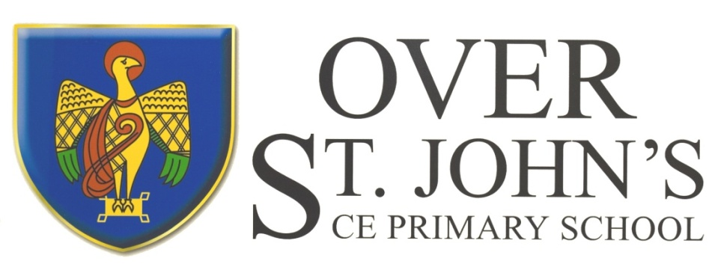

**‘**Let you light shine before others.’ Matthew 5:16

**Information for Candidates**

**Head Teacher: Mrs E Snowdon**

**Chair of Governors: Mrs H Rogers**

**Delamere Street, Winsford, Cheshire CW7 2LU**

**Tel. 01606 592608**

**Email:** [**head@overstjohns.cheshire.sch.uk**](mailto:head@overstjohns.cheshire.sch.uk)

**Website:** [**http://www.overstjohns.cheshire.sch.uk**](http://www.overstjohns.cheshire.sch.uk)

**Over St. John’s CE Primary School**

**Vision Statement**

Over St. John’s puts children first.

From our roots of faith and respect,

we encourage challenge,

develop confidence and inspire learning

so that children grow in the love of God, prepared for their future.

‘Let your light shine before others.’ Matthew 5:16

**Aims**

* To put the children first in offering a wide range of learning experiences within agreed boundaries that will prepare them for the future.
* To offer a small, friendly environment that supports children to learn and develop socially and academically whilst also having fun.
* To encourage children to develop emotionally and spiritually within a Christian ethos and to play an active role within the school and wider community.
* To involve children, teachers, parents and governors as part of its commitment to achieve high academic standards within the financial framework of the school budget.
* To strive forward and not stand still in pursuit of excellence.

### Introduction

St John’s has been the local school for Over since 1860, but the original part of the building dates back to approximately 1840, when it was designated to be a market hall. When this venture failed, the premises were used as a Dame School until Lord Delamere financed its conversion to a school to meet the needs of the Over area. St John’s long tradition and clear identification with the local community provides a firm base for the highest quality of primary education. The school has been modernised to provide extra classroom space and improved facilities, whilst the conversion of the original school house has been carried out sympathetically to its Victorian origins. The school is identified with providing a caring and happy atmosphere and for its high standards of education.

St John’s is a Voluntary Controlled Church of England School. Recognising the value of our foundation, the school preserves and develops its religious character in accordance with the Church of England and in partnership with the Church at parish and diocesan level. We aim to serve the community of Over by providing a high-quality education within the context of Christian beliefs and practice. We encourage an understanding of the meaning and significance of faith and promote Christian values through the experience we offer to all our pupils. The Vicar is a welcomed visitor and leads Collective Worship each week, whilst the children attend services in Church during the major festivals.

The school’s catchment area covers one side of Delamere Street and the houses behind as well as both sides of Chester Road. The catchment area covers a mix of both council and private housing and the school reflects the social mix of the town. The school has an admission limit of 21 children per year. There are currently 139 children on roll.

**Classes and Staff**

There are six classes with three having mixed year groups. Class sizes average between 20 and 28 pupils.

All staff work very well together as a team. The Teachers and Teaching Assistants support classes and individual children. There is also a School Business Manager, a Clerical Officer, two Premises Staff, four Mid-Day Assistants, Catering Supervisor and Kitchen Assistant.

**School Philosophy**

Over St John’s CE School is committed to providing a broad, balanced and relevant curriculum that serves the needs of all children and offers challenges and a richness of experience. We ensure that children have opportunities to apply and develop knowledge, skills, concepts and practical abilities to high standards. Pupils are offered a wide range of direct experiences, both inside and outside the classroom, including both day and residential visits.

The National Curriculum is the core of the school’s curriculum. Children have a designated English and Mathematics session each day and we have spent time developing a curriculum that is right for our children. We have a suite of laptops in school that are timetabled to support learning and each classroom has an interactive screen.

Over St. John’s school adopts a positive approach to behaviour management, where the emphasis is very much on praise and reward for good behaviour. The school has three simple rules to ensure the safety and happiness of everyone, which are mirrored in every area of the school.

**The concept of a school community is very real at St John’s: a community in which we value the contributions of all - children, parents, governors, friends and staff.**

**Parents and Carers**

We encourage an open partnership with parents and carers for the benefit of the children. To this end, staff are usually available for telephone calls from parents and endeavour to return these at the earliest opportunity. If parents wish to have a more detailed meeting, then an appointment will be made for them. We hold three Pupil Consultation Evenings each year and send a more formal, written report at the end of the summer term.

‘The Friends of St. John’s’ creates not only financial support but also provides enjoyable social occasions for the school community. We welcome using the talents of parents, carers and other friends of the school and are grateful for their help in the classroom. All volunteers, who help on a regular basis, are required to undergo an enhanced DBS check prior to working directly with children.

**Safeguarding**

Over St. John’s CE School is committed to the safety and protection of its pupils. As such, one of the post holder's responsibilities will be to promote and safeguard the welfare of pupils at the school – candidates will be subject to an enhanced DBS check and safer recruitment procedures as well as a rigorous induction period.

**Inspection**

The school was last inspected in May 2024 by Ofsted and underwent a SIAMS Section 48 Inspection in June 2022. The school continues to build on the good reports received as a result of both of these inspections.

**Final date for receipt of application forms**

Wednesday 25th June 2025 at 12pm

Emma Snowdon

Over St. John’s C.E. Primary School

Delamere Street

Winsford

Cheshire

CW7 2LU

Tel: 01606 592608

[head@overstjohns.cheshire.sch.uk](mailto:head@overstjohns.cheshire.sch.uk)