|  |  |  |  |
| --- | --- | --- | --- |
| **Job description** | | | |
| **Job title** | Fostering Independent Reviewing Officer (FIRO) | | |
| **Grade** | Grade Q | | |
| **Directorate** | Children's Services | | |
| **Service/team** | Safeguarding Quality Assurance | | |
| **Accountable to** | Service Manager | | |
| **Responsible for** | Fostering reviews | | |
| **JE Reference** | A4873 | **Date Reviewed** | June 2025 |

**Purpose of the Job**

*Under the supervision of the Service Manager the post-holder will ensure that safeguarding needs of children, young people and their families (including carers) are assessed and responded to in a timely manner.*

*The FIRO is responsible for ensuring the suitability of Foster Carers and that the terms of approval fully reflect their competence in meeting Looked After Children’s needs, using Knowsley Council’s policies and procedures, legislation and Fostering regulation.*

**Duties and Responsibilities**

This is not a comprehensive list of all the tasks, which may be required of the post holder. It is illustrative of the general nature and level of responsibility of the work to be undertaken.

**Key Accountabilities**

1.To chair and record statutory reviews of Local Authority foster carers.

2.To seek and promote the active consultation and participation of carers and their families, children, young people, parents, and significant others in the reviewing process.

3. To promote good professional practice and the best interests of Cared for Children. In particular to conduct Reviews as per Reg 28 of Fostering Regulations 2011.

4. To be aware of other meetings which inform the review process, such as Risk Assessment meetings etc.

5 To accurately record review outcomes, records and decisions within timescales.

6 To be familiar with IT systems and process reviews onto templates provided.

7. To monitor the implementation of review recommendations and decisions via the review process and draw to the attention of operational managers any areas of concern regarding practice, including non-compliance with agreed plans and practice, by use of the agreed Dispute Resolution system.

8. To maintain good relationships and effective communication with colleagues within both internal and external services.

9. To contribute to periodic reports for senior managers within the Department identifying any practice, process, procedural or systems issues.

10. To maintain an effective and up to date working knowledge of policies, procedures, practice and research in Fostering Service and to keep others informed as appropriate.

11. To seek and promote the participation of other agencies in the review process by effective liaison and communication.

12. To act as an advisor to other Departmental staff undertaking the chairing of reviews, if required.

13. To participate in the delivery of training to Departmental staff, carers and other agencies as appropriate.

14. To ensure the provision and availability of appropriate publicity and information available in relation to planning and review of foster households.

15. To ensure that the needs of all fostering families are taken into account.

16. To attend other practice and organisational meetings as required.

17. To contribute to the development of the service and ensure that objectives are delivered and outcomes achieved which address the Departmental/Service area Business Plan.

18. To be responsible for continuing self-development, undertaking training and contributing to team meetings and team days.

19. To present reviews to Knowsley Council’s fostering panel and to IRM panel if required.

20. To undertake any other duties which may reasonably be regarded as within the nature of the duties and responsibilities/ grade of the post defined, subject to the provision that normally any changes of a permanent nature shall be incorporated into the Job Description in specific terms.

21. To ensure foster placements provide a safe place for children and young people and meet the required standards set by Knowsley children social care and National Minimum Standards

22. To ensure, devise and update any processes to contribute to the role of IRO for foster carers and the performance data required.

23. To produce an annual report on the findings and any learnings associated with fostering reviews across the service.

24. To support other Quality Assurance roles within the service and Regulation 44 visits.

**Knowsley Better Together – Staff Qualities**

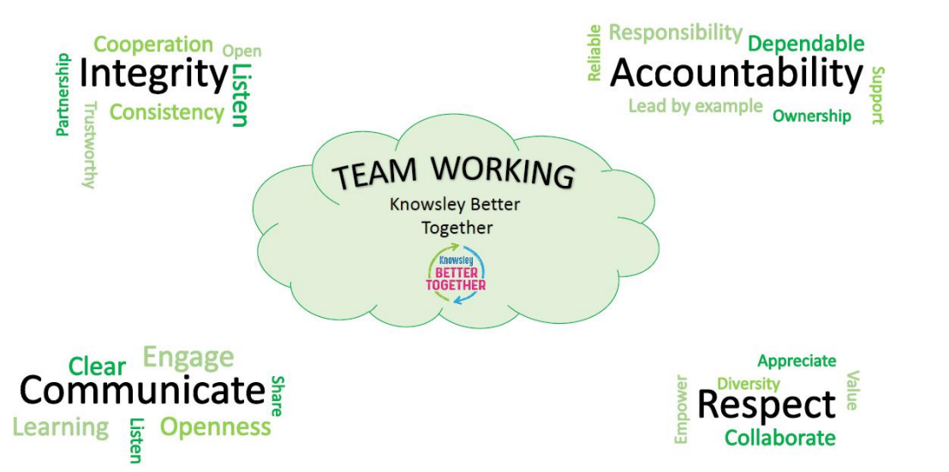

**Health and Safety**

* To use equipment as instructed and trained.
* To inform management of any health and safety issues which could place individuals at risk.

**Data Protection and Information Security**

* Implement and act in accordance with the Information Security Acceptable Use Policy, Data Protection Policy and GDPR.
* Protect the Council’s information assets from unauthorised access, disclosure, modification, destruction or interference.
* Report actual or potential security incidents.