CONFIDENTIAL
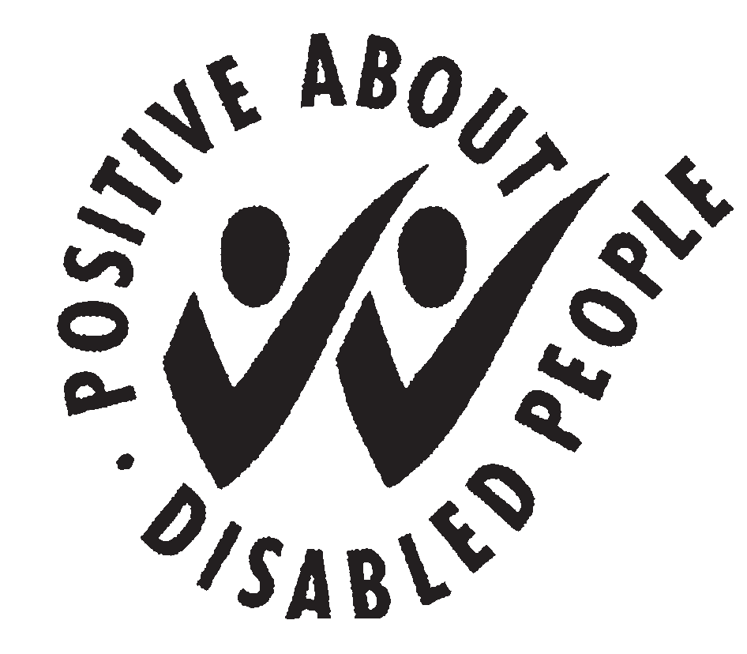
EQUAL OPPORTUNTIES MONITORING
We are committed to ensuring that all applicants for jobs and all members of staff are given equality of opportunity irrespective of race, sex, gender reassignment, sexual orientation, religion or belief, age, disability, marital status (including civil partnership) or pregnancy/maternity. We also want to avoid disadvantaging those who are carers.

The Council works to provide the best possible service to all members of the public. One way of doing this is to employ a workforce that reasonably reflects the local population. This means knowing and keeping under review how many people from the above categories are either working for us or applying for employment with the Council.

The questions in this form reflect the catergories (“protected groups”) identified in the Equality Act 2010. They also reflect questions asked by the National Census which means we can compare our workforce to the local population.

Please fill in this form; it will help us to make sure we are treating our job applicants and employees fairly. If you do not wish to provide all of the information, please answer those questions that you are happy to answer.

This information will not form part of your application and will not be made available to the selection panel except as may be necessary for applications who apply under the ‘two tick’ scheme.

Data collected on applicants who are unsuccessful will be confidentially destroyed within 3 months of the selection interviews taking place.
Name:

Post Applied for:

Post Number:

National Insurance Number:

- Gender
Are you: Male Female

b) Gender Identity
Do you live and work full time in a gender role opposite to that assigned to you at birth (e.g. gender re-assignment, transgender)?
Yes No

c) Disability
The Equality Act 2010 states that “a person has a disability if he/she has a physical or mental impairment which has a substantial and long-term adverse effect on his/her ability to carry out normal day-to-day activities”. The Act also specifies that a person has disability if they have a progressive condition such as cancer, HIV infection or multiple sclerosis.

Do you believe you have a disability as defined by the Equality Act 2010?
Yes No

Are you applying under the Disability Two Tick Scheme?
Yes No (please see Information for Candidates)

d) Age
Please tick relevant box | 16-24 |  | 25-34 |  | 35-44 |  | 45-54 |  | 55-64 |  | 65 or over

e) Marital Status
I am: married in a civil partnership not married

f) Ethnic Origin. To which of the following groups would you say you belong?
(please tick √ one box only)
- Asian or Asian British |  | - Black or Black British |  | - Chinese
Bangladeshi |  | African |  | Chinese
Indian |  | Caribbean |  | Other Chinese background
Pakistani |  | Other Black background |  | Please say if you wish
Other Asian background |  | Please say if you wish
Please say if you wish

- Mixed |  | (v) White |  | (vi) Other
White and Black African |  | British |  | Gypsy/Traveller
White and Black Caribbean |  | Irish |  | Arab
White and Asian |  | European |  | Any other
Other mixed background |  | Other white background |  | Please say if you wish
Please say if you wish |  | Please say if you wish

g) Your Religion or Belief
Please indicate, if you wish, which of the groups listed below you most identify with.
No religion |  | Baha’i |  | Buddhist
Christian |  | Hindu |  | Jain
Jewish |  | Muslim |  | Rastafarian
Sikh |  | Any other religion

h) Your Sexual Orientation
Please indicate, if you wish, which category below best describes you.
Bisexual |  | Gay man |  | Gay woman/lesbian
Heterosexual/straight |  | Other – Please specify if you wish

i) Carer Status
Are you a carer of a family member or a friend because of their age or disability?
Yes No
Please return this questionnaire with your application form to: Human Resources, Guildford Borough Council, Millmead House, Millmead, Guildford, Surrey GU2 4BB
If you have any queries relating to the questionnaire or to the monitoring process, please contact Human Resources: Telephone (01483) 444011.

