

Map to Swale Borough Council Offices

Swale House
East Street
Sittingbourne
Kent ME10 3HT
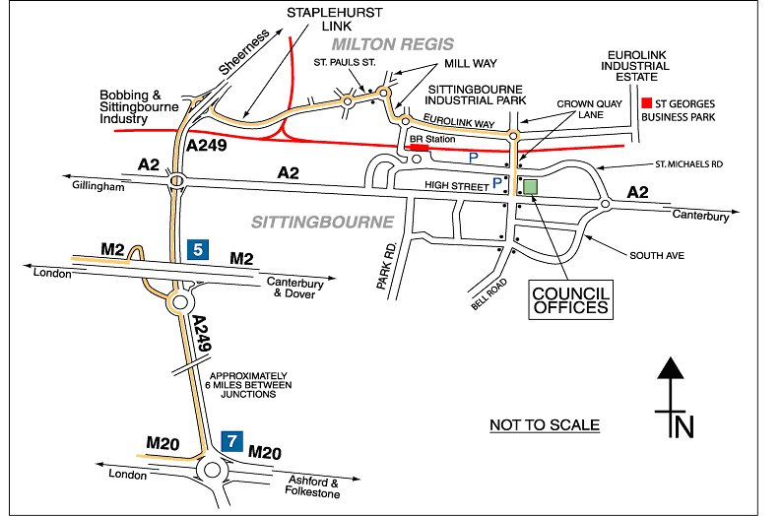

Crown Quay Lane Car Park (Short Stay)
St Michaels Road Car Park (Long Stay)
Car showroom
Single lane side road

