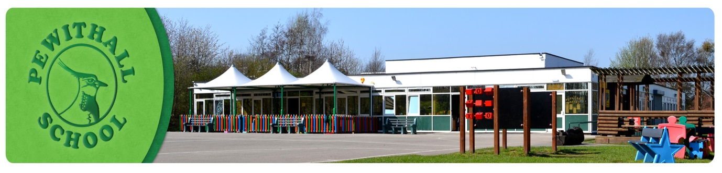

**Post:** Level 3Teaching Assistant

**Reports to:**  Head teacher

**Responsible for:**

**MAIN PURPOSE**

To work with and supervise individuals and groups of children under the direction/ instruction of teaching &/or senior staff, inclusive of specific individual learning needs, enabling access to learning for all pupils and assistance and support in a classroom management and behaviour techniques and providing specialist support in a specific curricula/resource area.

**SUPPORT FOR THE PUPIL**

* Establish good working relationships with pupils, acting as a role model and setting high expectations.
* Provide consistent support to all pupils, responding appropriately to individual pupil needs.
* Contribute to the development and implementation of Individual Education Plans.
* Promote inclusion and acceptance of all pupils.
* Encourage pupils to interact with others and engage in activities led by the teacher.
* Promote self-esteem and independence, employing strategies to recognise and reward achievement within established school procedure.
* Provide feedback to pupils in relation to progress and achievement under the guidance and direction of the teacher.
* Use specialist (curricular/learning) skills/training/experience to support pupils.

**SUPPORT FOR THE TEACHER**

* Provide minimal clerical/administration support (e.g. photocopying, typing filing, collecting money etc.) - may be deleted if not appropriate to school need
* Assist with the display of children's work
* Establish and maintain an appropriate learning environment under the supervision of the teacher
* Contribute to lesson planning, evaluation of lessons/ work plans as appropriate
* Monitor and evaluate pupils' responses to learning activities through observation and planned recording of achievement against pre-determined learning objectives
* Provide objective and accurate feedback and reports as required, to the teacher on pupil achievement, progress and other matters, ensuring the availability of appropriate evidence.
* Be responsible for keeping and updating records in agreed format with the teacher, contributing to reviews of systems/records as requested - may be deleted if not appropriate to school need
* Administer tests and invigilate exams as appropriate to Key Stage.
* Accurately record achievement/progress.
* Promote positive values attitudes and good pupil behaviour, dealing promptly with conflict and incidents and encouraging pupils to take responsibility for their own behaviour in line with established school policy.
* Liaise sensitively and effectively with parents/carers as agreed with the teacher within role/responsibility and participate in feedback sessions/meetings with parents under teacher's supervision.

**SUPPORT FOR THE CURRICULUM**

* Support the delivery of agreed learning activities/learning programmes, adjusting activities according to pupil learning styles and individual needs as directed by the teacher.
* Support the delivery of literacy/numeracy programmes, effectively utilising all alternative learning opportunities to support extended development.
* Support the use of ICT in learning activities and develop pupils' competence and independence in its use.
* Assist pupils to access learning activities through specialist support e.g., curriculum/SEN specialism.
* Determine the need for, prepare and maintain general and specialist equipment and resources.

**BEHAVIOUR & SAFETY**

Establish a safe, purposeful and stimulating environment for pupils, rooted in mutual respect and establish a framework for discipline with a range of strategies, using praise, sanctions and rewards consistently and fairly.

* Manage classes effectively, using approaches which are appropriate to pupils’ needs in order to inspire, motivate and challenge pupils.
* Maintain good relationships with pupils, exercise appropriate authority, and act decisively when necessary.
* Be a positive role model and demonstrate consistently the positive attitudes, values and behaviour, which are expected of pupils.
* Have high expectations of behaviour, promoting self-control and independence of all learners.

**TEAM WORKING AND COLLABORATION**

* Participate in any relevant meeting/professional development opportunities at the school which relate to the learners, curriculum or organisation of the school including pastoral arrangements and assemblies.
* Work as a team member and identify opportunities for working with colleagues and sharing the development of effective practice with them.
* Contribute to the professional development of other teachers and support staff.
* Ensure that colleagues working with you are appropriately involved in supporting learning and understand the roles they are expected to fulfil.
* Take part as required in the review, development and management of the activities relating to the curriculum, organisation and pastoral functions of the school.
* Be responsible for improving your teaching through participating fully in training and development opportunities identified by the school or as developed as an outcome of your appraisal.
* Proactively participate with arrangements made in accordance with the Appraisal Regulations.

**Other**

* To have professional regard for the ethos, policies and practices of the school and maintain high standards in your own attendance and punctuality.
* Perform any reasonable duties as requested by the Head teacher.