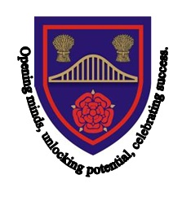

Chesnut Lodge

Chesnut Lodge School is a community special school in Widnes that caters for pupils with Complex Physical and Medical Difficulties and/or Cognition and Learning Difficulties. We cater for pupils from age 2-16 with a statement of SEN / Education, Health and Care Plan (EHC plan) as well as taking Vulnerable 2's and nursery age pupils on mainstream places.  All Vulnerable 2 and SEN placements are organised through Halton Borough Council.

Chesnut Lodge offers a full curriculum that is tailored to meet the needs of individual pupils, both academically and medically. We work closely with medical professionals providing a range of physiotherapy, occupational therapy, speech and language therapy and many more. Our experienced staff work closely with parents and carers and other professionals to ensure that each child receives the curriculum and care that they require.

**MISSION STATEMENT**

"Opening minds, unlocking potential, celebrating success."

**AIMS OF THE SCHOOL**

"Through high quality collaboration, Chesnut Lodge School aims to equip all members of the school community with:

* The skills and knowledge to lead a healthy, fulfilled lifestyle .
* A safe, secure and stimulating learning environment through a person centred approach.
* Opportunities to develop understanding of how to stay safe and make good choices in life.
* Enjoyable and challenging learning experiences which enable all to reach their full potential.
* Opportunities to celebrate each individual’s own achievement, effort and personal success.
* A passion for life-long learning by developing self confidence, intellectual curiosity and a thirst for discovery and achievement."