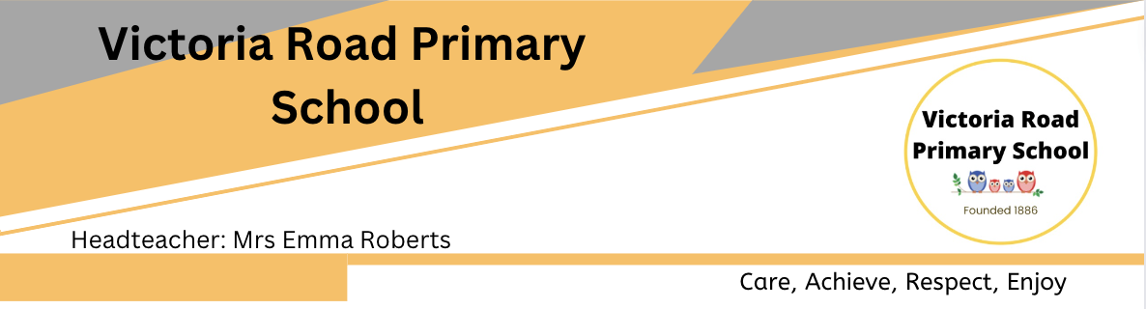

**AFTER SCHOOL CLUB ASSISTANT - JOB DESCRIPTION/PERSON SPECIFICATION**

**POST TITLE: AFTER SCHOOL CLUB ASSISTANT**

**GRADE: HBC 2 – 20 HOURS P/W TERM TIME ONLY**

**REPORTS TO: HEADTEACHER**

**RESPONSIBLE FOR: N/A**

**Main Purpose.**

* To deliver a suitable programme of imaginative and innovative activities suitable to the needs and interests of children age 4- 11 yrs old
* Be responsible to the club co-ordinator.
* To ensure the provision offers a safe and stimulating play environment
* Be responsible to the club co-ordinator.
* To ensure the provision offers a safe and stimulating play environment.
* To assist with the planning, preparing and delivery of activities, which meet children’s individual developmental needs.
* To assist in the administration of the club, keeping relevant records and ensuring that the agreed club procedures are implemented.
* To prepare and serve meals and to supervise mealtimes for the children.
* To Ensure the safe collection and transportation of children between the classes and the club. Communicating and liaising with parents
* Ensuring that areas are clean and cleared at the end of sessions.
* To carry out any other duties, which will be seen to enhance the work of the Before/After School Club.
* Adhering to legal responsibilities and duties under the 1989 Children Act, Care Standards Act 2000 and the Health and Safety Act, to take reasonable care for the health and safety of themselves, staff, children and members of the public who use the club.
* To follow guidelines and procedures for Safeguarding in accordance with VRPS policies & procedures.

**Knowledge/Experience required.**

* Experience of working with 4 – 11 year olds and their families
* Knowledge and understanding of child development.
* Understanding and commitment to good quality childcare

**Qualifications desired**,

* First aid certificate desirable.
* Basic food hygiene, Level 2 or above certification.
* Basic Health and safety certificate.
* Food Allergy Awareness Training certificate

**Skills required**

* Ability to meet individual needs of children
* Ability to provide and facilitate safe and creative play.
* Ability to communicate effectively at all levels.
* Ability to work on own initiative

**FLEXIBILITY STATEMENT**

The list of duties in this job description should not be regarded as exclusive or exhaustive. The school environment is a dynamic one and changes in working practices occur on a regular basis, the candidate should be resilient to change and show a willingness to adopt and champion new practices. As a term of your employment, you may be required to undertake various other duties as may reasonably be required and are commensurate with the level of the post holder. Your duties are set out in the above job description, but please note that Victoria Road Primary School and Halton Borough Council maintains the right to update your job description from time to time, to reflect changes as outlined above and to your role. You will be consulted about any proposed changes.

**Confidentiality:** Victoria Road Primary School are required to respect the confidentiality of all matters relating to the students and staff.

THIS POST IS SUBJECT TO AN ENHANCED DBS CHECK