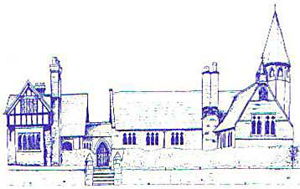

Eccleston C.E. Aided Primary School
"Let your light shine" - Matthew 5:16

Year 6 Teaching Assistant – Grade 4 – 32.5 hours a week – 38 weeks a year
Required for as soon as possible
Visits to School: by appointment
Closing Date: Friday 12th September at 12pm
Shortlisting: Friday 12th September
Interviews: Friday 19th September
Our very popular, voluntary aided school, is set in an attractive village on the outskirts of Chester and within the Eaton Estate. It has strong links with parents/carers, governors, the local church and community, which influence our pupils’ learning and development.
An exciting opportunity has arisen for a Teaching Assistant to join our dynamic team at Eccleston C of E Primary School. The Governors of this unique school wish to appoint an enthusiastic, motivated and committed Teaching Assistant to provide support for Year 6 and a pupil with an EHC Plan. Experience of working with children with additional learning needs, including speech and language and ASD, would be an advantage. We are looking for a practitioner whose character and skills will fit into our experienced team and who also has a commitment to high standards. They will value children as individuals and have a proven track record of supporting learners. They will have high expectations of children’s achievements and behaviour. Experience of supporting children with SATs would be beneficial.
The role will also involve helping the class teacher in planning and delivering lessons. The position will include phonics tutoring as well as small group and one-to-one intervention sessions with the aim of raising attainment in the afternoons. There is a possibility of class cover as and when needed.
If shortlisted, the interview will consist of an activity with children and a formal interview. Through the activity, candidates will have the opportunity to showcase their passion for education; deliver a short yet engaging session, which moves children on in their learning, and demonstrate high expectations. Through interview, candidates will demonstrate a commitment to supporting children and ability to work collaboratively with staff under the supervision of class teachers.
Visits to the school are welcomed and strongly encouraged prior to application. Please telephone 01244 506 560 or email head@ecclestonprimary.cheshire.sch.uk to arrange a visit.
Eccleston Church of England Primary School is committed to safeguarding and promoting the welfare of children and young people and expects all staff, volunteers and external agencies to share this commitment. This post is subject to an enhanced DBS check, identity, employment and qualifications checks. We are an equal opportunities employer welcoming applications from all sections of the community.
How to apply
Applications can be made using the attached Diocesan application form which needs to be submitted to head@ecclestonprimary.cheshire.sch.uk

