Dear Applicant,

Thank you for your interest in the post of Head Teacher at St. Peter’s Catholic Primary School, Romford.

We are very proud of our school and recognise that our greatest asset is our pupils. We had our latest OFSTED Inspection in November 2022. It reported that ‘Pupils are proud to be members of the St Peter’s community. They are incredibly kind and respectful towards one another. They understand what is special about their school and work hard to be ‘the person God created them to be’’. They also said ‘Pupils feel happy and safe here. Everyone is celebrated. This includes those of other faiths and those in all different kinds of families’.

All the staff and governors work tirelessly to deliver the best education possible for all our children. Every child matters at St. Peter's Catholic Primary School.

Visits to the school are welcome by prior arrangement. Please contact the School Office for more information. We believe you will feel the ethos of our school from the moment you arrive.

Yours sincerely,

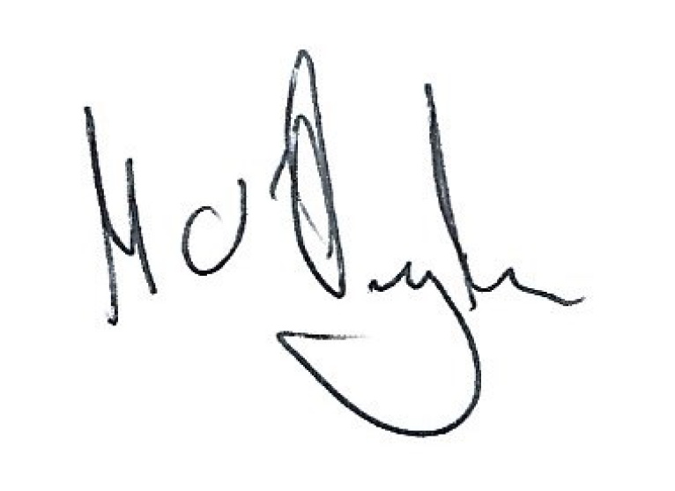

Mark O’Donoghue

Chair of Governors