**DRAFT SEFTON METROPOLITAN BOROUGH COUNCIL**

JOB DESCRIPTION

**Department: Public Health Location: Magdalen House**

**Division: Public Health Post No:**

**Job Evaluation Number:**

**Section: Public Health**

**Post: Public Health Lead –**

**Grade: L**

**Responsible To:**

Head of Service

**Responsible For:**

N/A

The Public Health department is a specialist, multidisciplinary team working across Sefton. The department works in partnership with other local authority departments, NHS, other statutory services and the voluntary sector. The department has a wide range of responsibilities to protect and improve the public’s health and tackle inequalities. These include identifying health needs of the population, advising on and commissioning health services to meet those needs, providing evidence on the effectiveness of treatments/interventions and highlighting the needs of the more socially excluded and vulnerable, as well as health protection and broader healthcare public health services which are also key component parts of our delivery.

The Public Health Lead will contribute to the public health duties within the local authority, these include advising council officers and Elected Members on all matters of public health, commissioning and performance management of a specified list of public health services.

It is expected that the post holder will work across specific programme areas , building strong partnerships which include wider council partners, NHS and the voluntary sector, assuring that local health improvement, health care and health protection arrangements are fit for purpose, aligned and robust. The post holder will be required to demonstrate a clear understanding of the local population needs for Sefton and will primarily focus on broad health improvement priorities with some additional support across health care and health protection when required.

Key areas and responsibilities will include:

* Lead commissioned programmes for health improvement, health protection, health care public health, wider determinants and health inequalities.
* Lead and co-ordinate contract performance and review meeting
* Interpret national data sets and address performance issues where required.
* Provide service stewardship and strategic development for a range of programme areas.
* Provide expert input to national, regional and local policy and reference groups.
* Provide public health support to the emerging health and social care structure.
* Provide public health advice / support to multiagency / multidisciplinary safeguarding reviews.

**JOB PURPOSE**

**MAIN DUTIES**

|  |
| --- |
| 1. ***Surveillance and assessment of the population’s health and well-being***  * To source, interpret and utilise the available evidence base, including in depth analysis and interpretation of health data and effectiveness appraisal of diverse public health interventions, in the context of conflicting views between professionals and agencies. Contribute specialist topic information to annual and public health reports, strategic documents and other reports as required. Prepare and process communications (e.g. press releases) with the media within overall guidelines set by the LA. * Identify public health needs using various methodologies e.g. health needs assessment, equality impact needs assessments (EINA’s), Health Impact Assessment (HIA) and develop appropriate health outcome measures when planning and commissioning projects or programmes to improve health and reduce health inequalities.  1. ***Assessing the evidence of effectiveness of health and healthcare interventions, programmes and services***  * Analyse and interpret national and local policy, data and national evidence of effectiveness (from a variety of highly complex sources), to develop, make recommendations and evaluate public health related projects or programmes some of which may be contentious. * Support the development of a culture of continuous evaluation by improving the efficiency and effectiveness of investment; identifying the need for and commission/undertake/contribute to evaluations, research and audits to assess the effectiveness of interventions, programmes and services. * Keep up to date with the evidence base of effective public health practice in particular relating to specific public health topic areas, and public health competencies (through literature searches, critical appraisal of literature, conferences, journal clubs, professional body communications, etc.)  1. ***Policy and strategy development and implementation***  * Develop and co-ordinate multi-agency and partnership collaborative work to engage and influence others, to identify and report on local need and to improve health and wellbeing. Take responsibility for strategic planning; leading the development, co-ordination and implementation of multi-agency strategy and action plans. * Effectively manage a delegated budget for specific commissioned services and/or projects, with supervision from senior public health staff. Write bids to secure funding for PH and partnership projects. * Commission services, as required, within allocated resources; ensuring that contracts are successfully negotiated and implemented in line with identified needs. Lead development of service specifications and performance management arrangements with all providers that will ensure financial and performance targets are met, that services offer value for money and are delivered efficiently. * Using standard project management techniques set up and manage specific projects or programmes to improve heath and reduce health inequalities.  1. ***Leadership and collaborative working for health***  * Influence statutory, community and voluntary sector partners to optimise health gains and reductions in health inequalities. * Provide leadership, support and advice to internal and external partners to inform investment decisions and strategic development to ensure that a public health perspective informs policy development, strategic commissioning and operational planning. * Provide highly specialist knowledge and expertise on health improvement topic areas utilising excellent project management skills, communication, partnership working, training, contributing to websites and disseminating information to partner organisations. * Provide support and supervision for health and other professional staff, in the development of interventions to tackle public health issues and to address health inequalities. Initiate, develop and commission training and education programmes for the benefit of health and other professional staff and evaluate effectiveness, including presentations to small groups, conferences, students, meetings and networks.  1. ***General***  * Responsible for the management of member(s) of the Public Health team, as allocated to the post holder – including direct line management and/or project/matrix management of staff. * Deputise for the senior public health team as required and represent the council at local, regional and national events; provide advice on policies and practices, and strategic direction and support to the relevant partnership boards and forums. * Use various software packages to enable reports, presentations, spread sheets, databases, and artwork to be produced. * Responsible for chairing and minute taking at meetings as required. * Aware of NHS and council information governance/ best practice and local guidelines. Demonstrate understanding by competently handing patient, confidential and sensitive data at all times. * In the performance of all duties, and in particular in the support and management of staff, to implement all council policies and procedures necessary to meet customer care needs and to reflect the council’s vision and values. * To ensure that client information data is lawfully gathered, accurate, up to date and only divulged in accordance with the Data Protection Act 1998 and the local government common law duty of confidentiality. Failure to apply these duties can lead to the individual or the Department facing court proceedings. * To undertake any other duties as directed from time-to-time to meet the exigencies of the service. |

ORGANISATION CHART

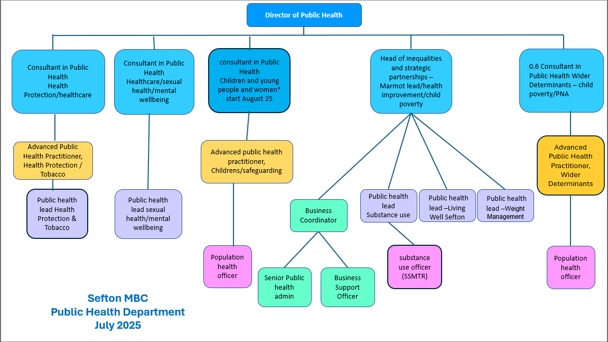

**SPECIAL CONDITIONS (if applicable)**

The nature of the work may require the post holder to undertake commitments outside normal working hours. This may include meetings and supporting Public Health Senior Leadership Team in response to public health incidents, outbreaks and emergencies.

The post you are applying for is exempt from the Rehabilitation of Offenders Act 1974 and therefore you are required to declare any convictions, cautions, reprimands and final warnings that are not ‘protected’ (i.e. filtered out) as defined by the Rehabilitation of Offenders Act 1974 (Exceptions) Order 1975 (Amendment) (England and Wales) Order 2013.

For further information, please refer to DBS filtering guidance at www.gov.uk/dbs.

The post you are applying for requires access to the Public Service Network (PSN) and requires compliance with the HMG Baseline Personnel Security Standard.

**GENERAL:**

This job description is a representative document. Other reasonably similar duties may be allocated from time to time commensurate with the general character of the post and its grading.

All staff have a duty to take care of their own health and safety and that of others who may be affected by your actions at work. Staff must co-operate with employers and co-workers to help everyone meet their legal requirements.

The Authority has an approved equality policy in employment and copies are available to all employees. The post holder will be expected to comply with, observe and promote the equality policies of the Council.

|  |
| --- |
| **Note:** Where the post holder is disabled, every effort will be made to support all necessary aids, adaptations or equipment to allow them to carry out all the duties of the job. |

**Other**

Since confidential information is involved with the duties of this post, the post holder will be required to exercise discretion at all times and to observe relevant codes of practice and legislation in relation to data protection and personal information.

Undertake, and participate in training, coaching and development activities, as appropriate.

The person appointed will be expected to work flexibly and the exact nature of the duties described above is subject to periodic review and is liable to change.

**Name: Margaret Jones**

**Designation: Director of Public Health**

**Date: August 2025**