SEFTON COUNCIL

JOB DESCRIPTION

Directorate: Corporate Resources Location: Sefton Corporate

Learning Centre Ainsdale

Division: Corporate Personnel Post No:

Section: Workforce Learning & Development

Post: Office Manager

Grade: H

Reporting to: Workforce Learning and Development Manager

Responsible for: Learning and Development Support Assistants (x3)

Job Purpose:

To provide an efficient and effective support function within Sefton Corporate Learning Centre with responsibility for financial and administration functions, management information systems, management of the building and the day to day operations of all new and existing business activities. This also includes line management responsibilities for 3x Learning and Development Support Assistants.

Main Duties:

FINANCE

- Monitor income generation against income targets. This includes the raising of purchase order numbers/invoices, coordinating and recording gross and net income.

- To co-ordinate all financial information, whilst liaising with the management team and other relevant stakeholders across the Council including partners. This includes preparing up to date expenditure and budget reports when required.

- Submitting claims for income, preparing financial returns and reporting on expenditure to be signed off by the Head of Finance relating to externally funded grants.

- Monitoring and reporting on budget progress, identifying any risks that could impact on the short, medium and long term sustainability of the service.

- To be responsible for the day to day management of Agresso and I Want Finance (the Council’s financial management systems) which includes approving and authorising expenditure, processing sundry debtor invoices, BACS payments, and raising journal transfers, request inter-ledger adjustments banking of cash and processing of cheques.

- To procure a diverse range of goods, supplies and services, including items on leasing arrangements as and when required. To approve and authorise expenditure of supplies and services.

- To liaise on a regular basis with delegated budget holders to forecast projections of possible over / under spend and to identify budgetary trends, to enable informed financial management decisions to be taken.

- To support alternative funding sources which includes setting up systems to monitor expenditure, income and to recover any costs from external funding bodies when applicable.

- To regularly review Sefton Corporate Learning Centre’s charging policy to be signed off by the service manager on an annual basis. This includes the implementation of monitoring processes and interventions in order to mitigate risk of non-payment of debtors.

BUSINESS DEVELOPMENT

- To work with staff to identify new business opportunities and to communicate new product developments to prospective and existing customers.

- Responsible for the development of marketing literature which will include newsletters, flyers and the use of social media channels to promote the service.

- To maintain and update the website.

MANAGERIAL

- To assist the management team in providing managerial direction for the service in relation to best practice and organisational aims and objectives.

- To provide/undertake direct supervision to all staff accountable to this post and on a regular basis assess developmental progress, agree achievable targets, monitor progress and identify individual learning and development needs.

- To recruit, select and appoint staff as appropriate.

BUILDINGS MANAGEMENT

- To co-ordinate all matters relating to security, the building, equipment and services.

- To co-ordinate matters relating to Health and Safety i.e. COSHH, Legionella, Fire Testing, PAT testing including maintaining the relevant records and having responsibility of Chief Fire Warden and First Aid responsibilities.

- To produce risk assessments for the building which includes Fire Risk Assessment and further specific assessments relating to staff such as Health and Safety, Stress and DSE.

- To maintain staff records relating to Fire Warden, Manual Handling at Work and First Aid training.

OTHER

- To provide day to day to administrative support to Learning and Development Business Partners, the Corporate Apprenticeship Team and external customers.

- Work with other teams, departments and stakeholders to align processes and identify where long-term efficiencies can be achieved through collaboration and partnerships.

- Work with stakeholders to design, develop and implement a system of customer feedback to evaluate progress and to inform future marketing development.

- To ensure the confidentiality, security and quality of service user and client records within all relevant electronic systems.

- To support the service manager with FOI requests in a timely manner.

- To oversee Sefton Corporate Learning Centre as an efficient and effective resource for all staff and all customers who are using the centres facilities and physical resources, including the reception service, all training rooms, and a variety of portable electrical equipment.

- To review and streamline management information systems for example, the Council’s Learning Management System (LMS) and to collaborate with the LMS provider to resolve any to suggest improvements to the system.

- To monitor and review physical resources to facilitate the constantly changing needs and demands of our customers and stakeholders.

- To contribute towards the implementation of departmental policies and procedures.

- To prioritise own workload and work with minimal supervision.

- To prepare for and attend own supervision and PDR meetings.

- To provide administration cover when required.

- To undertake any other duties as directed from time to time to meet the demands of the service.

Organisation Chart

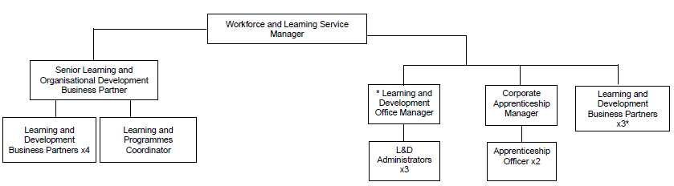

*This post.

The Authority has approved a policy on Equal Opportunities in Employment and copies are freely available to all employees.

All staff are responsible for the implementation of the Health and Safety Policy so far as it affects them, their colleagues and others who may be affected by their work. The post holder is also expected to monitor the effectiveness of the health and safety arrangements and systems to ensure that appropriate improvements are made where necessary.

General

The person appointed will be expected to work flexibly and the exact nature of the duties described above is subject to periodic review and is liable to change.

This job description is a representative document. Other reasonably similar duties may be allocated from time to time commensurate with the general character of the post and it’s grading.

All staff are responsible for the implementation of the Health & Safety Policy as far as it affects them, colleagues and others who may be affected by their work. The post holder is also expected to monitor the effectiveness of the health and safety arrangements and systems to ensure appropriate improvements are made where necessary.

The Authority has an approved equality policy in employment and copies are freely available to all employees. The post holder will be expected to comply, observe and promote the equality policies of the Council.

Since confidential information is involved with the duties of this post, the post holder will be required to exercise discretion at all times and to observe relevant codes of practice and legislation in relation to data protection and personal information.

Undertake, and participate in training, coaching and development activities, as appropriate.

Note: Where the post-holder is disabled, every effort will be made to support all necessary aids, adaptations or equipment to allow them to carry out all the duties of the job.

Prepared by

Name: Michael Mainwaring

Designation: Workforce Learning and Development Manager

Date: August 2025

