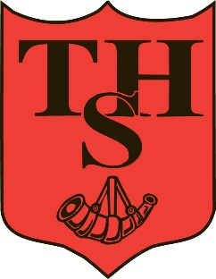**THORNTON HOUGH PRIMARY SCHOOL  
TEACHING ASSISTANT REQUIRED**

The Governors of Thornton Hough Primary School are looking to appoint an outstanding, caring and enthusiastic Teaching Assistant Level 2.

The successful candidate will be:

- Experienced in working with Primary-aged children  
- Calm and consistent in approach – putting the needs of the child first

* Passionate about the learning and development of children
* Experienced in supporting individual children with additional needs
* Understanding of and knowledgeable about the needs of children with Autism

We aim to ensure that Thornton Hough is a happy place to work where staff feel supported, valued and part of the team.

We offer:

- a hard-working, enthusiastic and dedicated team

- a welcoming, happy, vibrant and inclusive learning environment

- highly-motivated and well-behaved pupils

- supportive parents and community

The post is for 26 hours per week. This will initially be fixed term until August 31st 2026, with the potential to become permanent. Specific days of the week and times to be discussed at interview and may be negotiated for the right candidate.

Application forms for the above post are available online at [www.wirral.gov.uk](http://www.wirral.gov.uk). Please return completed application forms with a supporting letter, outlining how you feel you meet the criteria of the job specification, to the Headteacher, Mr W Lowe, at the school address.

Closing Date: Friday 19th September 2025 - 12 noon. Interview process during week beginning 22.09.25.

This post is subject to an Enhanced Level DBS check.  
  
The school is committed to safeguarding and promoting the welfare of children and young people and expects all staff and volunteers to share this commitment.  
  
The school is an Equal Opportunities Employer and positively welcomes applications from all people regardless of their sex, creed, marital status, race, age, disability, sexual orientation.  
The salary details, job specification and application form is available on the Wirral website. CVs will not be accepted. For further information please contact the school office.

An interview will be held on week commencing 22nd September 2025 which will include a short observation of a group activity.