
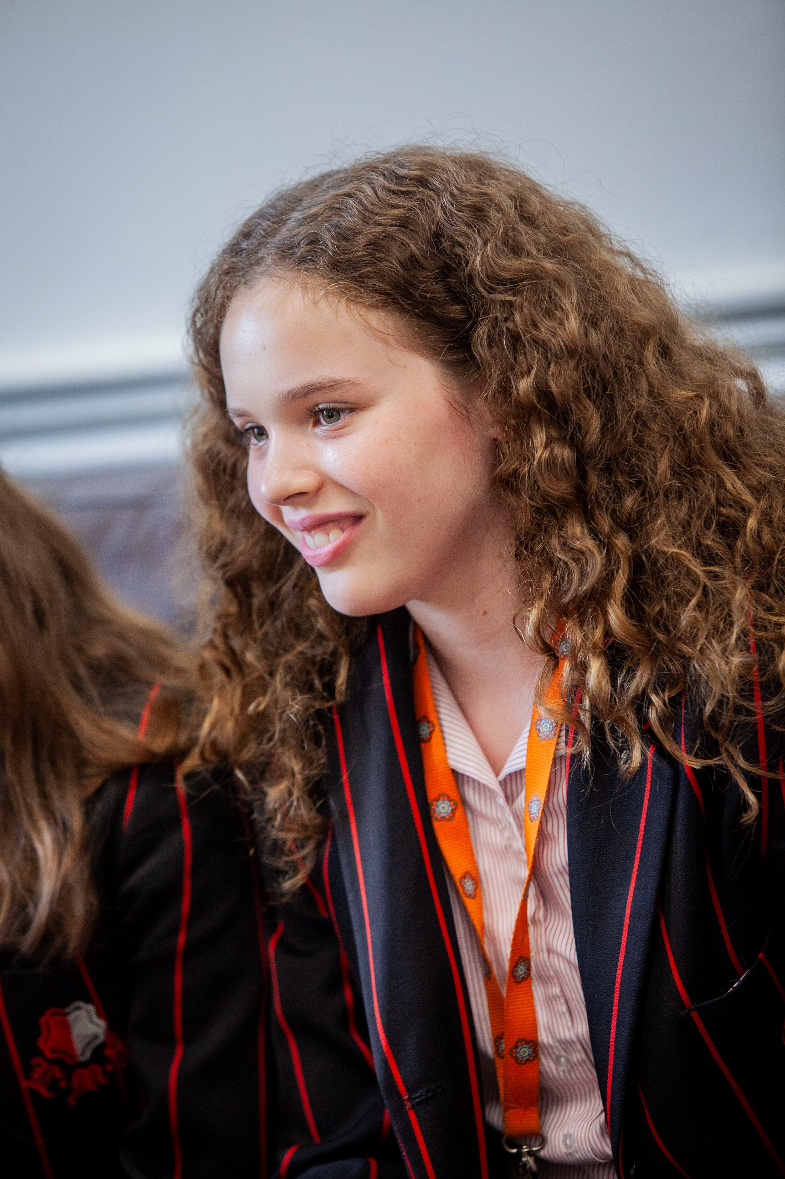

Lady Margaret School
Candidate Application Pack

Art and Display Technician

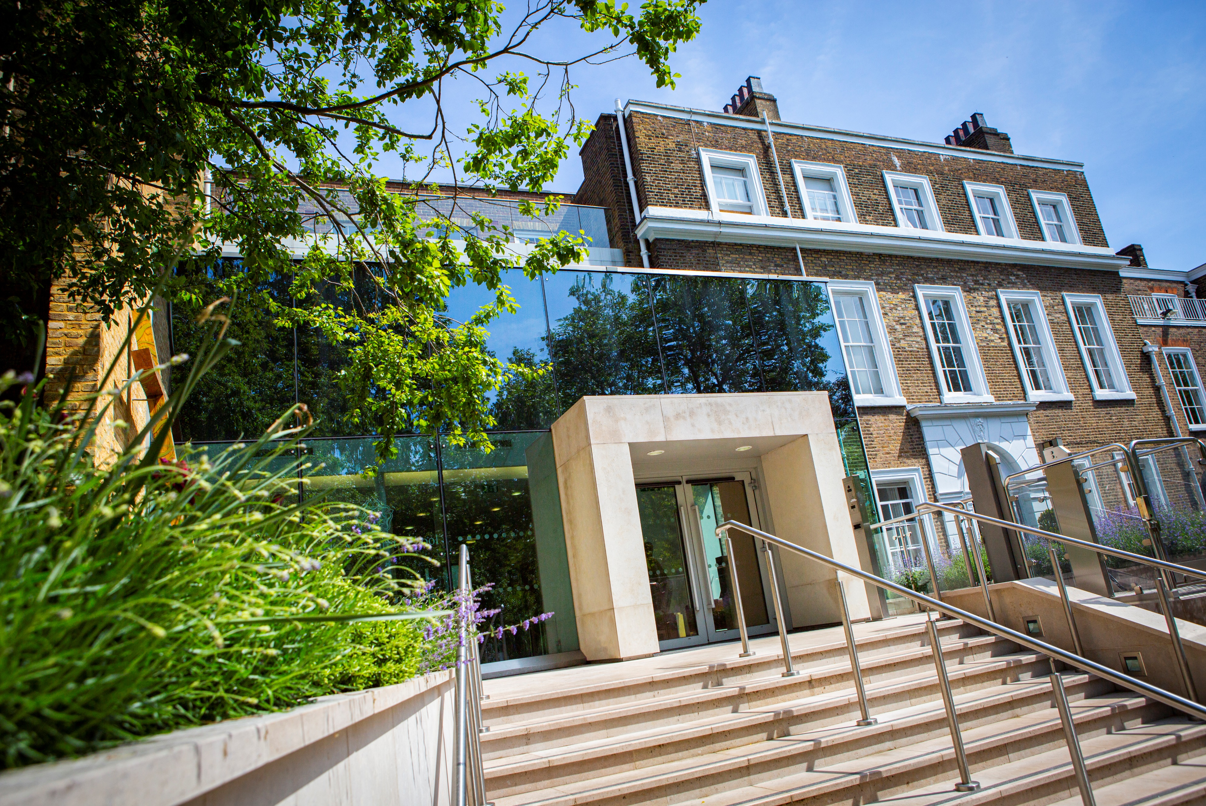
Letter from Headteacher


Dear Candidate,
Thank you for showing interest in the post of Art and Display Technician at Lady Margaret School.
Founded in 1917, Lady Margaret School has a proud and successful heritage in educating girls. We wish to appoint an Art and Display Technician to build on the great strengths of the school, maintaining the highest academic and behavioural standards, whilst adapting to the fast-changing educational landscape.
Lady Margaret School is a high performing school, as testified by its most recent ‘Outstanding’ Ofsted and SIAMS ratings. Our SIAMS Inspection in October 2023 noted the ‘transformational’ impact the school has and the School was graded ‘Outstanding’ in all categories in our Ofsted Inspection in November 2023. LMS was awarded ‘London Comprehensive School of the Year’ by The Sunday Times ‘Parent Power’ poll in 2023. Recent results at GCSE and A Level results are excellent and show extremely high levels of attainment and achievement for all students. We continue to offer a rich curriculum for all our students.

This post offers the chance to work with a committed and experienced staff as part of a talented learning community, supporting each other to develop an innovative and exciting curriculum. This is a unique opportunity to work in a school with a strong and proud heritage.
Thank you again for your interest in joining us.

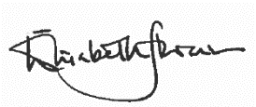
Yours faithfully

Elisabeth Stevenson
Headteacher

Part-time Art and Display Technician
Required for September 2025
Term Time Only, 39 weeks, 2 days per week (14.4 hours)
Scale S05 £34,359 - £35,892 (AYR) / £11,770.10 – £12,295.25 (TTO Actual Salary)

We are seeking an ambitious and experienced Art and Display Technician to join our small and dynamic team at Lady Margaret School.

About the Role

We are looking for a committed and enthusiastic Art and Display Technician to support our busy Art Department from September 2025. You will also maintain and present all department displays and exhibitions across the school. The successful candidate will use his or her initiative and enjoy working as part of a team. You will be responsible for the organisation of materials and students’ work, and will engage with students by supporting their ideas and helping them to use materials effectively. You will also take pride in maintaining a tidy and organised department.

About Lady Margaret School

Our exam results reflect the hard work of our students and staff. In 2025, 91% of our girls attained GCSE English and Mathematics at grades 9-4. At A Level, our results are consistently outstanding, with high numbers of girls progressing to a wide range of Higher Education courses. In 2025 69% of grades were A*-B. Students at LMS have an excellent record of securing places at top universities.

What you can expect from us

- A supportive school that has staff well-being at its core
- Excellent career progression opportunities in addition to the high quality CPD which is part of our established systems for staff support and development
- A comprehensive benefits package including defined government pension scheme (ER’s contribution 23.9%), employee assistance programme, flu vaccination vouchers and Cyclescheme
- A convenient location served by excellent transport links, close to local amenities and green spaces.

Closing Date: 19th September 2025

Interview Date: 26th September 2025

Start Date: Immediate / To be arranged

Early applications are encouraged. Suitable candidates may be interviewed before the closing date and Lady Margaret School reserves the right to withdraw the position if an early appointment is made.

How to apply: Please click on the ‘Quick Apply’ button on our TES listing to fill out an online application form. Alternatively, visit our website to complete our own application form: https://ladymargaret.lbhf.sch.uk/our-school/vacancies

Lady Margaret School Art Department

At present, Art at LMS consists of one full time and two part time teachers. It is important to us that we each maintain our own artistic specialism and are able to utilise our knowledge as artists in our role as teachers. We have a part-time technician whose specialism is painting who is also responsible for displays around the school.
The department has high expectations of all the students and has been recognised as a ‘Flagship Department’ within the school. We are dedicated to ensuring our students are taught a strong technical skill base at Key Stage 3 so that they are able to create artwork which is challenging, innovative and relevant. At the end of every year we have an exhibition for the GCSE and A Level students which is widely attended and celebrated.
At Key Stage 3 we have over-arching schemes of work covering sculpture, painting and printmaking. Students are taught in groups of 24 at KS3 and have a double and single lesson over the two-week timetable. KS4 consists or 2-3 classes per year group and they have one double and one single lesson a week. We have one class in Year 12 and one in Year 13 both of which have 3 double lessons per week.
We currently use the Edexcel examination board and offer Fine Art at GCSE and A Level. The Art department is a unique and inspiring space; we have five art classrooms including a dedicated studio for Year 13 students to work independently on their projects, a room of large-scale screen-printing tables and three Key Stage 3 classrooms which are used by all art teachers. Our studio space affords our students the opportunity to create large scale, ambitious paintings and drawings and would be ideal for a candidate who has experience in this area.
In addition, the department also includes a History of Art room, a resources room with dedicated Art library for Sixth Form students and several storage areas. We have access to digital resources such as Photoshop/PIXLR software.
The Head of Art is responsible for all students who apply to Art Foundation courses including portfolio preparation and references. All of the students who have applied to foundation courses have received offers from prestigious institutions such as Kingston University, UAL, and the Royal Drawing School amongst others.

Department Style

We believe it is essential that students are given the opportunity to visit galleries and exhibitions to see artwork and we are fortunate to be able to access a wealth of galleries within a short tube-journey. Each year we aim to take every year group to an exhibition or outside of school for a drawing lesson. We also invite speakers into the school to give our students insight into professional creative careers.
We work collaboratively and share our methods and materials. We believe it is important that all members of the department contribute ideas and resources and are encouraged to write schemes of work to keep our students inspired and excited. We are ambitious, hardworking and passionate about Art. We like to encourage students to use of a variety of media to allow students to create individual, courageous, often large-scale art work with their own style. We find it important that students work from primary source, use their own photography and take strong inspiration from the work of other artists. Every year we hang an end of year exhibition of a professional standard to celebrate the work of all GCSE and A Level students.
The department has an open-door policy and we offer a good range of extra-curricular activities including life drawing at Key Stage 4 and 5, GCSE Oil painting club, lunch-time homework support sessions and an Art-based KS3 Activities Week. Our technician also runs a club weekly with selected students which can be planned and discussed with the Head of Department.
Many of our students have taken part in the Royal Academy’s AttRAct scheme which offers Year 12 students opportunities for mentorship and additional CPD for members of the department. We encourage all students to enter their work to the Royal Academy online exhibition and many students have been successful in this over the years.
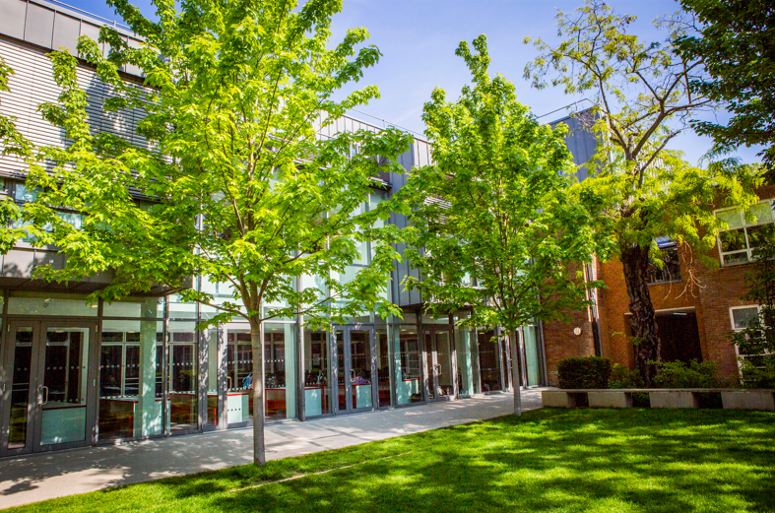
We wish to maintain the high standards and success of the department and encourage a stimulating and impressive visual culture within the school.
Job Description
Art and Display Technician
Post Title: Art and Display Technician

Responsible to: Head of Art

Grade: Scale 5: £34,359 — £35,892 per annum (actual salary £11,770.10 —£12,295.25 per annum)

Hours: 14.4 hours per week / Term Time Only

Disclosure: Enhanced

Main Duties and Responsibilities

• Maintaining all art materials in each of the ﬁve art rooms
• General tidying of all art rooms
• Managing all ordering of stock and maintaining stock cupboards
• Following the schemes of work for each year group in order to help staff and prepare the materials needed for lessons in advance
• Helping all art staff on a day to day basis with materials for lessons
• Supporting students at lunchtimes and after school to make their art work
• Tidying and organising the books and materials in the students’ art resource room
• Managing and cleaning the oil painting studio
• Putting up display work for all departments in the school (in consultation with Heads of Department)
• Changing the display of students’ art work around the department and school
• Cleaning, de-greasing, exposing and developing screens for screen printing as needed
• Servicing the screen printing tables and registration bars
• Cutting fabric and other materials for printing and painting surfaces
• Making and dismantling the still life collections
• Organising and maintaining resources and art work storage
• Hanging the GCSE and A level shows with guidance from the Head of Art and other art teachers
• Photocopying, printing labels for display, etc
• Making slide shows, researching exhibitions, etc
• Accompanying school trips to art galleries
Safeguarding
- Lady Margaret School is committed to safeguarding and promoting the welfare of children and young people and expects all staff to share this commitment
- Appointment to this post is subject to an enhanced Disclosure and Barring Service check

PERSON SPECIFICATION
Lady Margaret School
Job Title : Art and Display Technician |  | Grade: SO5
Line Manager: Head of Art
Requirements  (On the basis of the Job Description) | Essential (E)  Or  Desirable (D)
Qualifications
GCSE Maths and English ( Grade C / Grade 5 and above ) | E
Degree or equivalent | E
A recognised first aid qualification | D
Experience
Experience of Microsoft Office and Google Docs | E
Experience of working in an administration role | E
Experience of using mail merge and email merge | D
Experience of working with different levels of seniority | E
Experience of working with external suppliers and agencies | E
Experience of using SIMS data base and other database systems | E
Experience of using internet and updating websites | E
Experience of communicating through a multi-platform communication system using SMS text, email and mobile phone apps | D
Knowledge/skills/abilities
A high standard of written and spoken English | E
A high standard of spelling and grammar
A high standard of numeracy | E
A high standard of IT skills | E
Good interpersonal skills and ability to communicate across all levels and mediums | E
Ability to produce good and accurate copy, reports and information | E
Ability to work autonomously, proactively and on own initiative | E
Ability to devise and implement efficient systems and processes | E
Ability to multi-task, plan and prioritise workload | E
Ability to research information | E
Ability to produce good quality, clear and accurate minutes | E
Ability to time manage | E
Ability to devise and implement efficient systems and processes | E
Ability to multi –task, plan and prioritise workload | E
Other (include special requirements)
Demonstrates a commitment to schools Christian ethos | E
Demonstrates a commitment safeguarding | E
An enhanced DBS check will be required for this post.
The successful candidate will undergo a 6 month probationary period in line with the school’s policies and procedures.

Safeguarding

Lady Margaret School is committed to safeguarding and promoting the welfare of children and young people and expects all staff and volunteers to share this commitment.
- Successful candidates are required to undertake an enhanced Disclosure and Barring Service check.
- This post is exempt from the Rehabilitation of Offenders Act 1974 and therefore shortlisted candidates will be required to declare any convictions, cautions, reprimands and final warnings that are not ‘protected’ (ie filtered out) as defined by the Rehabilitation of Offenders Act 1974 (Exceptions) order 1975 (Amendment) (England and Wales) Order 2020. Having a criminal record will not necessarily prevent you from taking up appointment; it will depend on the nature of the offences and their relevance to the post you are applying for. However, should a shortlisted candidate NOT declare an offence that is subsequently revealed, e.g. through the DBS check, this may place their appointment in jeopardy.
- It is a criminal offence for barred individuals to seek or undertake work with children.
- In compliance with Safer Recruitment guidelines, CVs cannot be accepted.

Referees

Two references will be sought for candidates invited to interview. It is our policy to obtain references prior to interview, therefore if you have any concerns regarding this please contact us.
- The first reference must be from your present or most recent employer.
- If any of your references relate to your employment at a school or college, your referee must be the Headteacher or Principal.
- If you are currently working with children, your present employer will be asked about any disciplinary offences relating to children, current and/or time expired, and whether you have been the subject of any child protection concerns and if so, the outcome of these investigations. If you are not currently working with children, but have done so previously these issues will be raised with your former employer.
- If you are not currently working with children but have done so previously the second reference must be from that employer.
- We are unable to accept references from anyone acting solely in the capacity of a friend or relative.
- Other previous employers may also be approached for information, before interview, to verify details on your application form such as particular experience or qualifications.
- If you have worked with any of the referees you have provided for less than 24 months, please provide an additional referee.

Thank you for your application. Applications may not always be acknowledged; however, we aim to advise non-shortlisted applicants of the outcome within a reasonable period after the closing date. Where a large number of applications is received this may not be possible, and if you have not been contacted within 3 weeks of the closing date, please assume that you have been unsuccessful.


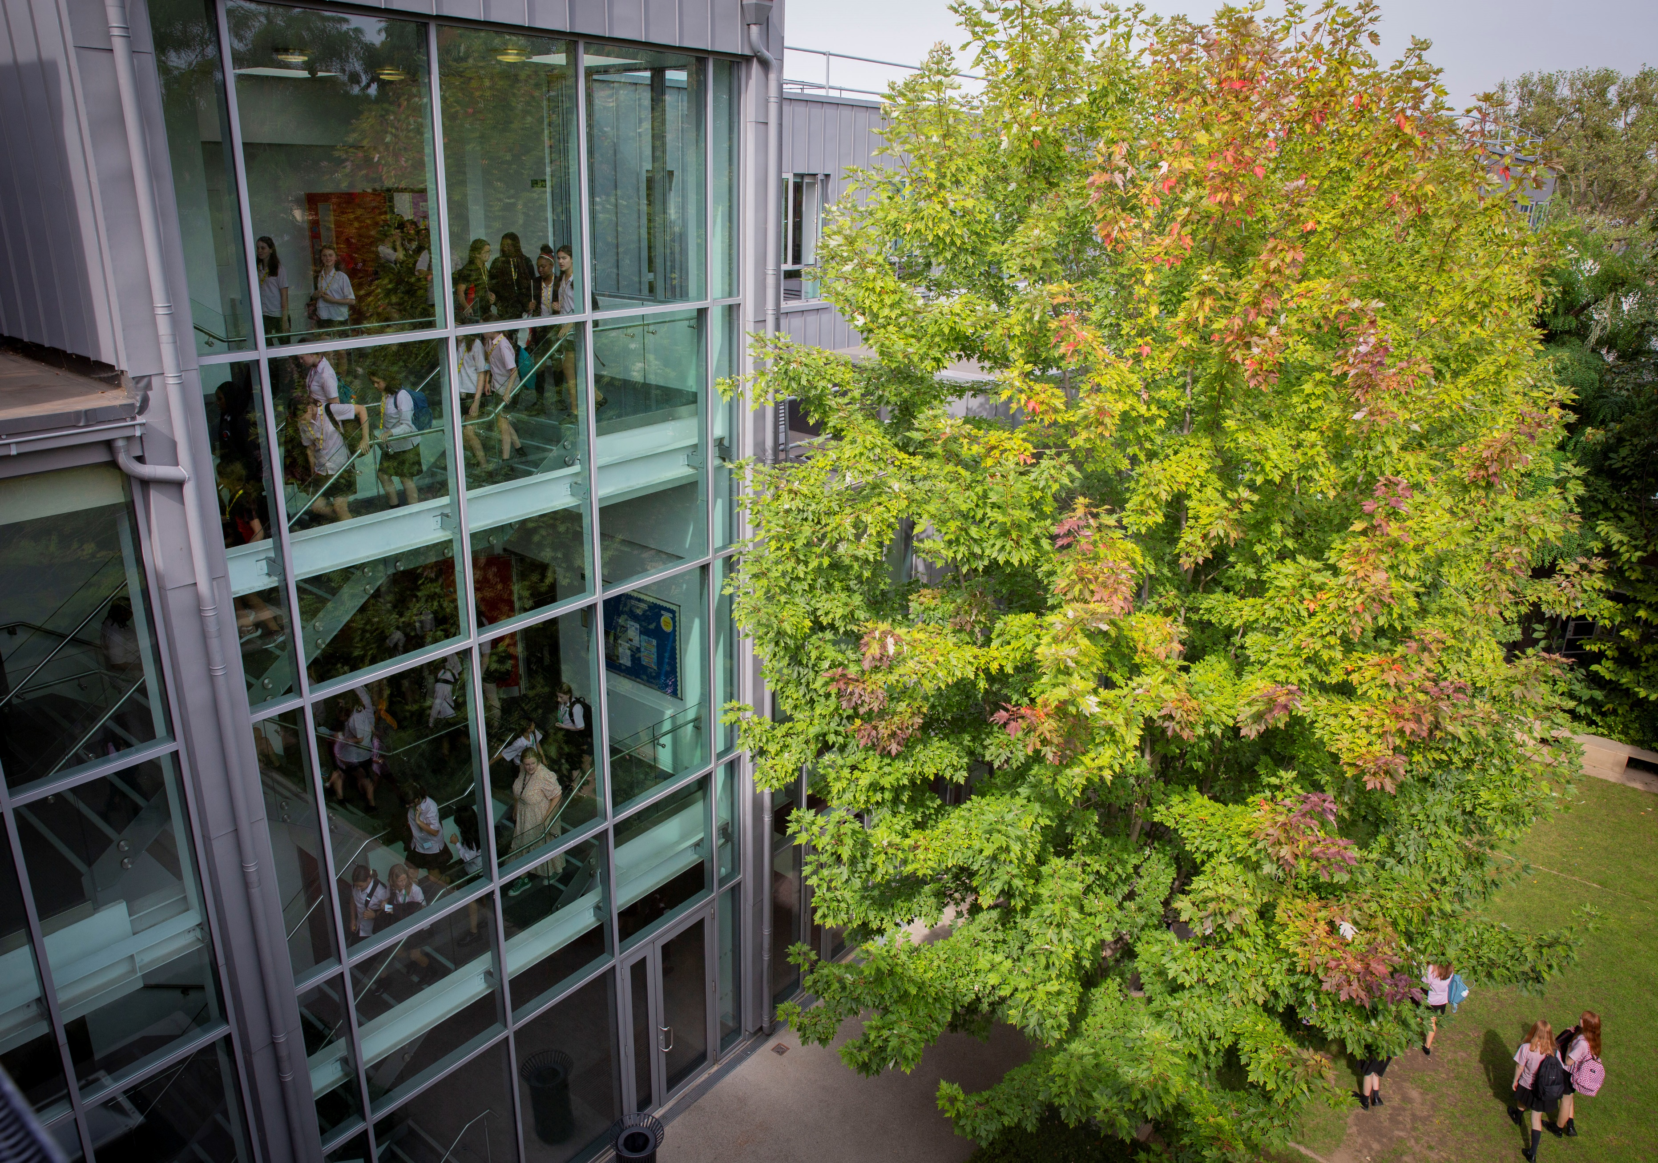
Lady Margaret School
Parsons Green
London
SW6 4UN
Tele: 020 7736 7138

recruitment@ladymargaret.lbhf.sch.uk
www.ladymargaret.lbhf.sch.uk

