 |  |  | Job Description |  |  | Job Reference
 |  |  |  |  |  | 712705
Job Title |  |  | Casual SEND Play Workers
Service |  |  | Children’s Services | Team
Location |  |  | Locations within the Wokingham Borough
Reports to |  |  | Sophie Hookway
Responsible for |  |  | Engaging SEND Children and young people to access activities.
Grade |  |  | Type of position: |  |  |  | Date
G4  £13.26 - £14.13 per hour |  |  | Casual if and when delivering activities after school or through the holidays |  |  |  | Open
This job description has been designed to indicate the general nature and level of work required of the post to indicate the level of responsibility. It is not a comprehensive or exhaustive list and the line manager may vary duties from time to time which do not change the general character of the job or the level of responsibility entailed.

Service Purpose
1 Provision of high quality and effective services to children, young people and families

2 Provision of effective and high quality Safeguarding services for children and young people at risk of harm

3 Delivery of high quality support and challenge to schools, recognising the Council’s enduring responsibility to promote
the best outcomes possible for its children and students

4 Assurance that the Council is effective, ambitious and successful as a Corporate Parent to the children and young people in its care

5 Development and implementation of effective strategic commissioning for children and adults, working effectively with partners to secure good outcomes

6 Delivery of effective and efficient services offering good value for money

7 Discharge of the statutory function of the Director of Children’s Services, in conjunction with the Lead Member

Purpose of the role

Main Accountabilities
SEND play worker will work closely with the SEND project Coordinator to deliver flexible, diverse and innovative activities for children and young people who have SEND and their families, focussing on individual needs and ensuring a positive and enjoyable experience.

Activities and support offered may include stay and play sessions, community sessions, childcare provisions, providing healthy meals, signposting and access to local support services. The provisions offered will allow children and young people aged 4-17 years with SEND needs to access a range of safe, enjoyable and enriching activities both on and off site. with staff trained to support the full range of young people’s health needs, challenging behaviours, and communication techniques to ensure a positive experience.

1 | To support the delivery of a range of holiday and respite provisions for Children with SEND with a particular focus on activities offered through the Holiday Activities and Food Programme (HAF).
2 | To take responsibility for ensuring care and support is delivered to the highest possible standards, ensuring that children and young people are safeguarded at all times.
3 | Provide support and care for the children accessing the HAF programme and provisions delivered by Wokingham Borough Council.
4 | Ensure that the children and young people are supported and encouraged to be as independent as possible in accessing activities and having their personal care needs met, ensuring a positive experience.
5 | Carry out other daily tasks, including administering medication, cooking and cleaning and other reasonable requests, to ensure the smooth and effective running of the provisions.
6 | Actively participate in supervision, team meetings and training to improve own practice and development.
7 | Manage competing demands and be a positive role model in a changing environment.
Supervision Received |  | HAF programme manager Lisa Hookway and Jo Jolly will provide supervision and guidance to the SEND Project Worker.
Supervision Given |  | SEND Project Worker will provide guidance and some supervision to Casual Playworkers. Playworkers will be expected to work on their own initiative.
Contacts & Working Relationships |  | Children, young people, parent, carers and team members
Management of resources or budget |  | Grant funded, and Budget income generation
Special Factors |  | Ability to travel to a variety of locations in borough, be flexible to work at short notice to cover illness, attend evening meetings or training, management of children’s difficult behaviour.  First Aid Administration, Identifying & reporting of Safeguarding concerns, DBS check required.

Organisation Chart
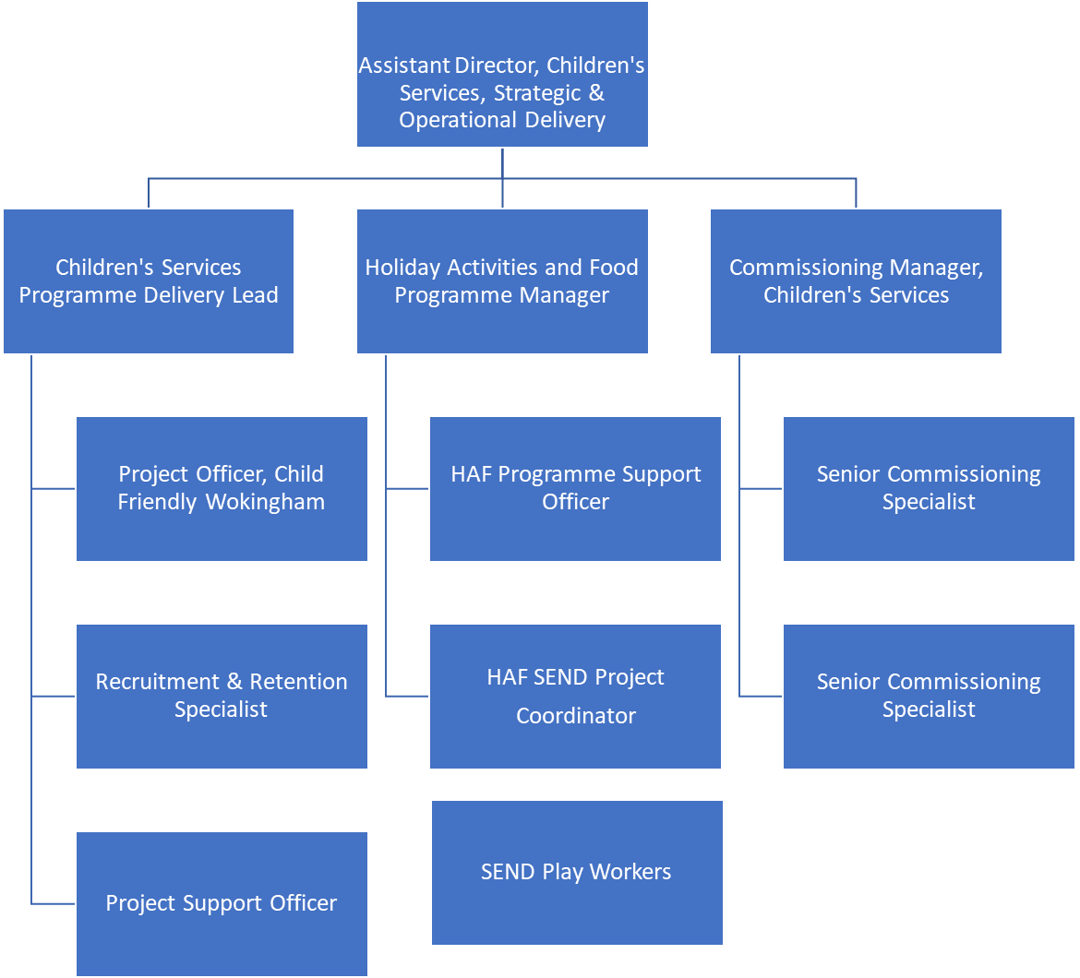

Person Specification
Focus on describing the qualifications, skills, knowledge and experience an individual will require to successfully undertake the role. These should be split between essential and desirable.
Qualifications |  | Essential |  | Desirable
Childcare qualifications i.e. NVQ is childcare, Supporting Teaching and Learning in Schools. |  |  |  | x
Technical Skills. |  | Essential |  | Desirable
Ability to engage children and young people to access activities |  | x
Awareness of non-verbal communication techniques |  |  |  | x
Ability to work with children who may display challenging behaviour or have health needs |  |  |  | X
- Knowledge |  | Essential |  | Desirable
- Familiarity with local government services |  |  |  | X
- Knowledge of working with children and young people and/or people with learning difficulties/disabilities. |  |  |  | X
Experience |  | Essential |  | Desirable
- Experience of working under pressure and prioritising workload, in a changing environment. |  |  |  | x
- Experience of facilitating provisions to support SEND children, young people and their carer’s |  |  |  | x
Ability to plan and undertake a range of activities with young people |  |  |  | X
Participate in all aspects of providing person centered care to young people and the smooth running of the service. |  | X
Work effectively under pressure in a busy, diverse and demanding work environment |  | X
Work well as part of a team. |  | X
Ability to carry out delegated areas of responsibilities. |  | X
Proven ability in capturing, storing and accurately retrieving information |  |  |  | X
Tact, diplomacy, confidentiality and sensitivity |  | X
Ability to work without supervision using own initiative |  |  |  | X
Completed by: | Lisa Hookway |  | Date: 20/06/23

