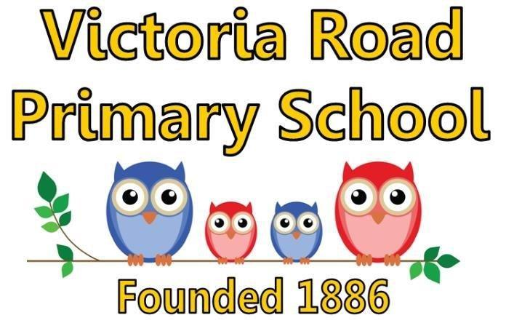

JOB DESCRIPTION: AFTER SCHOOL CLUB SUPERVISOR

POST TITLE: AFTER SCHOOL CLUB SUPERVISOR
GRADE: HBC 3 – 20 HOURS P/W TERM TIME ONLY
REPORTS TO: HEADTEACHER
RESPONSIBLE FOR: After school club assistant

MAIN PURPOSE

Day to day organisation of the after school club. Provide quality play care within the framework of the club’s policies and procedures

JOB PROFILE

- Planning, preparing and delivering quality play opportunities within a safe and caring environment.

- Providing comprehensive care for the children.

- Providing refreshments and ensuring that hygiene, health and safety standards are met. This will include toileting, hand washing, cleaning spillages, insisting on and modelling good table manners.

- Administering first aid when necessary.

- Consulting with children and involving them in planning activities.

- When necessary, providing support and other staff, including volunteers.

- Administration and record keeping, of club registers, purchasing items for snack from the School Fund petty cash.

- Developing and maintaining good communication with all staff members and parents.

- Undertaking and renewing appropriate and relevant training. (First Aid , Food Hygiene and any other relevant certificates)

- Monitoring and maintaining a healthy, safe and secure working environment.

- Working within the framework of the club’s policies and procedures.

- Promote inclusion and acceptance of all pupils

- Promote a positive ethos and role model positive attributes, self-esteem and independence.

- Provide pastoral support to pupils.

Note: Undertake any other duties and responsibilities as may be assigned from time to time, which are commensurate with the grade of the job.

This job description is not intended to be either prescriptive or exhaustive; it is issued as a framework to outline the main areas of responsibility.

PERSON SPECFICATION: AFTER SCHOOL CLUB SUPERVISOR

POST TITLE: AFTER SCHOOL CLUB SUPERVISOR
GRADE: HBC3 (SCP005) - 20 HOURS P/W TERM TIME ONLY
REPORTS TO: HEADTEACHER

ESSENTIAL QUALITIES
- Experience of working with 4 to 11 year olds
- Experience of administration
- Delivering equal opportunities in a play setting
- Awareness of needs of children and families
- Appropriate child protection training
- Ability to provide and facilitate safe and creative play
- Ability to work as a team member and demonstrate leadership skills
- Good communication skills
- Ability to work on own initiative, using judgement and common sense

DESIREABLE QUALITIES
- At least 2 years experience of working in a childcare setting
- Experience of working within a play-based setting
- Ability to use IT based resources to support play and club administration
- Food Hygiene Certificate
- First Aid Certificate
- Experience of working in a supervisory or management capacity

