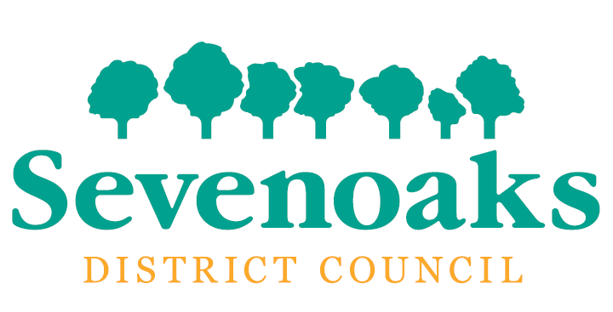



October 2017

Career grade progression for planning officers to be read in conjunction with job descriptions.

Please note that progression to the next level is not automatic and will need to be effectively evidenced at the appropriate time.

Level one – Grade C

# Qualifications and or experience

* A levels or equivalent and
* no or very limited practical experience in a Development Management section or relevant planning private practice organisation

Expected to undertake a Royal Town Planning Institute (RTPI) accredited degree relevant to the provision of a planning service and apply for student membership of the RTPI.

# Main role – general terms

* To manage and maintain a case load of minor and other planning applications and make recommendations
* To give advice to and undertake negotiations with applicants and others on allocated applications
* With guidance and supervision from a senior officer, to give advice on pre application submissions
* To be part of the duty officer rota

# Expected competencies

## Effective communication

* Delivery of clear and concise communications verbally – face to face, in writing, by email and by phone
* Demonstration of listening skills
* Attends meetings/seminars to keep up to date
* Knowledgeable of who to seek advice from both within the service and in the wider Council
* Provides responses to email and verbal requests in a timely manner

## Continuous improvement

* Keen and eager to identify and seek out relevant improvement opportunities via course, self-improvement and other training opportunities
* Keeps up to date with relevant developments in planning including technology and legislation
* Shares new knowledge and skills with others

## Customer focus

* Delivers and demonstrates excellent customer care by being helpful, courteous, respectful, accessible, responsive, knowledgeable and patient
* Respects customer confidentiality where appropriate
* Actively listens to and responds to customer needs with relevant action
* Looks to and seeks advice regarding problem solving for the customer
* Able to deliver difficult information to the customer whilst remaining calm and in control

## Planning and organising

* Follows all our procedures and guidelines appropriately
* Develops and use systems to help prioritise, organise and keep track of own workload
* Knows the status of own workload at all times
* Uses time and resources efficiently to set and meet deadlines
* Can ask for help to adjust plans to cope with the unexpected

## Working with others

* Works well with a variety of different customers
* Treats the team and others with respect and in a professional manner
* Actively shares ideas and information
* Builds up constructive relationships
* Actively listens to others’ points of view before taking action

Move to level two – on successful completion of an accredited degree and demonstration of the competencies.

There maybe the potential to accelerate progression through the grade by taking on additional duties and job swaps within the Planning Service.

Level two – Grade D

# Qualifications and or experience

* Undergraduate degree or equivalent and
* studying for a relevant Masters or post graduate diploma in planning and
* up to two years’ experience in a Development Management section or relevant planning private practice organisation

Expected to be a Licentiate membership of the Royal Town Planning Institute

# Main role – general terms

* To manage and maintain a case load of planning applications, make recommendations and present cases to Development Control Committee as required
* To give advice to and undertake negotiations with applicants and others on allocated applications
* To give advice on pre application submissions
* To be part of the duty officer rota

# Expected competencies – building on level one

## Effective communication

* Builds effective two way communication with their team and others including customers
* Demonstration consultation prior to decision making
* Engages with team discussion on planning matters
* Actively seeks ways to refresh communication in order to encourage engagement

## Continuous improvement

* Assists the less confident to put their ideas forward
* Inspires others to be creative
* Participates in the formulation of team objectives in order to improve performance
* Brings new ideas to the table for consideration
* Demonstrates a desire to exceed our standards and competencies

## Customer focus

* Consistently strives to give a positive customer experience regardless of outcome
* Actively tries to put customers at ease and explain carefully our planning processes and actions needed
* Consistently evaluates whether they are acting in line with our requirements for obsessive customer care and acts or adapts behaviour as appropriate
* Proactively addresses internal and external complaints

## Planning and organising

* Plans workload, prioritises accurately and allocates time appropriately to ensure that planning application and other targets are met
* Keeps others informed of current work
* Able to pre-empt issues through clear planning and reviewing
* Copes with set backs without panic – demonstrates a calm approach

## Working with others

* Delivers high quality work regardless of pressure
* Sees the teams goals as equally important as their own
* Demonstrates sensitivity to the feelings of others
* Actively works with others to resolve conflict internally and externally

Move to level three – on successful completion of a masters of post graduate diploma and demonstration of the competencies.

There maybe the potential to accelerate progression through the grade by taking on additional duties and job swaps within the Planning Service.

Level three – Grade E

# Qualifications and or experience

* relevant Masters or post graduate diploma in planning and
* up to three years’ experience – one of which is post qualification in a Development Management section or relevant planning private practice organisation

Expected apply for full membership of the Royal Town Planning Institute

# Main role – general terms

* To process and undertake appropriate evaluations of planning proposals including complex and major applications and development proposals including the preparation of appeal statements and evidence
* To give advice to and undertake negotiations with applicants and others on complex and major applications
* To present cases to Development Control Committee, at Committee site visits and appeal hearings or public inquiries
* To provide colleagues will help as may be required to help in the processing of planning applications and appeals
* To give advice on pre application submissions
* To be part of the duty officer rota

# Expected competencies – building on previous levels

## Effective communication

* Confident user of presentation media
* Able to deliver our messages to all forums and in an appropriate format
* Promotes the Council’s strategies and approach externally and internally
* Delivers information clearly and concisely to customers on applications with confidence

## Continuous improvement

* Assists in ensuring that our service targets are met
* Ensures that we contribute to the services improvement in key areas identified by the Council
* Embraces change and seeks ways of improving our performance
* Encourages others to contribute to improvement ideas

## Customer focus

* Keeps customers informed using appropriate communication channels, consulting with and inviting feedback from customers on our performance
* Maintains awareness of public opinion, pressure groups and current local issues that might have an impact on our service
* Uses customer feedback to assist in suggesting service improvements where possible

## Planning and organising

* Plans workload, prioritises accurately and allocates time appropriately to ensure that planning application and other targets are met
* Keeps others informed of current work
* Able to pre-empt issues through clear planning and reviewing
* Copes with setbacks without panic – demonstrates a calm approach

## Working with others

* Is recognised as a sounding board for others in the team
* Is confident in discussing cases with all colleagues and external customers
* Encourages the team to take a holistic approach to problem solving which might include working with others across the Council

Move to level four – on successful application for membership of the RTPI and demonstration of the competencies.

There maybe the potential to accelerate progression through the grade by taking on additional duties and job swaps within the Planning Service.

Level four – Grade F

# Qualifications and or experience

* relevant Masters or post graduate diploma in planning and
* up to five years’ experience in a Development Management section or relevant planning private practice organisation
* is a Member of the RTPI

# Main role – general terms

* To process and undertake appropriate evaluations of planning proposals including complex and major applications and development proposals including the preparation of appeal statements and evidence
* To give advice to and undertake negotiations with applicants and others on complex and major applications
* To present cases to Development Control Committee, at Committee site visits and appeal hearings or public inquiries
* Demonstrate a high level of expertise across a number of role related discipline and is recognised as a reliable source of professional advice with expertise to support the team in delivering a customer focused service
* To be part of the duty officer rota

# Expected competencies – building on previous levels

## Effective communication

* Assists in leading a team in a manner that builds morale, encourages ownership, develops team identity and fosters excellent customer focus in all aspects of the delivery of our service
* Is visible, accessible and approachable for others when advice is required
* Regularly communicates the service vision and objectives explaining our roles in achieving them
* Uses their own positive behaviours to influence the behaviour of the team

## Continuous improvement

* Uses praise and recognition as a motivational and performance tool
* Is an effective team and individual coach
* Proactively seeks fresh ways to deliver our service
* Strives for and encourages excellence in our service

## Customer focus

* Demonstrates an in depth understanding of our customer strategy and actively seeks to support and enhance it
* Sees the bigger picture and anticipates the impact of our actions on customer – seeking to minimise conflict
* Actively seeks solutions for our customers

## Planning and organising

* As per previous levels

## Working with others

* Is recognised as a sounding board for others in the team
* Encourages others to share their successful ideas to facilitate excellent customer care within the service
* Goes out of their way to understand the success of others in delivering quality services and applying that learning to our service

