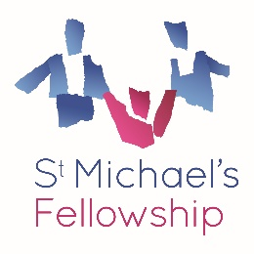
Job Description: Consultant Practitioner – Outreach
Reports to: Outreach Strategic Programme Manager
Direct Reports: None (practice leadership, not line management)
Location: St. Michael’s Fellowship
Salary:
Role Purpose
The Consultant Practitioner is the senior practice expert within Outreach, responsible for driving quality, embedding frameworks of best practice, and ensuring the service delivers to the highest professional standards. With a small caseload, the Consultant Practitioner will provide direct work with families, lead group reflective supervision, and act as the “go-to” advisor on complex cases. They will model outstanding practice, contribute to service evaluation, and play a critical role in shaping Outreach’s professional culture.

Key Responsibilities
- Carry a small caseload, working directly with families with complex needs.
- Deliver group reflective supervision to Outreach staff, supporting resilience and critical reflection.
- Contribute to allocation of work, ensuring cases are matched appropriately.
- Offer consultation and advice on complex cases and practice dilemmas.
- Support operational quality by contributing to safeguarding, evaluation, and service development.
- Mentor colleagues and model strengths-based, culturally competent approaches.

Person Specification
- Degree in social work, psychology, education, or related field or equivalent professional experience in outreach/family support.
- Substantial practice experience with children and families in community or outreach settings.
- Familiarity with multiple service delivery frameworks (e.g., systemic, trauma-informed, restorative).
- Strong safeguarding knowledge and ability to manage risk, including good knowledge of relevant legislation and statutory guidance, including the Children Act 1989, Working Together and Family First principles.
- Commitment to anti-racist, anti-oppressive practice and improving outcomes for families.
- Significant senior-level experience in outreach/family interventions.
- Recognised as a practice leader, with proven ability to embed frameworks and influence others.
- Strong facilitation skills and confidence in leading reflective spaces.
- Evidence of shaping service delivery and contributing to systemic change.

