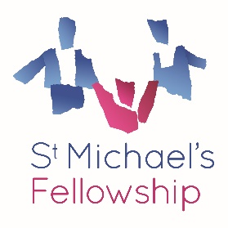
How to Apply
Please submit the following to Oretha Wofford by Friday 14 November 2025, 5pm:
- Expression of Interest (maximum 2 pages)
  - What excites you about the Consultant Practitioner role and how do you see yourself contributing to the next stage of development in Outreach?
  - Describe how your skills and experience align with the Consultant Practitioner role.
  - Outline what you would bring to practice leadership within Outreach.
- Up-to-date CV (maximum 3 pages)
Include professional qualifications, relevant experience and any recent training or achievements that demonstrate your readiness for senior practice leadership

