

Hornchurch Academy Trust

Job description

Class teacher
Post title: Class teacher
Range: MPS

Status of the post

The teacher is a member of Trust staff appointed in the first instance to (insert) school The appointment is in terms of teachers’ pay and conditions.

The post is jointly line managed by the HOS or other leader as so delegated

Main purpose of the post

Description

- To discharge all duties in line with the standard terms of employment for teachers.
- To be responsible for a class of pupils within the HAT as required
- To follow all HAT policy, practice and procedures
- To plan and prepare activities that challenge and meet the needs of all pupils in terms of HAT, local and national guidance as required
- To deliver the national curriculum and RE in terms of HAT, local and national guidance as required
- To record evaluate and monitor the progress of the pupils
- To monitor the personal, social and emotional needs of the pupils and liaise with appropriate staff and agencies.
- To report any child protection issues to the relevant person
- Attend CPD, staff meetings and all activities designated as within directed time
- To take responsibility within the HAT as agreed with the line manager, HAT principals and HAT CEO
- To co-ordinate a subject area within the definition of an MPS role as designated by the HoS
- Other duties as designated by the line manager which fall within teacher’s pay and conditions

Addition MPS responsibility

- To be responsible for developing provision for (insert subject) within the school under the guidance of senior leaders.
- To ensure subject guidance in school is up to date and aligns to school and Trust policy.
- To support the delivery of CPD in (insert subject)
- Liaise with other Trust leaders and subject leaders to develop provision for (insert subject)
- To monitor outcomes and data as specified in the Trust Monitoring Policy and report any concerns to school leaders
- To support school leaders in monitoring (insert subject) as required
- To advise colleagues on school and Trust expectations and support the development of teacher knowledge.

Staff development

The post holder will be professionally accountable for the work of the following colleagues, acting as performance management team leader for:

(insert)

Other duties

Other HAT development plan responsibilities as designated by line manager and the CEO

Appendix 1: Teaching standards

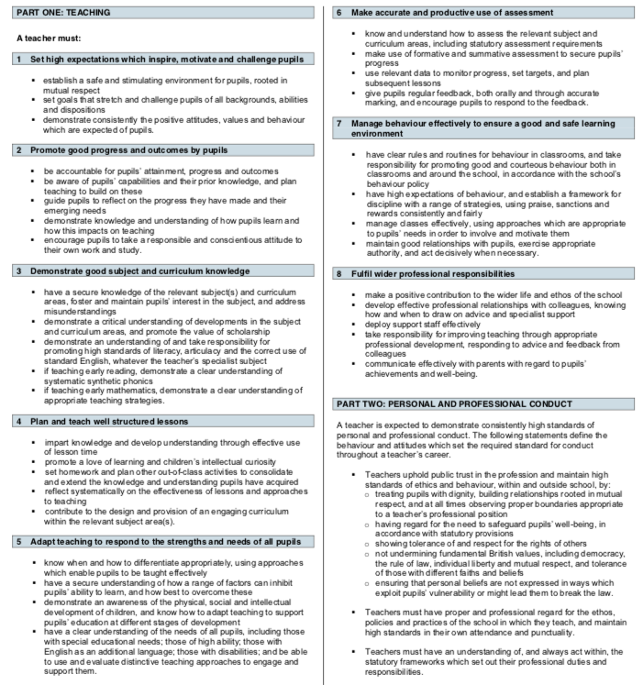

MPS teachers support leaders in qualitative monitoring but do not hold accountability

