


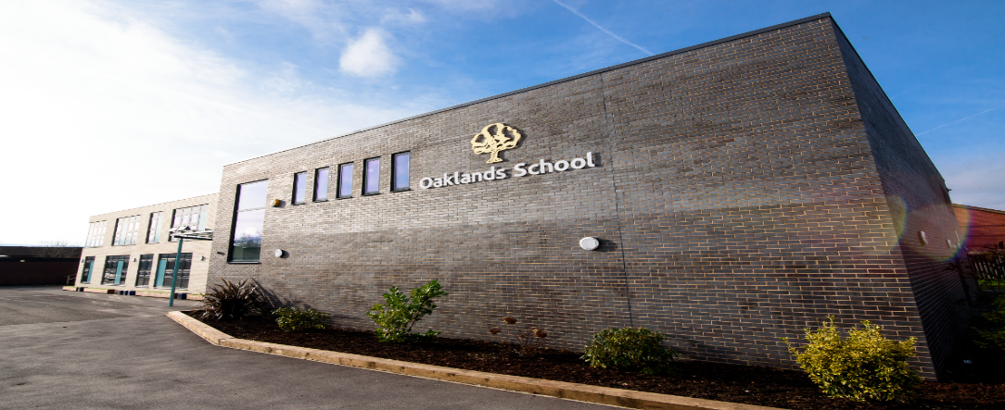

Montgomery Way, Winsford, Cheshire, CW7 1NU

Teacher of Science -
Permanent post

Candidate Application pack
An OFSTED Outstanding School 2024/2025

Montgomery Way, Winsford
Cheshire, CW7 1NU
Telephone: 01606 551048

Head Teacher: Neil Oxley

4th November 2025

Dear Colleague
Re: Permanent Teacher of Science (Main Scale + SEN Lower Point) to start January 2026
Thank you for showing an interest in this important position within our school. I hope that you find sufficient information enclosed to inform your decision and aid your application. We welcome applications from candidates who have a primary or secondary teaching background.
Are you:
Someone who wants to make a positive difference to young people?
An enthusiastic and inspiring individual?
Able to work as part of a successful multi-disciplinary team?
Committed to quality and equality of opportunity for all?
Dedicated to providing an excellent level of support for young people with SEND?
A person who is dedicated to supporting young people to thrive?
Can you:
Create a nurturing learning environment that enables students to reach their full potential?
Do you:
Want to be part of an experienced and supportive team?
Have the ability to teach engaging and well-structured lessons in Biology, Chemistry and Physics, up to and including GCSE level?

Then:
We would like to meet you! Visits to the school are welcome – please contact the school office to arrange a convenient time.

If you would like to apply for this exciting post, then please complete the enclosed application form and return to the school with a covering letter by noon on Wednesday 3rd December 2025. Interviews will be held on Thursday 11th December 2025.

The school is committed to safeguarding and promoting the welfare of our children and expects all staff and volunteers to share this commitment. A copy of our safeguarding policy can be found in the School Info/Policy section of our website: www.oaklandsschool.org. Applicants must be willing to undergo child protection screening appropriate to the post, including checks with past employers and the Disclosure and Barring Service, and successful candidates will be subject to an enhanced DBS check. Please be aware it is an offence to apply for the role if you are barred from engaging in regulated activity relevant to children. In order to comply with Asylum and Immigration Act 1996 (as amended by S147 of the Nationality, Immigration and Asylum and Immigration Act 2002), all prospective employees will be required to supply evidence of eligibility to work in the UK. All candidates called for interview must bring with them three forms of identification, preferably driving license, passport, birth or marriage certificate and a document showing their current address. In addition it is a requirement that copies of all relevant qualifications should be brought to interview.

This is a wonderful opportunity to make a positive difference to the lives of many young people and I look forward to receiving your application. Should you require further information prior to completing your application, please do not hesitate to contact me.

Yours sincerely
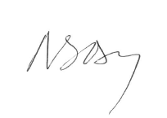
Mr Neil Oxley
Headteacher



An OFSTED Outstanding School 2013/2014, 2014/2015 and 2019/2020, 2024/25
www.oaklandsschool.org



INFORMATION ABOUT OAKLANDS SCHOOL

Type of School: Secondary Special School
School Category: Community
Age Range of Pupils: 11-17
Gender of Pupils Mixed
Number on Roll: 178
School Address: Montgomery Way
Winsford, Cheshire, CW7 1NU
Telephone Number: 01606 551048
E Mail: J.Fox@oaklandsschool.org
Appropriate Authority: Governing Body
Name of Chair of Governors: Mr John Williamson
Name of Headteacher: Mr Neil Oxley

ABOUT US
Oaklands is a child-centred outstanding school, where pupils learn in a nurturing and happy environment. Nestled in the heart of Cheshire West and Chester, our school embodies a transformative 'can do' philosophy, where every pupil is supported to achieve their full potential. With a deeply caring and supportive staff, we create a happy, nurturing environment that celebrates individual progress and enriches each pupil's educational journey.
Our school's core motto, "The best for all, the best from all," reflects our unwavering commitment to providing exceptional, personalised education. We believe in creating an inclusive atmosphere where pupils can develop crucial life skills, overcome challenges, and discover their unique strengths.
All pupils have an Education, Health and Care Plan with moderate learning difficulties stated to be their most significant difficulty. However, a small number of pupils also have severe learning difficulties, social and emotional difficulties, or speech and communication difficulties. In line with their learning difficulties, the attainment of pupils is well below what is expected for their age when they enter the school. There are three classes in each of the five year groups from Year 7 to Year 11, as well as a small sixth form, and these are organised largely by academic ability and appropriate educational pathways.

“The best for all, the best from all”
The Headteacher/Governing Body seek to appoint with effect from January 2026
An outstanding Teacher of Science – Permanent position
(Main Scale + SEN Lower Point)
We are seeking to appoint an enthusiastic and inspiring Teacher of Science who can create a nurturing learning environment in which everyone can reach their full potential. Join the Science department at Oaklands School and you will be part of an experienced and supportive team. We believe in working collaboratively, sharing ideas and supporting each other to achieve great things and see this as the key to further developing innovative teaching and learning strategies.
Interest, enthusiasm, knowledge and experience of teaching Science is essential. The successful candidate will join an established team in a well-resourced, successful department. A willingness to teach across all years is essential. We would welcome applications from ECTs and candidates who have a primary teaching background.
Our pupils’ ability ranges begin at working significantly below national expectations on admission with our more able pupils achieving GCSE/level 2 qualifications. Our pupils are genuinely positive about their education and are a pleasure to teach.
Joining us from January 2026 or earlier, the ideal candidate will have the ability to teach across KS3 and KS4 - a real interest in developing teaching and learning is also important.
We welcome applications from teachers at all stages of their career. We would also be pleased to support an ECT looking to start in July or September 2026.
Closing date for applications: Noon on Wednesday 3rd December 2025
Oaklands is a 2024/25 OFTSED Outstanding School. Please see our website for further details.
Our commitment to safeguarding: Oaklands School is committed to ensuring the highest levels of safeguarding and promoting the welfare of our pupils, and we expect all our staff to share this commitment. We adopt a fair, robust and consistent recruitment process in line with Keeping Children Safe in Education guidance. All offers of employment are subject to an Enhanced DBS check, references, and where applicable, a prohibition from teaching check.
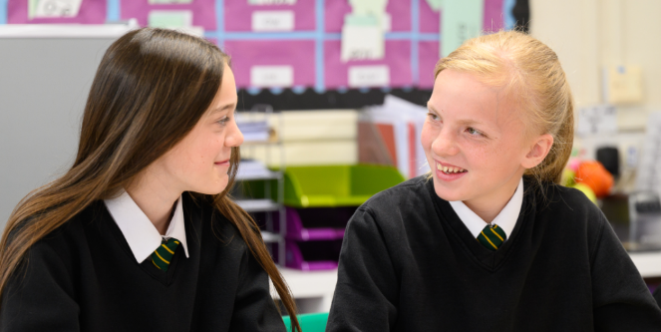
PERSON SPECIFICATION – Teacher of Science
Qualifications/Experience | Essential | Desirable | How Evidenced
Education and Training | Graduate  Qualified Teacher  Keeps appraised of new ideas/developments in education |  | Application form/interview
Relevant Experience | Recent experience of teaching Science across appropriate ability range  Excellent classroom management skills  Ability to deliver outstanding teaching and learning | Experience of teaching pupils with Moderate Learning Difficulties  Recent experience of teaching GCSE Science.  Recent experience of teaching other subject areas | Application form/ interview/references  Lesson observation
Specific skills and knowledge | Awareness of the strategies available for improving the learning and achievements of all students  Excellent understanding of the use of both summative and formative assessment  Able to use a range of teaching and learning strategies  Working closely with Teaching Assistants  Excellent personal organisational skills  Ability to create positive relationships with all stakeholders | A good understanding of curriculum developments in Science | Application form, interview and references  Lesson observation  Lesson observation  Lesson observation  Lesson observation  Lesson observation
Safeguarding | Understanding of the issues surrounding the safeguarding of children and commitment to child welfare and safety  Safeguarding training  Knowledge of child protection procedures |  | Application form and interview
Additional factors | A flair for teaching and the ability to contribute and work as a member of a strong team  A passion for supporting young people with SEND  A well-developed sense of humour  An excellent communicator  Enthusiastic |  | Application form, interview and references

Key Responsibilities:
- Plan and deliver engaging and well-structured lessons in Biology, Chemistry, and Physics, tailored to the needs of our pupils.
- Assess and monitor pupil progress, adapting teaching methods to support individual learning needs.
- Foster a positive and inclusive classroom environment that encourages curiosity and a love for science.
- Collaborate with colleagues to develop and implement the science curriculum, ensuring alignment with school policies and values.
- Contribute to the wider school community and participate in professional development opportunities.
- Create an inclusive classroom environment that sparks scientific curiosity

- Participate in ongoing professional development

CONDITIONS OF SERVICE
Teaching staff serve under the direction of the Headteacher and exercise their office in accordance with:-
The provisions of the Education Act 1944 and/or any amending Acts.
The Education (School Teachers’ Pay & Conditions) Order 2009.
The Professional Standards for Teachers.
The Articles of Government in force for the school.

In addition the appointment is subject to:-
The Articles of Government of the School;
The Authority’s relevant Conditions being in force at the time;
Disclosure of any criminal background/CRB check/a satisfactory medical report and positive confidential references

A detailed job description will be negotiated on appointment.

INTERVIEW ARRANGEMENTS
Interviews will be conducted by the Headteacher and Senior Staff. Interviews will be held on Thursday 11th December 2025. Senior Leaders by agreement, may visit short-listed candidates in their current schools.
As part of the interview process, shortlisted applicants will be observed teaching a lesson.

Prospective candidates are actively encouraged to visit the school.

Oaklands School
Montgomery Way, Winsford, Cheshire, CW7 1NU
Tel: 01606 551048
Email: head@oaklands.cheshire.sch.uk
Website: www.oaklands.cheshire.sch.uk

