


Job Description
Job title: | Website Content Editor
Service and team: | Customer & Digital Services
Band:  Post number: | Grade 4  FG20 SD04
Reporting to: | Web and CRM Lead
Responsible for: | N/A
Our Organisational Values
Collaboration   | We know, work with and support one another.
Wellbeing   | We look after our own and others’ wellbeing.
Trusted   | We abide by the Nolan principles of public life.
Value for Money   | We spend public money wisely and carefully.
Professionalism   | We provide professional advice and excellent service, we know our local areas and understand the communities we serve.
Principal purpose of the team and role
- Team - Ensuring a swift and efficient customer experience; understanding when and how to build self-serve capability as well as tailor exceptional advice and guidance to put customers first.

- Role - To develop and deliver a strategic vision for the Council’s Digital Communication programme in agreement with the Communications team.
Areas of Accountability
- Develop digital and self-service channels and implement customer enabling and prevention opportunities.
Main duties and responsibilities
- Using the CMS system, contribute to and maintain, content for the website and intranet including: writing and editing copy, managing the use of images and ensuring that the website’s shared resource gallery is well maintained; creating and maintaining online forms; moderating web pages, supplying information to websites connected to the borough; administering the Council’s domain names and redirects.
- Promoting the website and the services it provides for both internal and external marketing campaigns, advising staff on how the website can be used to effectively market services. Work proactively with the communications policy officers to utilise existing campaigns, ensuring the website is consistently and appropriately referenced throughout the Council’s marketing activities.
- Maintaining the web team’s section on the intranet, paying specific attention to the development of the web administrator’s section, producing easy to use help guides, hints and tips files and providing quick access to corporate web administration guidelines.
- Implementing national online targets and standards, including Government Digital Design Standards, web related elements of the UK Digital Strategy and working closely with ICT staff and external suppliers to ensure effective website security and support.
- Work with the Web and CRM Lead on improving customer journeys across the website and customer CRM platform.
- Collaborate with internal teams to gather content requirements and translate them into clear, engaging digital content.
- Ensure all content meets accessibility standards, usability best practices, and SEO principles.
- Conduct regular content reviews and audits, identifying outdated or underperforming content and recommending improvements.
- Monitor website analytics and user feedback to inform content decisions and enhance the user experience.
Dimensions of the team role
Corporate Strategy 2024-2034 - Guildford Borough Council
Customers and Contacts
Internal
- All council services and teams
- Elected members
External
- Stakeholders and organisations operating within the borough
- Website provider (currently Goss)
- Search and Anyltics providers (currently Cludo/ Site Improve)
Service/Team Structure
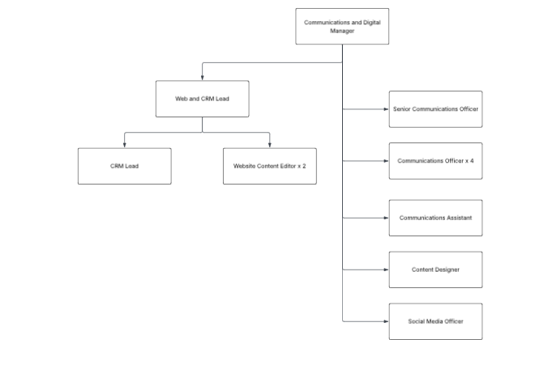

PERSON SPECIFICATION
Candidates must be able to demonstrate, giving examples, all essential criteria marked as A, A/C or A/I within their application form to be shortlisted for this role.

How assessed
A = Application CV/Personal Statement
C = Certificates/professional Registration
D = DBS police check
E = Exercise
I = Interview
M = Medical assessment

 | Essential criteria | How Assessed | Desirable criteria | How Assessed
Qualfications | - Educated to A Level standard/ NVQ 3 | A, C | - Degree is relevant subject | A, C
Knowledge | - Familiarity with web improvement and quality assurance platforms, such as Siteimprove, with the ability to use these tools to identify and address accessibility, SEO, and content quality issues. | A,I
Experience | - Hands-on experience in the day-to-day maintenance and development of websites with a sound knowledge of web accessibility issues and experience in using a content management system  - Experience and understanding of user experience (UX) principles, including testing and refining end-to-end user journeys to enhance usability and engagement.  - Awareness of best practice and current legislative requirements regarding internet technology (for example, accessibility) and government standards  - Experience in running creative on and offline promotional campaigns from initiation through to evaluation. | A,I
Skills
Technical skills | - Hands-on experience in using graphical software with an appreciation of web colours, image resolutions, graphic positioning and manipulation.  - Ability to interpret web analytics and user behaviour data to inform content decisions and improve user experience | A,I
Communication skills | - Experience in writing strong and creative promotional copy for on and offline publications | A,I
Team Working skills | - Ability to work well in a team. | A,I
Customer Service skills

Organisational skills
ADDITIONAL SPECIFIC REQUIREMENTS FOR THIS POST

Behavioural competencies

This section details the level of competency required to carry out this role (please see below for an overview of the framework and refer to the full Organisational Culture Framework - Guildford Borough Council Intranet for clarification where needed). | Level
Embraces change | 1
Innovation and creative thinking | 2
Effective communication | 2
Customer focus | 2
Problem solving and decision making | 1
Focus on efficiency | 2
Performance and learning | 1
Team working | 1
Builds relationships | 1
Commitment to the organisation | 1

Reviewed By: |  | Date:
Checked in: |  | Date:
Last Updated: |  | Date:

 | Guildford Borough Council behavioural competencies
Cluster | Transformation  Forward looking. The focus on our ability to respond to ever changing needs of our customers and bring about new ideas to ensure value for money. |  | Delivering excellence  Efficiently run. The focus on the values and behaviours (in addition to internal systems) that ensures efficiency and effectiveness at every level across the Council. |  | Our people  To ensure that individuals at all levels of the organisation are supported, committed and engaged in the pursuit of our mission and work in a collaborative manner to fulfil our objectives.
Values | Challenge ourselves  We strive to improve what we do by seeking out new ways of working, encouraging innovation and enabling change. |  | Customer care  We put the customer at the heart of what we do by engaging in clear, honest, and meaningful communications to deliver professional services shaped around their needs. | Quality focus  With customer insight, we provide high-quality services and find ways to improve. We aim to get things right first time, drive out waste and exceed expectations whenever possible. | Organisational learning  We strive to create a work environment where everyone is valued, trusted, and supported. We encourage and facilitate growth and learning at individual, team, and organisational levels. | One Council  We work together collaboratively, recognising that we are one organisation, working to achieve a common mission.
Behavioural competencies | Embraces change  Has a positive attitude to change, adapts to meet new challenges, and introduces changes to improve organisational performance. | Innovation and creative thinking  Proactively generates and develops innovative ideas, opportunities or improvements in order to meet organisational objectives more efficiently and effectively. | Customer focus  Puts the customer first, builds effective relationships and seeks feedback to address their needs. | Problem solving and decision making  Understands and analyses issues in order to identify the most appropriate solutions. Makes effective decisions based on thorough analysis and the needs of the organisation. | Performance and learning  Demonstrates personal commitment to meet agreed performance standards and objectives. Learns from experience and takes responsibility for identifying and addressing personal development needs. | Team working  Proactively cooperates and interacts with colleagues, internal and external partners across the Council. Encourages others to develop a collaborative approach to share information, knowledge, and ideas.
Behavioural competencies | Effective communication  Communicates effectively. Uses communication methods and standards, together with well-reasoned arguments to convince and persuade where necessary. |  | Focus on efficiency  Meets or exceeds the Council’s standards by monitoring the quality of own work, team or service delivery. Continually looks for areas of improvement to ensure efficiency, effectiveness, and value for money. |  | Builds relationships  Presents a professional image; uses interpersonal skills to form positive and productive working relationships within and beyond the organisation. | Commitment to the organisation  Consistently supports and demonstrates an understanding of and commitment to the Council’s vision and values. Acts with integrity and accountability.

This page is left intentionally blank

