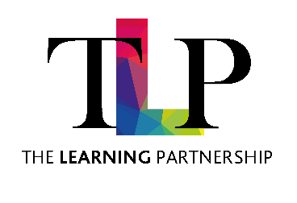
Egerton Primary School

PERSON SPECIFICATION

JOB TITLE | TA Primary | GRADE | 4

ATTRIBUTES | DESCRIPTION | DESIRABLE
Knowledge and Experience | - NVQ Level 2 or 3 (or equivalent qualification) in Early Years Education or Supporting Teaching and Learning.  - Sound understanding of the Early Years Foundation Stage (EYFS) Framework, including the Characteristics of Effective Learning and the Prime and Specific Areas of Learning.  - Experience of supporting children’s learning and development in a Nursery or Reception setting.  - Knowledge of early phonics, language, and number development,  - Commitment to safeguarding and promoting the welfare of young children. | - Experience of working with children with Special Educational Needs and/or Disabilities (SEND), including implementing individualised support strategies and working alongside the SENCo.  - Experience of supporting children’s personal, social and emotional development, including implementing positive behaviour strategies in line with school policy.  - Evidence of effective collaboration with teachers and other professionals to plan and deliver high-quality learning opportunities.  - Understanding of observation, assessment, and recording processes within the EYFS, and the ability to contribute to learning journals.  - Experience of supporting more able and less confident learners to ensure progress across all areas of learning.  - Evidence of recent and relevant professional development within the Early Years sector.
Skills and Abilities | - A genuine commitment to providing the highest quality care and education for all children, ensuring they feel safe, valued, and motivated to learn.  - Ability to observe, listen and respond sensitively to children’s individual needs, interests, and stages of development.  - Skilled in promoting independence, curiosity, and a love of learning through play-based and child-initiated experiences.  - Ability to support children’s speech, language, and communication development, including modelling high-quality talk and extending vocabulary.  - Strong organisational and time-management skills, with the ability to assist in planning, preparing, and setting up engaging learning environments both indoors and outdoors.  - Ability to use initiative and creativity to adapt activities and resources to meet the needs of all learners, including those with SEND or EAL.  - Commitment to safeguarding and promoting children’s wellbeing, maintaining confidentiality and professionalism at all times.
Personal Qualities | - Reflective and open to professional learning, demonstrating a willingness to develop knowledge and skills in line with current Early Years best practice.  - Excellent interpersonal and communication skills, with the ability to build nurturing, trusting relationships with children, staff, and families.  - Ability to work effectively as part of a team, showing flexibility, initiative, and a positive attitude in supporting colleagues across the EYFS setting and wider school. | - Evidence of working with outside agencies linked to school

The Trust is committed to safeguarding and promoting the welfare of children and young people and expects all staff and volunteers to share this commitment.
Notwithstanding the detail in this job description, the jobholder will undertake such work as may be determined as necessary by the Trust.

