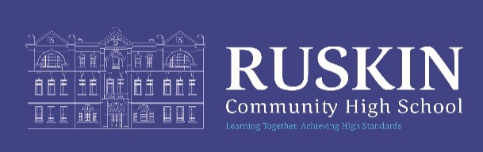

AAAE5036X Librarian (training will be provided)

NJC Grade 4–6 (final grade to be determined based on experience and suitability for the role). This will be subject to pro rata.
Permanent/ Term Time only
Hours can be discussed, 39 weeks per year

CLOSING DATE: MONDAY 5th January 2026 12.00 noon

STARTING DATE: TBC

The Governors of Ruskin Community High School are seeking to appoint a Librarian into this valuable role for the whole school literacy values and objectives. Candidates with no librarian experience, but with a love and passion of books and reading, will be considered.

We are looking for a motivated and enthusiastic candidate to provide effective support for students in the School's Library and support and encourage reading throughout the school. To also promote the further use of the Library with staff and students.

To apply for this position - please use this link https://ruskin.face-ed.co.uk/ or visit our website www.ruskinhighschool.co.uk on the vacancies page and access the link. You will then be able to track your application progress from the account you create.

Please email recruitment@ruskin.cheshire.sch.uk if we can support further.

Please note – CVs will not be accepted.

Please see the Job Description for further information.

Ruskin Community High School is an equal opportunities employer. Our school is committed to safeguarding and promoting the welfare of children and expects all staff to share this commitment. All posts are subject to enhanced DBS checks and references.

Telephone enquiries about the post will be welcomed if applicants require any further information at any time on 01270 560514.

We will always acknowledge receipt of applications but It will not be possible to inform candidates if they have not been shortlisted.

Please be advised that this post will be advertised on CEC Website, Ruskin Website and internally.

