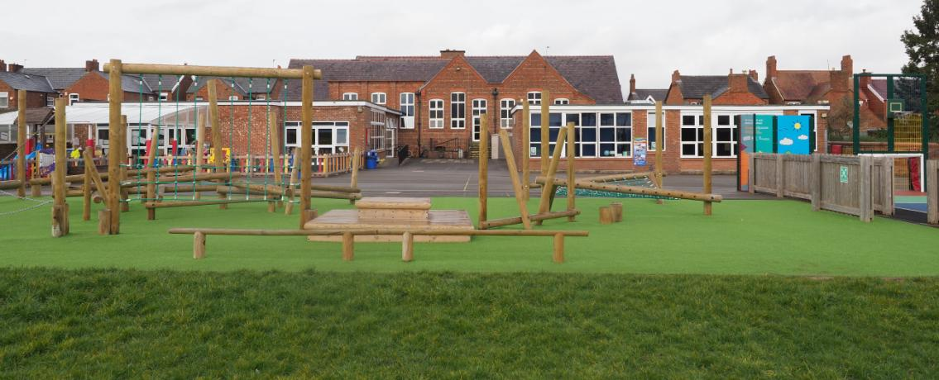
Dear Applicant,
Firstly, thank you for your interest in the role of Headteacher at St Chad’s CE Primary School. As governors we are looking to appoint a dynamic engaging leader, who will strive to ensure that all children within our school achieve their full potential. This will be delivered through high quality first teaching, in an environment that supports our vision; ‘a future with hope’.
St Chad’s is a thriving school that is at the heart of the local community with strong links to the parish church and other community partners. Our Nursery provision is from the age of 2 and is provided by S4YC, a private provider with whom the school works very closely. S4YC also provide our wrap around care options through their ‘before and after’ school clubs.
Our Christian values, along with our high expectations for all, underpin the calm and purposeful atmosphere within our school. St Chad's prides itself on being an inclusive school, where all students, regardless of their abilities, backgrounds, or disabilities, learn together. SIAMS found “A shared understanding of Christian teaching ensures that every decision stems from the vision and its broader biblical roots. Thus, the vision sustains every element of school life resulting in a welcoming, nurturing and aspirational community.” (October 2023).
Our children are our best advert, and you will find details of times where you can visit our school within the application pack.

We look forward to receiving your application,
Yours faithfully
Jill Marriott
Chair of Governors
jmarriott@stchadsce.cheshire.sch.uk

