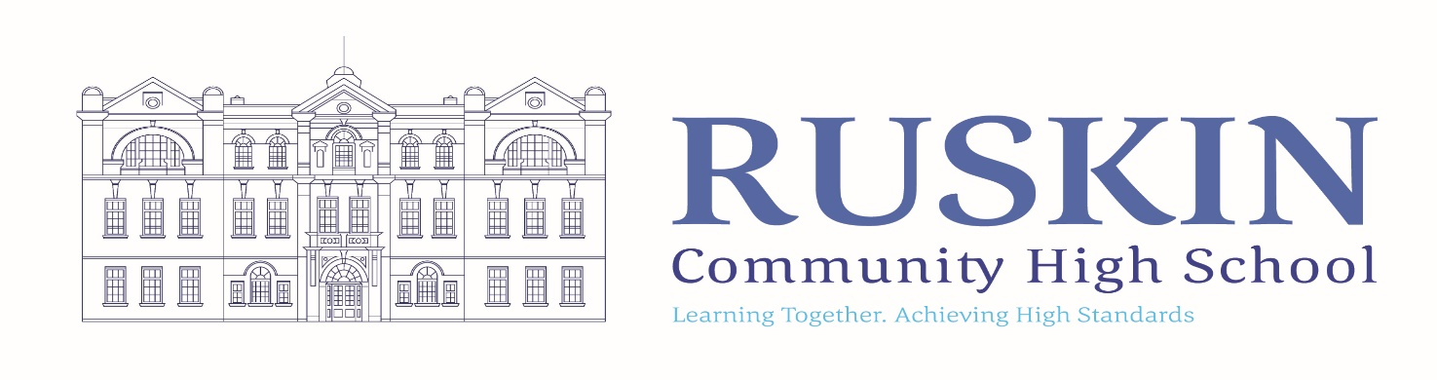
TEACHER OF ENGLISH – MATERNITY COVER

12 MONTHS MATERNITY COVER : MPR/UPR (ECT’s are welcome to apply)

CLOSING DATE: MONDAY 9th MARCH 2026 - please note we may offer interviews as candidates apply before the closing date.

TO COMMENCE: TUESDAY 1st SEPTEMBER 2026

Ruskin Community High School is seeking to appoint a talented and ambitious Teacher of English to teach across KS3 and KS4 for a 12 month maternity cover. The successful candidate will have excellent subject knowledge and an understanding of curricular content and delivery.

Our team is well established and experienced and we would like an enthusiastic colleague with a passion for English and is current with learning and teaching strategy. We are looking to appoint inspirational practitioners who have a passion for working with students to help them achieve beyond their aspirations.

We would also welcome a colleague that has a presence in the classroom and someone seeking to be part of a strong team and wider school community.

If you would like a tour or wider discussion around the role, please contact the school on 01270 560514.

To complete the application online please follow the link to https://ruskin.face-ed.co.uk

For any further details of this position or the school please visit the School Website at www.ruskinhighschool.co.uk or email recruitment@ruskin.cheshire.sch.uk.

Please note – CVs will not be accepted.

Ruskin Community High School is an equal opportunities employer. Our school is committed to safeguarding and promoting the welfare of children and expects all staff to share this commitment. All posts are subject to enhanced DBS check, medical and references.

Telephone enquiries about the post will be welcomed if applicants require any further information at any time on 01270 560514.

The vacancy will close sooner if we receive a large number of applications.

Please be advised that this post will also be advertised on Jobs go public, Teacher vacancies, Ruskin Website and internally.

