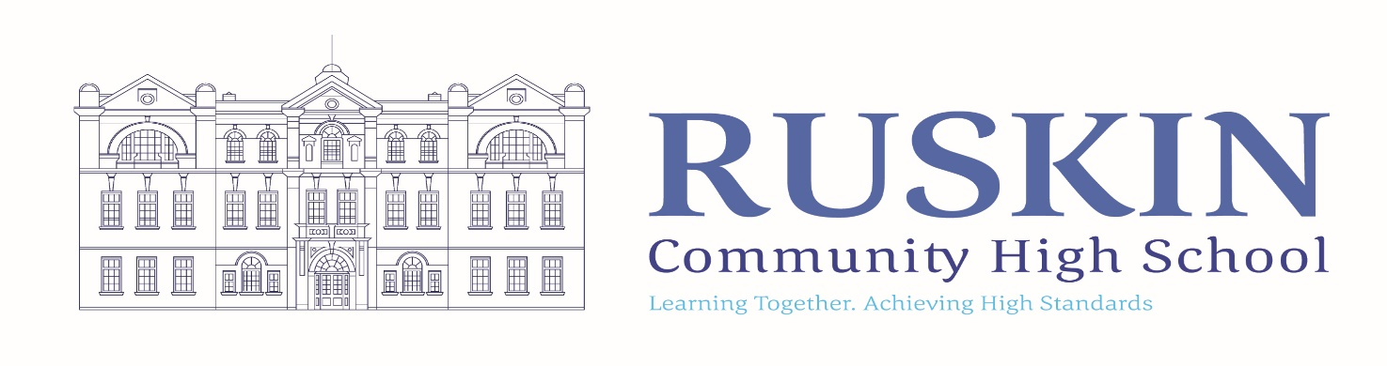
SECOND IN ENGLISH (TEACHER SALARY + TLR2B)

FULLTIME/PERMANENT: MPR/UPR

CLOSING DATE: Thursday 19th March 12.00 noon

TO COMMENCE: TUESDAY 1st SEPTEMBER 2026

Ruskin Community High School is seeking to appoint a talented and ambitious Teacher of English to teach across KS3 and KS4. We are looking for an individual with excellent subject knowledge and a clear understanding of curriculum design and effective delivery. We are particularly interested in a confident and creative teacher who can develop engaging resources and deliver high-quality writing instruction.

This role is available due to the current post holder securing promotion in school, offering a fantastic opportunity to take a key leadership role within a well-established department. The successful candidate will support the Head of Department to drive standards and improve outcomes for all students.

The English team is supportive, and collaborative. We are looking for a colleague who is not only passionate about English but also:
- Enthusiastic and positive in approach
- Committed to high standards and continuous improvement
- Ready to co-lead with vision and professionalism
- Keen to contribute to the wider life of the school community

For a suitable candidate we will also consider applications from teachers without the second in department responsibility.

If you would like a tour or wider discussion around the role, please contact the school on 01270 560514.

To complete the application online. Please follow the link to https://ruskin.face-ed.co.uk

For any further details of this position visit the School Website at www.ruskinhighschool.co.uk or email recruitment@ruskin.cheshire.sch.uk.

Please note – CVs will not be accepted.

Ruskin Community High School is an equal opportunities employer. Our school is committed to safeguarding and promoting the welfare of children and expects all staff to share this commitment. All posts are subject to enhanced DBS check, medical and references.

The vacancy will close sooner if we receive a large number of applications.
Please be advised that this post will also be advertised on CEC Website, Ruskin Website and internally.

