Job Description

This job description has been designed to indicate the general nature and level of work required of the post to indicate the level of responsibility. It is not a comprehensive or exhaustive list, and the line manager may vary duties from time to time which do not change the general character of the job, or the level of responsibility entailed.

Post Details
Job Title | Practice Consultant
Job Reference | 706528
Service | Children’s Services - Quality Assurance and Safeguarding Standards
Team | Children’s Services Workforce Academy
Location | Hybrid: Home & Shute End
Reports to | Principal Social Worker/Head of Academy
Responsible for | N/A
Grade | NRSG4 (pay scale NL41-NL45)
Contract Type | Permanent
Hours | Full-time (37 hours a week)

Main Accountabilities
1 | To support the Academy to implement Systemic and Relational Practice service wide, so experiences for children and families across the system are positive and consistent.
2 | To actively strengthen the quality, consistency and impact of practice across Children’s Services, ensuring we directly contribute to improved outcomes and better everyday experiences for children, young people and families who use our services.
3 | To design and deliver training for the workforce, linked with the practice framework and other key areas of children’s services practice improvement.
4 | To facilitate group reflective spaces with teams, helping to unpick complex situations, learn from each other, role model creative and curious thinking, and apply systemic and relational practice approaches.
5 | To contribute to quality assurance activity, including undertaking core and thematic audits and participating in wider quality assurance processes, to actively contribute to continual improvement across Children’s Services.
6 | To establish and develop effective working relationships and productive partnerships with internal and external colleagues, including those in SEND, education and health, to promote coordinated, connected, holistic support for children and families.
7 | To contribute to initiatives that strengthen recruitment, retention and workforce stability, as well as contributing to pathways for career progression and continuous development for the workforce.
8 | To champion innovation and creativity by bringing forward new ideas and contributing to the development of the Academy, including through constructively challenging practice issues.
9 | To actively support, coach and guide people early in their social work careers (i.e. students and newly-qualified social workers social work apprentices), fostering their professional confidence, developing their practice skills, and creating a supportive learning environment.
10 | To contribute to building the wellbeing, confidence and resilience of the workforce, through supportive and trauma informed approaches, and being responsive to individual and team needs.
11 | At all times to prioritise and positively reinforce our commitment to safeguarding and promoting the welfare of children and vulnerable adults.
12 | To attend relevant internal and external meetings as required.
13 | Any other duties that correspond reasonably to the general character of the post and are commensurate with its level of responsibility.

Person Specification Essential Desirable
Education/Qualifications | Recognised professional Social Work qualification and current registration with Social Work England (SWE). | Practice Educator Standards (1 and/or 2).  Systemic Practice Qualification.  Coaching or teaching qualification.  Supervisory/leadership qualification.
Experience | Minimum of 3 years post-qualifying experience, working within statutory children’s services.  Holds current position of Senior Social Worker or above.  Experience of supporting and leading others to develop their confidence, knowledge and skills through coaching, mentoring or budding.  Experience of applying critical reflection and analysis to complex situations and thinking creatively and innovatively about interventions for practice. | Experience across multiple areas of practice across children’s services (i.e. child protection, court work, children in care, children with disabilities, youth justice).  Experience as a manager and supervisor.  Experience of developing and delivering training to others.  Experience of assessing and support student and newly-qualified staff.  Experience of contributing to quality assurance practices and processes.
Skills/Knowledge | Strong child and family centred, relational practice, with a motivation to improve outcomes for those accessing the help of children’s services.  Solid understanding of what constitutes best practice in children’s services work, and a passion for driving continuous improvements.  Up to date and detailed knowledge of relevant legislation, key policy changes and evidence-based practice approaches.  Ability to think curiously and creatively, and bring innovative ideas to life in practice.  Knowledge of safeguarding thresholds, risk assessment and risk management – commitment to improving outcomes for children by helping families make changes as our primary duty.  Knowledge of systemic practice approaches, and its application in work with children and families.  Excellent IT skills, including proficiency in MS Office package.
Behaviours/Attributes | Willingness to learn about other areas of practice withing children’s services, in order to broaden the Academy’s scope of support.  Ability to work productively as part of a team and alone.  Strong relational practice skills, with evidenced ability to overcome difficulties or complexities in relationships.  Commitment to and passion about anti-racist, anti-oppressive and anti-discriminatory practice.  Understanding of and commitment to working in accordance with the Council’s values and high-performance indicators.  Excellent verbal and written communication skills.  Ability to provide high-level support and high-level professional challenge when required.  Strong timekeeping skills and ability to work under pressure and to deadlines.

Purpose Details
Service Purpose | To work as part of the wider Quality Assurance and Safeguarding Standards Service, to strengthen practice across Children’s Services by using qualitative and quantitative analysis to build self-knowledge, establish robust standards and drive continuous improvement. The service seeks to foster a culture where learning and quality assurance are shared responsibilities and are everybody's business. In doing so, it creates meaningful opportunities for staff development so individuals can fully utilise their skills and strengths, and promotes excellence in practice to ensure children and young people consistently experience the best possible outcomes.  The Children’s Services Workforce Academy strengthens, sustains and supports the whole children’s services workforce, building professional confidence, capability and resilience so practitioners and leaders feel equipped to deliver the best experiences and outcomes for children, young people and families.  Through purposeful practice, relational learning and a culture of opportunity, the Academy offers high‑quality training, clear development pathways and responsive support. Learning is practical, reflective and closely connected to everyday practice, helping professionals grow throughout their careers.  The Academy is committed to developing and retaining a skilled, stable and motivated workforce. By valuing staff, listening to their experiences and responding to their needs, it fosters a connected and supported workforce able to thrive in complex and demanding work. The current structure of the Academy is:  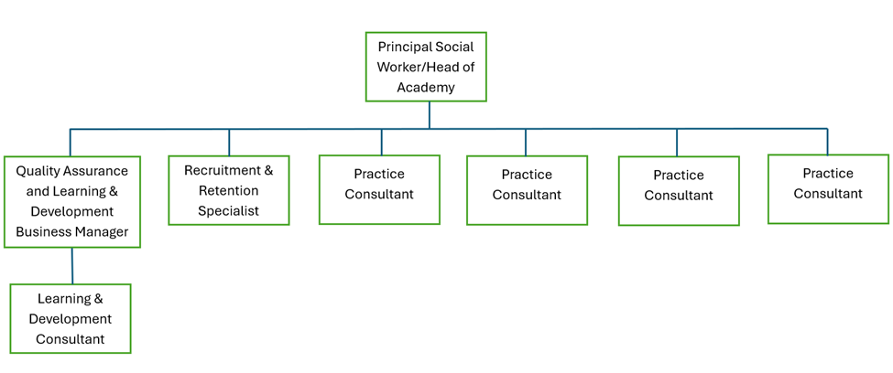
Role Purpose | The primary focus of the role is to support the ongoing practice development of the children’s services workforce by delivering training, coaching and mentoring, and by facilitating reflective learning spaces. The post holder will play a key role in strengthening and embedding systemic, relational, therapeutic and trauma responsive practice across children’s social care, as well as supporting the implementation of the Families First reforms and contributing to improved outcomes for children and families.

Supervision and Relationships
Supervision Received | Supervision will be provided on a monthly basis by the line manager.
Supervision Given | Not applicable.
Contacts | Internal colleagues across the entire of Children’s Services, including social care, SEND, education, health, youth justice, and commissioning.  External colleagues/partner agencies, including educational establishments for student social workers.

Resources/Budget Management
The postholder has no budget management responsibility.

Special Requirements
- Willingness and flexibility to undertake a range of duties across children’s social work.
- Flexibility in working hours including some availability to work outside normal office hours.
- Able to work with degrees of risk, change and conflict and to identify personal stress levels and to seek advice/support when necessary.
- Ability to travel to a variety of locations.
- Understand and follow data sharing and confidentiality boundaries.
- Enhanced DBS check.

Occupational Health Risk Assessment Details
Skin/Respiratory Sensitisers | No
Working at Height | No
Exposure to Noise (>80-85dB) | No
Confined Spaces | No
Frequent Display Screen Equipment Use | Yes
Driving for Work | No but ability to travel to variety of office locations around Wokingham is essential.
Hand Arm Vibration | No
Lone Working | No
Healthcare/Social Contact with Patients | No
Blood Borne Viruses Exposure | No
Food Handling | No
Working with Animals | No
Specialised Medical Screening | No
Night Working | No
Safety Critical Work | No

Nature of the Role Details
Healthcare or Hospital Work | No
Working with Children (under 18) | No
Working with Elderly/Vulnerable Adults | No
Work Environment Details | Hybrid - Council office and home

Role Involvement Details
Working with Children | Yes (mostly indirectly but may be times this is direct to support the practice/development of a practitioner)
Working with Vulnerable Adults | No
Both of the Above | No
Providing Care/Supervision for Children | No
Providing Care/Supervision for Vulnerable Adults | No
Both of the Above | No
None of the Above | No

Disclosure and Barring Service (DBS) Details
DBS Requirement | Enhanced level
Eligibility Tool | Find out which DBS check is right for your employee - GOV.UK (Find out which DBS check is right for your employee - GOV.UK)

Re-checks
DBS will be renewed every 3 years.

Evaluation Declaration
Date of Evaluation: | 09/03/26
Evaluated by: | Jennie Oatham, Principal Social Worker and Head of Academy

