SCHOOL OFFICE ADMINISTRATOR
Permanent

Alsager School part of The Cornovii Trust

Hours: 19 hours; 39 weeks (term-time plus 1 week)
Working hours: Monday to Thursday 12:30pm to 16:00pm and Fridays 10:30am to 16:00pm.

Grade 4: Scp 05 to 06 £11,335 to £11,515 (actual salary)
(whole year equivalent: £25,583 - £25,989)

Closing Date: Thursday 26th March 2026 (12:00pm)
Required for – ASAP

Thank you for your enquiry about the above post. It is a part-time, part-year, permanent post and the successful applicant will join the school’s highly efficient front office Team.

The post is based in the Main School Office which is a well-equipped reception area with an adjoining administration office and First Aid Room. You will be part of a well-established team working together to provide outstanding support to staff, students, and parents.

As the first point of contact, it is essential for the person appointed to be an exceptional communicator and we pride ourselves on the service we currently offer to pupils, staff and visitors. The successful candidate will also need to be able to work calmly under pressure, whilst working on their own initiative and have a willingness to undertake appropriate training in relation to First Aid and SIMS.net. Applicants should have a good general educational background and be computer literate. Knowledge of SIMS.net (Schools Information Management System) would be an advantage but not essential as appropriate induction and training will be provided when in post.

About Alsager School
Alsager School is a high-achieving, inclusive 11-18 mixed comprehensive, with 1,500 students on roll, including 220 students in the Sixth Form. As the only secondary school in the town, we serve a broad catchment area across Alsager and neighbouring parts of Cheshire and Staffordshire.

We are proud of our school community. Our students are friendly, respectful and ambitious with positive attitudes to learning and strong relationships with staff. Visitors regularly comment on the calm, purposeful atmosphere around the school and the pride students take in their work.

The school benefits from:
- A committed and experienced staff body
- Strong relationships with students, families and the local community.
- A supportive trust that values collaboration, leadership development and evidence-informed practice.
- Ongoing support from experienced colleagues within school and the wider trust, including access to high-quality training and Leadership development.
- A community cover scheme that supports staff wellbeing.

Key Responsibilities:
  - Creating and managing documents, spreadsheets and presentations
  - providing essential support for daily operations,
  - Handling communication (calls/emails)
  - To be the first point of contact for parents, pupils, and visitors (in-person, phone, email).
  - Handle incoming/outgoing mail, photocopying, and general correspondence.
  - Update and manage school communications
  - Maintain student records and databases (e.g., SIMS/Talaxy/CPOMS)
  - Promote and safeguard the welfare of children and young people.
  - Administer basic first aid
  - Maintain confidentiality and adhere to data protection policies.
  - Act as cover for reception
  - Support the Office Manager and School team.
  - Undertake other reasonable duties as required.

Safeguarding
Alsager school and The Cornovii Trust are committed to safeguarding and promoting the welfare of children and young people. All appointments are subject to enhanced DBS checks and pre-employment screening.

Application Process
Applications for this role can be found on The Cornovii Trust website. Applications should be sent to hr@thecornoviitrust.org by the closing date of Thursday 26th March 2026. CV’s will not be accepted.

Statement in support of your application may be written as part of the application form or submitted separately. It is important that your supporting statement should give comprehensive information about your skills and it should emphasise your qualities which are relevant to the post.

The Interview
Interviews are to be confirmed. In the interests of economy, those applicants who have not received an invitation for interview or any further communication within two weeks of the above date are asked to consider their application unsuccessful on this occasion.

It is the School’s practice to take up references for all shortlisted candidates. One referee should be from your current or most recent employer. Where you are not presently working with children but have done so in the past, you should provide a referee from that employer. References will not be accepted from relatives or from people writing solely in the capacity of friends.

PERSON SPECIFICATION

Job Title: school Administrator Grade: 4 scp: 05-06
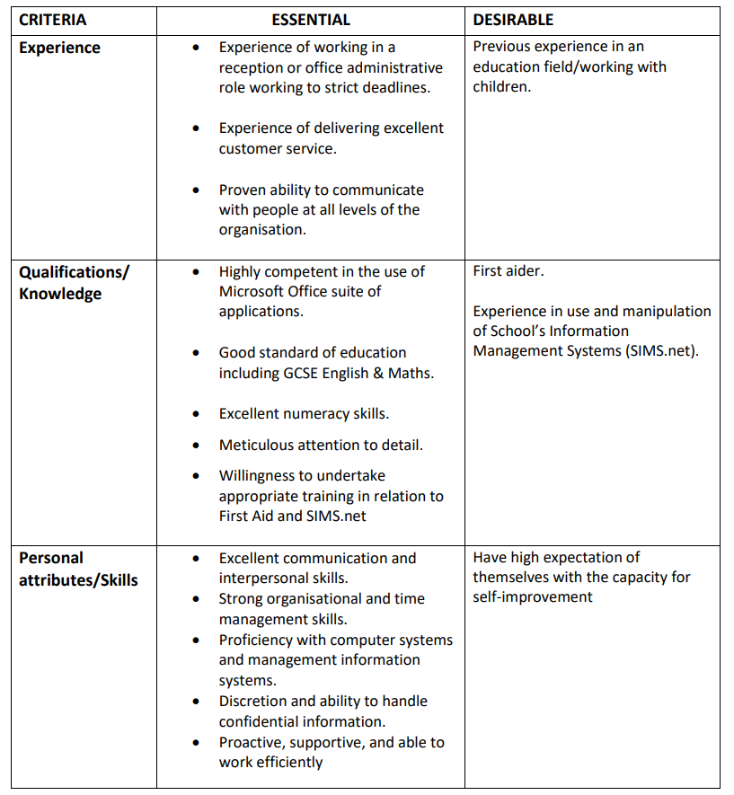

Rewards and Benefits
Our people are at the heart of our success. We recognise that every school and every individual is of equal importance, we respect and have tolerance of all, and we ensure that everyone feels known, appreciated and valued.

We have developed a strong culture of collaboration and best practice, investing in our staff with support, coaching, mentoring and a wide range of top-quality training programmes at every level.

You will have opportunities to learn from colleagues who are highly experienced, knowledgeable, and committed education practitioners to support your development and career with the trust.

You will have the autonomy to evolve your school’s vision, values, performance and culture, but you will never be alone, you will have continuous support from the wider trust.

You will also have full access to our rewards package:

Learning and development
We offer a wide range of training and development opportunities including structured qualifications, and you will be able to access support, coaching and mentoring by senior members of staff from across the trust.

Competitive pension scheme
Teaching and School leadership staff are part of the Teachers' Pension Scheme (TPS). You receive a guaranteed pension through the Teachers’ Pension Scheme. This is a defined benefit scheme, via career average arrangement; benefits are accrued each year based on 1/57th of your pensionable salary including overtime.

Employee Assistance Programme
We have partnered with Legal and General to offer free and confidential advice to our staff. This is available 24 hours, 7 days per week for you and your immediate family. Some of the services include support with family, financial information, legal advice, stress and anxiety, and bereavement. You will also have access to ‘in the moment’ counselling sessions.

Flexible working
We offer various flexible working arrangements, and all staff are encouraged to submit applications for flexible working to suit their individual circumstances.

Discounts on shopping, leisure, and travel
Through our Legal and General EAP our staff have access to a wide range of offers and discounts on high street and supermarket shopping, leisure facilities such as cinema and gym, and travel options such as holidays and hotel stays.

Gym - Access to Alsager Everybody Health and Leisure.

Flu vaccinations - All staff have the option to access their annual flu vaccination via a local pharmacy.

Employees will be expected to comply with any reasonable request from a manager to undertake work of a similar level that is not specified in this job description. Employees are expected to be courteous to colleagues and provide a welcoming environment for visitors and telephone callers.

The school will endeavor to make any necessary reasonable adjustments to the job and the working environment to enable access to employment opportunities for disabled job applicants or continued employment for any employee who develops a disabling condition (as defined in the Equality Act 2010).

This job description will be reviewed where necessary and may be subject to amendment or modification at any time after consultation with the post holder. It is not a comprehensive statement of procedures and tasks; it sets out the expectations of the school in relation to the post holder’s professional responsibilities and duties.

Important - The Rehabilitation of Offender Act
All posts involving direct contact with children are exempt from the Rehabilitation Act 1974. The successful applicant will be required to apply for an enhanced DBS certificate. As the post will involve regulated activity with children, it is a criminal offence to apply for this post if you are included on the children’s barred list held by the DBS.

Amendments to the Exceptions order 1975 (2013, 202 & 2023) provide that certain spent convictions and cautions are protected. These are not subject to disclosure to employers and cannot be taken into account. Guidance and criteria on the filtering of these cautions and convictions can be found on the Ministry of justice website or visit https://unlock.org.uk/advice/what-will-be-filteredby-dbs/.

Shortlisted candidates will be asked to provide details of all unspent convictions and those that would not be filtered, prior to the date of the interview. You may be asked for further information about your criminal history during the recruitment process. If your application is successful, this self-disclose information will be checked against information from the Disclosure & Barring Service before your
appointment is confirmed. Any data processed as part of the DBS check will be processed in accordance with data protection regulations and the trusts privacy statement.

