Role Profile
Post Title: | Solicitor
Department: | Legal
Job Band / Job Family: | G / Business Support
Effective Date: | January 2026

1. Purpose
To provide comprehensive legal advice and support across the charity to meet legal obligations, including compliance with legislation and sector best practice. To provide advice to directors and senior leadership on regulatory and compliance matters

2. Key relationships
- Reports to Senior Solicitor
- No line management responsibilities
- Works collaboratively alongside other members of the Legal Department
- Internal contacts include all levels of management
- External contacts include law firms, barristers, ACAS, employment tribunals
- Responsible for working alongside and/or line managing volunteers within your team if applicable

3. Qualifications required
- Qualified Solicitor with significant post qualification experience
- Educated to degree level or higher
- Hold current practising certificate

4. Proven experience, skills and ability
- Commitment to professional development and staying abreast of legal and regulatory changes
- Broad understanding of main areas of English law affecting the charity
- Understanding of sector governance responsibilities and standards and lines of accountability
- Commercial acumen with a focus on the need to give pragmatic advice
- Demonstrated ability to manage priorities in a timely manner
- Able to work flexibly
- Excellent interpersonal skills to collaborate and influence at all levels of the charity
- Strong communication skills and ability to put across complex legal concepts to managers with a non-legal background
- Able to draft with clarity and demonstrate attention to detail
- Analytical skills with solution-driven approach
- Ability to identify reputational and other risks and devise strategies to manage them
- Alert to ethical and professional issues, capable of identifying conflicts of interest
- Resilient and professional approach
- Ability to work independently
- Able to undertake legal research
- Proficient in using IT

5. Complexity and accountability
- Authorised signatory for contracts, deeds and other legal instruments
- Authority to incur expenditure up to limits of delegated authority
- Authorised to file information online (e.g. Companies House, Charity Commission, OSCR)
- Authority to negotiate and settle claims
- Authorised under Legal Services Act 2007 to sign HM Land Registry AP1s
- UK Govt-approved person to certify copy documents
- Cannot authorise/make changes to salary levels
- Cannot recruit/dismiss
- Not responsible for a departmental budget

6. Key responsibilities
- Advise on Data Protection/ GDPR
- Draft, review and negotiate commercial and non-commercial contracts
- Develop legal resources, including template agreements
- Licensing agreements and licences to occupy
- Healthcare commissioner and acute trust contracts (NHS Standard Contract)
- Model grant agreements
- Educational placement agreements
- Provide guidance and review compliance
- Provide guidance and review compliance on governance (legal and regulatory) frameworks and practice (Charity Commission, Office of the Scottish Charity Regulator, Companies House, DEFRA and Environment Agency, Care Quality Commission, NHS England).
- Provide guidance on professional regulatory matters, including: NMC/HCPC referrals and fitness to practise, BACP code
- Legal voice on groups/committees/focus groups
- Review grant funding agreements, sponsorship agreements
- Advise on political campaigning restrictions
- Advise on unauthorised fundraising practice
- Monitor and protect the charity’s trade marks (through Company Names Tribunal applications, ‘cease and desist’ letters)
- Apply for new trade mark and device registrations
- Advise on copyright infringement
- Defend ET claims
- Advise on disciplinary investigations
- Negotiate COT3 agreements
- Defend EL/PL claims
- Advise on/defend criminal prosecutions
- Court of Protection proceedings
- Advise on online offences
- Draft access permissions (eg research, elective placements)
- Draft and review policies, procedures and guidelines
- Advise on HM Coroner matters (reports, investigations, inquests)
- Advise on StJRs
- Advise on Deprivation of Liberty Standards
- Requests for patient data from healthcare professionals, lawyers etc
- Advise on complaints up to Ombudsman level
- Advise on human rights
- Advise on LPAs
- Monitor healthcare legislation as it affects the charity’s areas of operations
- Advise on legal, regulatory and compliance matters (anti bribery, anti-money laundering, data protection, care standards and charity regulations)
- Manage relationships with external solicitors, barristers in both contentious and non-contentious matters.
- Support senior managers in navigating new legal and regulatory developments.
- Draft and review policies, procedures and guidance
- Positively influence the charity’s ethical culture
- Advise on document retention period
- Work collaboratively on tasks assigned to the legal team
- Produce occasional briefings on topical subjects for internal audience.
- Provide training on specific legal topics.
- Undertake other job-related duties and special projects, contributing to the overall success of the legal team.

7. Behaviours
Operate within the Sue Ryder values and behaviours standards:
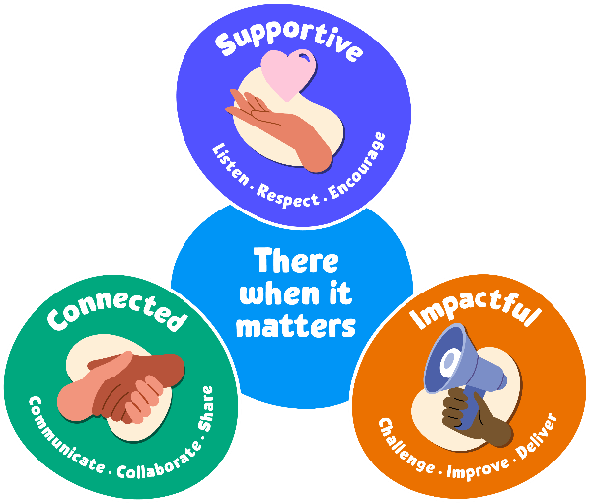
Supportive:
Our first value is supportive. We're here for people when it matters, and that includes each other. We encourage, inspire and help one another, and celebrate success.

The behaviours for this value are listen, respect and encourage.
We will take time to listen and understand; respect and value each other’s differences; and encourage and nurture each other.

Connected:
Our second value is connected. When we work together, we can achieve so much more for the people we support. We respect that everyone at Sue Ryder plays a vital part in delivering quality care.

The behaviours for this value are communicate, collaborate and share.
We will communicate effectively; actively collaborate and appreciate each other’s contribution; and share ideas, experience and knowledge.

Impactful:
Our third value is impactful. We find new and inspiring ways to positively impact the people we support – from small gestures to big breakthroughs. This proactive attitude drives us forward to achieve our ambitions and transform lives.

The behaviours for this value are challenge, improve and deliver.
We will welcome feedback and constructively challenge each other; reflect, learn and continue to improve; and each play our part to deliver the charity’s aims.
8. General
In addition to the specific duties and responsibilities outlined in this job profile, all Sue Ryder colleagues should understand the impact that their role has on achieving our organisational aims. Our values tell us how to do this, as they guide us in our choices and influence our behaviour. We ask all our staff and volunteers to follow our values while being an ambassador for Sue Ryder.
In practice, this means:
- Being able to talk confidently about Sue Ryder, our services and campaigns
- Being able to talk confidently about why we need to fundraise, how we are funded and how people can get involved
- Promoting an equitable, diverse and inclusive environment within the charity
- Keeping up to date with our internal communications; and following the correct organisation processes and using the right systems
- Always connecting with experts from across the organisation to ensure best practice and maximum impact.
Colleagues should also be aware of their specific responsibilities towards the following:
- To adhere to all health and safety and fire regulations and to co-operate with the charity in maintaining good standards of health and safety.
- To uphold ethical and professional standards and not behave in a manner that is likely to bring the charity into disrepute.
- Demonstrate a commitment to on-going registration requirements or any national professional or occupational standards associated with the role.
- Demonstrate a commitment to on-going learning and development and to participate in any training relevant to the role.
All employees are expected to be competent with the use of technology and information systems and understand their duties and responsibilities with regard to the appropriate use of data, including sensitive personal data.
This job description is not exhaustive. It merely acts as a guide and may be amended to meet the changing requirements of the charity at any time after discussion with the post holder.

