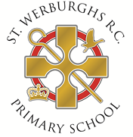

St Werburgh’s Catholic Primary School - Social Media Search

In line with Keeping Children Safe in Education, St Werburgh’s Catholic Primary School will undertake general online searches for all shortlisted candidates, this may include social media and video platforms such as Facebook, Twitter, Instagram, TikTok and YouTube Linkedin. Online searches will only examine data that is publicly available, and the aim is to identify any incidents or issues. Any areas of concern will be discussed during the interview process.
The information provided by you will be used for pre-employment recruitment monitoring and checks only and will supplement or form part of your application.
Name:
Position applied for:
School:
To enable the check to be undertaken it would assist if would detail your username for the relevant social media platforms below:
- TikTok
- Facebook,
- YouTube
- Instagram
- Twitter
- Linkedin
- SnapChat
Thank you for your cooperation.
Name:
Signed:
Date:

