POST: | Social Work Team Manager
LOCATION: | Agile Worker based across North East Lincolnshire
REPORTING TO: | Deputy Head of Service (Practice)
ACCOUNTABLE TO: | Head of Service (Practice)

KEY AREAS OF RESPONSIBILITY

- Responsible for the management of the day to day running of the operational social work functions (inc. SPA) within Focus.
- Instil a positive culture whilst providing inspirational leadership to the social work function and the wider organisation.
- Manage a small caseload of complex cases and lead of court work / cases for Focus, this will include preparation of reports and attending court as and when required.
- Deputise for the Deputy Head of Service, in a variety of situations, as appropriate.
- Act as the Lead for focus on specific areas of work, being actively involved in project groups and ensuring feedback is shared with Social Work Team Manager colleagues, the Deputy Head of Service and the wider organisation as appropriate.
- To work in conjunction with the Practice Development, Assurance and Education Team to ensure the Practice Framework and Quality Assurance Framework are embedded in the Social Work Teams.

PRINCIPAL DUTIES & REPONSIBILITES

Leadership

- Provide day to day leadership to a team of Social Work Practitioners, Social Work Co-ordinators, Single Point of Access staff and also to the wider organisation.
- Continually manage the performance of staff and undertake monitoring, improvement plans and formal capability processes as required; this could include attending and presenting at disciplinary hearings.
- Continually develop staff in line with the KSS and the Professional Capabilities Framework (PCF) for Social Work.
- To be involved in the recruitment of new staff; developing recruitment paperwork such as adverts as well as partaking in interviews, group discussions and skills tests.
- Plan, oversee and lead on onboarding of new staff, provide mentorship for students
- Allocation of work, management of resources and capacity planning across the teams.
- Authorise service requests from staff via the Adult Social Care database (SystmOne), holding Practice Surgeries, case discussions with staff and continually provide advice / guidance to staff on cases.
- Through strong leadership and good management practice, motivate staff to work in a responsive and effective way that demonstrates the values of social work and achieves the standards and performance measures set.
- Provide excellent social work supervision to direct reports, complying with the professional supervision framework across social care in Focus.
- Collect information about individual and team workloads to use to plan / prioritise work and resources effectively and efficiently across the service area.
- Set team performance objectives / targets
- Available to undertake On Call Rota system duties.

Peformance Management, Quality & Improvement
- Assist the Deputy Head of Service on performance standards / targets in matters relating to:
  - Key national and local performance indicators
  - Data quality issues
  - Adherence via supervision framework to workforce processes e.g. standards relating to onboarding, supervision etc.
  - Practice standards of the team and wider organisation
- Improving social work practice on the front line and supporting and advising on the quality of practice, which includes:-
  - The practice of others and monitoring / managing the performance of individuals
  - Providing supervision, coaching, mentoring and challenge to a wide range of practices at various levels within the organisation
  - Monitoring operational front-line practice within the team, providing observation and constructive feedback.
  - Observing and providing feedback to staff on their performance, practice and behaviours
  - Encouraging and supporting self-reflection / critical reflection within practitioner groups to develop and support a framework of self-management
  - Facilitating case study working groups / case discussion groups / peer support groups to encourage self-responsibility and increase competence and confidence of staff group
- Work to the Focus Quality Assurance Framework to ensure services are compliant; conduct regular audits and evaluations of social work programmes, processes and documentation, highlighting areas for improvement.
- Work closely with social work teams (inc. SPA), management and external stakeholders to foster a culture of continuous improvement and quality excellence.
- Investigate and formulate draft responses to formal and informal complaints received into the service.
- Keeping self and others up to date with best practice and excellence in practice, regulatory and legislative changes, contemporary models of delivery and changes in practice required to meet delivery demands.
- Contribute to the development and implementation of policies and procedures relevant to the service.

Partnership Working & Networking

- Work with external professionals and partner agencies to ensure consistency, ease of practice, best use of resources and the best outcomes for the individual.
- Proactively seek opportunities for self and team members to further develop and maintain strong multi-agency relationships.
- Represent Focus at local, regional and, where appropriate, national working groups, events, meetings and conferences which relate to role.
- Development and sustaining partnership arrangements with stakeholders within and outside of the organisation.

Note: No role profile can cover ever issue which may arise within the post at various times. The post holder is expected to carry out other duties from time to time with are broadly consistent with those described.

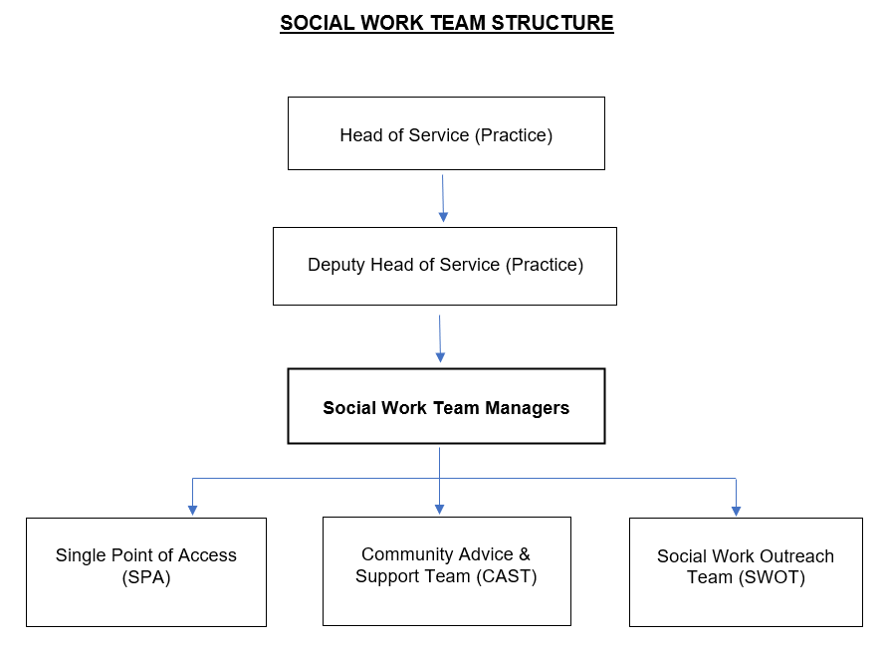

PERSON SPECIFICATION

Essential Qualifications

- Social Work Qualification (e.g. Dip.SW / Degree in Social Work)
- Current Registration with Social Work England
- Best Interest Assessor Qualification (or willingness to undertake within 12 months of commencement in post).
Essential Knowledge

- Knowledge of relevant Legislation, national guidance and local and regional good practice in relation to Adult Social Care, including Safeguarding knowledge and procedures
- Knowledge and experience of performance management and quality assurance frameworks and systems
- Knowledge of the Mental Capacity Act and the European Convention on Human Rights
- Knowledge of Safeguarding Adults procedures and the requirements of Section 42 of the Care Act and Chapter 14 of the Care and Support Guidance
- An understanding of CQC’s Inspection Framework for Adult Social Care Services
Essential Experience

- Case Management, including completion of statutory Adult Social Care Assessments
- Social Work Supervision
- Multi-Disciplinary Working
- Successful management experience of working in Adult Social Care
- Risk management and high level decision making
- Leading, motivating and managing teams successfully
- Demonstrable experience of working with people with lived experience
- Demonstrable experience of working collaboratively with a range of stakeholders & partners to achieve results and outcomes for adults

Essential Skills

- IT literacy, sufficient to work with systems, databases, spreadsheets and other Microsoft Office products competently and confidently
- Ability to manage the risk associated with case management and make sound professional decisions.
- Collaborative style
- Strong communication skills (written, oral & via electronic communication methods)
- Able to motivate, lead and develop staff
- Able to think strategically and analyse complex data
- Able to build effective relationships and partnerships (public, private and voluntary sector)
- Excellent communication skills; written, oral and via electronic communication methods
- Clear sighted and lateral thinker able to challenge constructively
- IT literacy, sufficient to work with systems, databases, spreadsheets and other MO products competently and confidently (and to use such systems to interrogate data for performance management and quality assurance purposes).

Essential Personal Attributes

- Personal and professional credibility and a high level of probity and integrity.
- Strong commitment to high performance (of self and others)
- Highly motivated and robust under pressure
- Degree of political awareness and sensitivity
- Willingness to work flexibly, which may be outside of ‘normal’ office hours according to the needs of the service
- Willing to work within a duty system which does cause frequent interruptions.

PERSONAL RESPONSIBILITIES

As well as the departmental rules and procedures, which you are required to observe and follow, focus has developed a number of general policies and procedures that apply to your employment.

Whilst focus recognises specific responsibilities fall upon management, it is also the duty of all employees to accept personal responsibility for the practical application of these policies, procedures and standards. You should familiarise yourself with these, and ensure that you understand and adhere to them.

Particular attention is drawn to:-

Health and Safety
Under the Health & Safety at Work Act 1974 it is the responsibility of individual employees at every level to take care of their own health and safety at work and that of others who may be affected by their acts at work. This includes co-operating with management in complying with health and safety obligations, particularly by reporting promptly any defects, risks or potential hazards.

Fire Procedure
The post holder must adhere to the focus Fire Policy, including training attendance.

Equal Opportunities
Focus has policies covering Equal Opportunities and Harassment. The aim is to ensure that no colleagues, potential employees, patients/clients are harassed, or receive less favourable treatment on the grounds of disability, age, sex, sexual orientation, marital status, race, colour, religion or ethnic/national origin.

Security and Confidentiality
The post holder must adhere to a range of policies, procedures and legislations relevant to security and confidentiality, these include:

- Data Protection Act 2018 and UK GDPR
- Copyright, Designs and Patents Act 1988
- Access to Health Records Act 1990
- Computer Misuse Act 1990
- BS7799 (Information Governance)
- Caldicott
- Document and Records Management
- Mental Health Act

Additionally, all staff are required to attend an annual briefing on Information Governance and Security.

You are required to keep all client information confidential unless disclosure is expressly authorised by your employer. Misuse of or a failure to properly safeguard confidential data will be regarded as a disciplinary offence.

This job description reflects the current main organisational priorities for the post. In the context of rapid change taking place within the Health /Social care, these priorities will develop and change in consultation with the postholder in line with service business needs and priorities.
Specific objectives for the postholder will be regularly agreed and reviewed as part of an individual performance process.

