










Cleaner

Candidate Pack

About the role

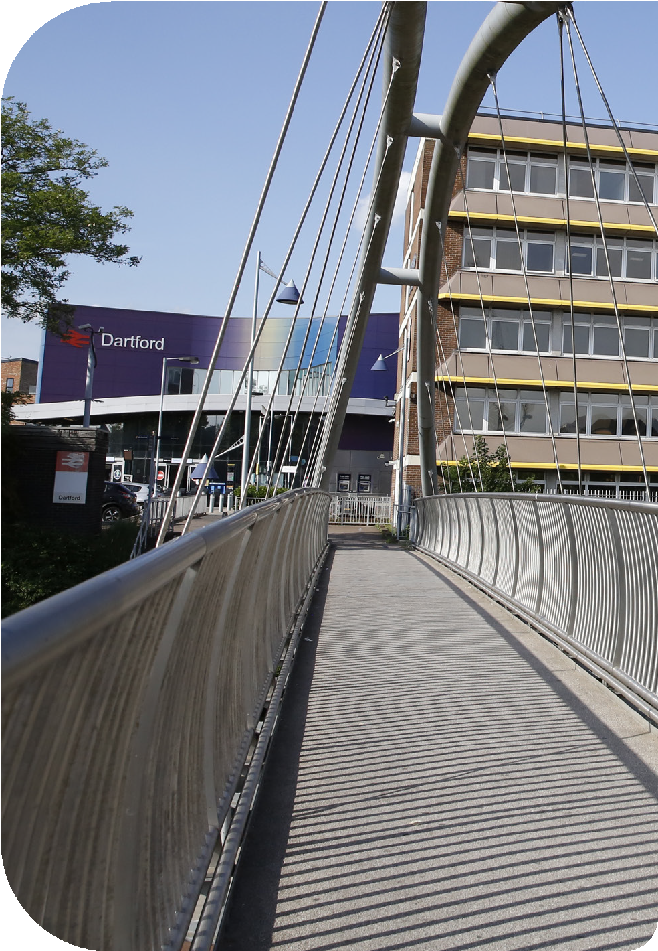

Cleaner
Directorate – Corporate Services Department – Human Resources Grade – Living Wage
Salary – £12.60 per hour
Hours - 11 hours and 15 minutes per week.
Monday – Thursday 17:30 - 19:45, Friday 17:00 – 19:15

About the role
Working as part of a small team you will be responsible for all cleaning of the Civic Centre. You will have the full support of a supervisor throughout your shift.

Skills, Knowledge and Experience:
- General office cleaning,
- Vacuuming and steam cleaning carpets,
- Polish all desks, tables and cupboards
- Empty rubbish bins,
- Clean staff kitchens and toilets, lobbies and stairwells,
- Regular deep cleans of all areas.

Full training is provided. A flexible approach to your work is essential.



Disability Confident Employer

DBC is Disability Confident Employer and welcomes applications from candidates with a disability.
We operate a Guaranteed Interview to any candidate with a disability who meets the minimum criteria for the role. If you have a disability and are applying for a particular role, please ensure that you
indicate this on your application form, and advise us of any reasonable adjustments which you may require.
A disability under the Equality Act 2010 is defined as a physical or mental impairment which has a substantial and long term adverse effect on your ability to carry out normal day to day activities.


Care Leavers
We will offer an interview to care leavers who meet the minimum criteria for the post. If you are a care leaver, you must inform us of your care leaver status at the time of your application.

Armed Forces

As part of the Council’s commitment to the Armed Forces Covenant and to ensure that ex-armed forces personnel are not disadvantaged as a result of their service, veterans of the armed forces and/or their spouses/civil partners, applying for a job at the Council will be guaranteed the offer of an interview, provided that:
- They or their spouse/civil partner are currently serving in the armed forces and are within 12 weeks of their discharge date
- They or their spouse/civil partner were in long-term employment with the armed forces within the last five years
- They meet the essential criteria for the advertised role
- They confirm that they wish any application for a post at the Council to be considered under the guaranteed interview scheme.


How to apply
Please apply via:
https://www.dartford.gov.uk/by-category/jobs-and-careers/job-va-cancies-at-the-council
Do not send your CV – only fully completed application forms via the link above will be accepted
We reserve the right to close this vacancy before the advertised closing date. Please apply early to avoid disappointment.


Shortlisted?
Shortlisting and selection will be based on the job profile and experience required. You will need to address these requirements in your application drawing on any experience you have gained at work or in a voluntary capacity. You should give examples of how you meet the criteria outlined in the job profile and the Council’s Core Behaviours. If you are unable to explain how you meet the requirements of the role, we may not be able to shortlist you.

Closing date:
23:59 4th May 2026

Interview date:
TBC

About the Council

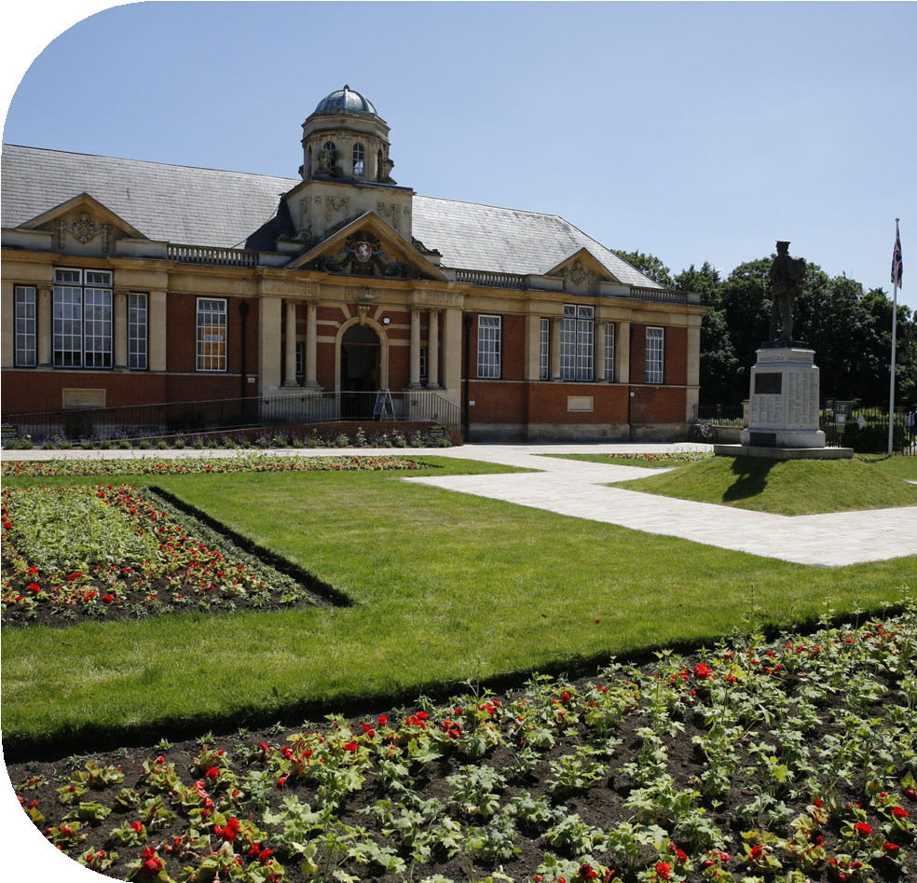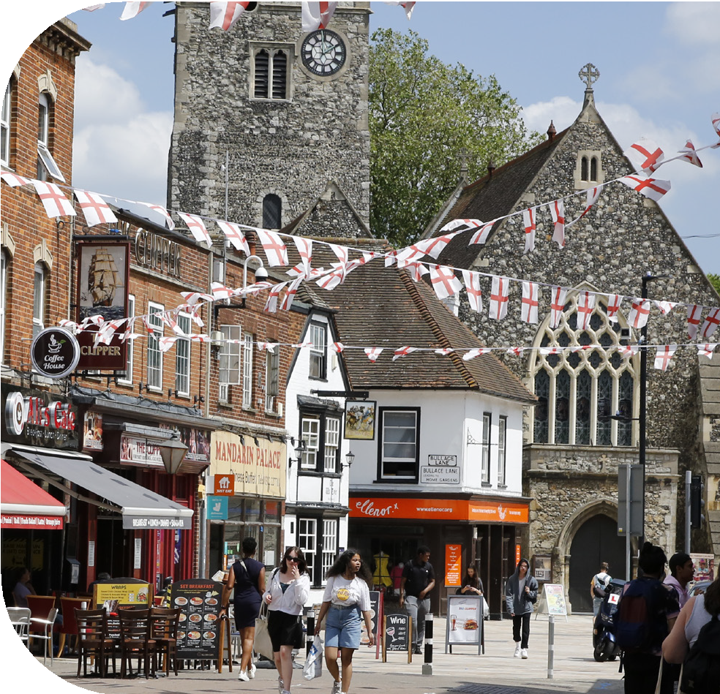

Why Dartford
‘Dartford is a place of quality, choice and safety. A place where great communities, concern for the environment and a successful economy support people who want to live, work and enjoy leisure time.’
Dartford Borough Council is one of the most exciting places to work in the region. Not only are we working on some special projects to improve life in the borough but we also have one of the most accessible offices in the country.

Our Commitment to Equality and Diversity
Dartford Borough Council is committed to equal opportunities policies and action to ensure that the best candidates for any post are appointed irrespective of age, disability, gender reassignment, marriage and civil partnership, pregnancy and maternity, race, religion and belief, sex and sexual orientation. We operate a name-blind recruitment process and remove candidates’ personal information to ensure that people will be shortlisted for interview on merit.
Our aim is to remove barriers to employment, promotion and development so that all employees have equal access to these on the basis of ability and the requirements of the job.
We are committed to challenging inequality, discrimination and disadvantage and to achieving the highest standard of employment practice. Equality of opportunity for all sections of the community and workforce is an integral part of this commitment, and we welcome applications from all sectors of the community.

The Council has signed up to the Disability Confident Scheme. Through Disability Confident, we are working to ensure that disabled people and those with long term health conditions have the opportunities to fulfil their potential and realise their aspirations. We are committed to interviewing all disabled candidates who meet the minimum criteria for the role.
In addition the Council will where possible make reasonable adjustments to ensure the interview process is accessible
to disabled candidates.

Getting to us
Civic Centre Home Gardens Dartford
Kent DA1 1DR

By car...
The Civic Centre can be accessed via A206 to the north, A282/M25/M20 to the east and the A2 to the south. The A226 Dartford Road links Bexley to Dartford Town Centre. The Council offers free car parking for staff.

By train...
Dartford Civic Centre is situated opposite Dartford station. Dartford is part of the TfL Oystercard area and there are regular and frequent services from Central London (Charing Cross, Victoria and London Bridge). In the opposite direction there are regular services to Gravesend and the Medway Towns with connections to Canterbury and the Kent Coast.

By bus...
Good bus services serve Dartford town centre, including TfL buses, and the Fastrack rapid transit system. Bus stops in Home Gardens, two minutes walk to the Civic Centre, are served by:
- TfL bus routes 96, 428 and 492
- Fastrack bus routes A, B & C
- Arriva Sapphire bus services routes 480 & 490 between Dartford Town Centre and Gravesend.

By bike...
Dartford Town Centre lies on strategic cycle routes. View the routes on the Explore Dartford Maps:
https://explorekent.org/wp-content/ uploads/2020/06/EK-DARTFORD_PRINT.pdf

Link to map and more info

Dartford Borough Council Civic Centre

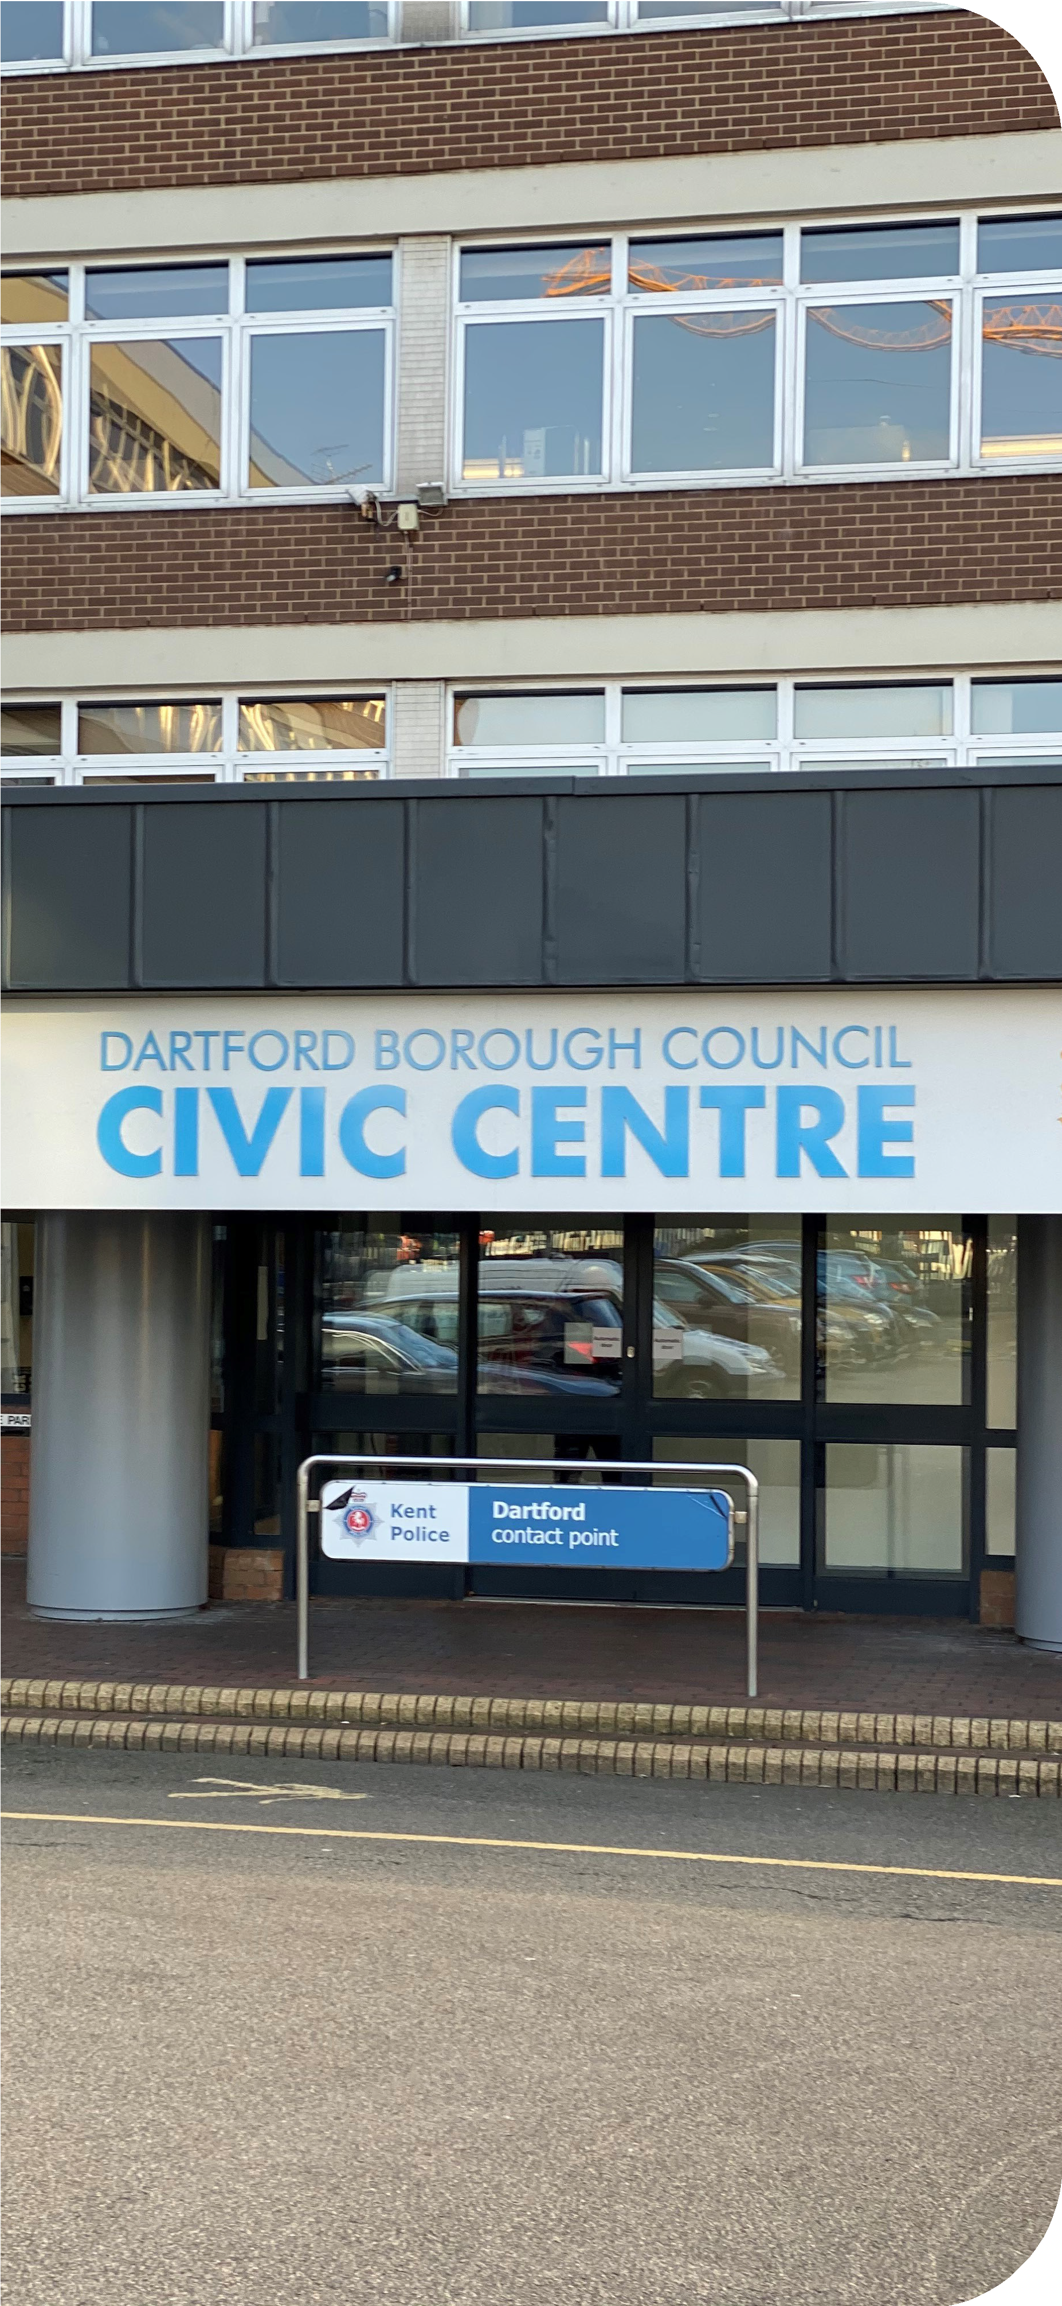

Values are a key component of a healthy workplace culture because they clarify how the Council and its staff should behave and help to ensure that everybody is working towards the same goals. They provide the framework within which employees can test decisions, accomplish tasks, and interact with others.
The Council’s core behaviours reflect the special qualities that attract, engage and retain the talent that we want; and will be used to shape our culture by influencing the work we do, and how we do it. These behaviours focus the way we expect employees to approach daily business practices, conduct communications and interact with one another.
The Council has five core behaviours that guide the way we think and act as an organisation, and each member of staff is responsible for incorporating them into their day to day roles.

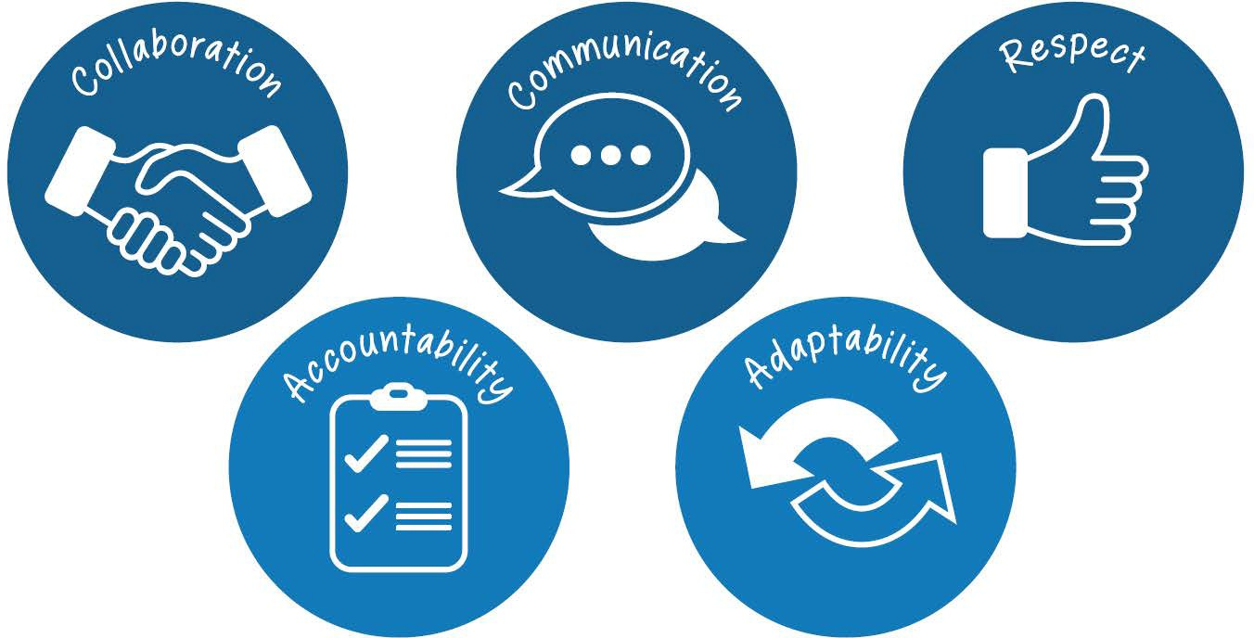

Communication
Demonstrated by:
- Actively listening to customers and colleagues and asking questions to provide clarity
- Seeking to understand customer and colleague needs and proactively looking for ways to exceed expectations
- Being clear, concise and courteous
- Providing regular and timely feedback
- Leaving a positive impression of the Council

Respect
Demonstrated by:
- Creating trusted relationships with customers, colleagues and communities to achieve mutual goals
- Treating customers and colleagues with respect and dignity and valuing others as individuals
- Learning from others and valuing differences
- Being thoughtful, tactful and considerate
- Acting with integrity, loyalty and trust

Accountability
Demonstrated by:
- Taking the initiative and ownership of our decision, actions, performance and behaviour
- Learning from our mistakes and seeking out opportunities to improve
- Delivering on promises to customers and colleagues
- Being proud of what we do

Adaptability/Flexibility
Demonstrated by:
- Displaying a ‘can do’ attitude and being innovative
- Embracing change
- Getting out of our comfort zones and creating our own opportunities
- Looking for the positive in every situation
- Challenging negativity and bad behaviour

Collaboration
Demonstrated by:
- Sharing ideas and challenges with our colleagues and actively seek out their opinion
- Working together beyond departmental boundaries to achieve superior results
- Ensuring everyone has an equal opportunity to share and contribute ideas
- Being part of the solution

Pension


We are part of the Local Government Pension Scheme (LGPS). There is a 50/50 section which enables a member to pay half rate contributions for half the benefits. The LGPS is a career averaged revalued
scheme (CARE), which means your benefits are based on your salary for each year you are in the scheme.
Your contribution rate, based on your salary, is 5.5%



Holiday Entitlement
You will be given a generous holiday entitlement of
162.8 hours (equivalent to 22 days) plus a further
37 hours (equivalent of 5 days) after 5 years of service and a bank holiday entitlement per annum.

These amounts are pro-rated for part-time hours.

Car Parking
Free car parking for work



Private Medical Insurance
Subsidised private medical insurance for employees on Grade H and above on application



Shared Cost AVC’s

LGPS members have access to our Shared Cost Additional Voluntary Contribution (Shared Cost AVC) scheme, which offers you a cost-efficient way to invest in your financial future.

Professional Membership Fees
The cost of one membership a year to a professional organisation that you require for your job



Car Loan
A loan to assist you with buying a car, subject to certain criteria being met



Season Ticket Loan
An interest free loan to assist with the purchase of a season ticket to travel to and from work




Cycle to Work

A salary sacrifice arrangement which allows employees to purchase a bicycle for travel to work. The scheme allows the cost to be spread over a monthly deductions and also reduces the employee’s tax and national insurance costs.



Hybrid Working
A Hybrid Working Policy which allows you to work part of your week remotely (depending on role and in agreement with your line manager)



Flexi-Time Working
A flexi-time working scheme (in agreement with your line manager)


Wellbeing
We have achieved the national Workplace Wellbeing Charter accreditation demonstrating our commitment to proactively championing a health workplace culture.



Employee Assistance Programme
Access to a free and confidential Employee Assistance Programme which offers support for a wide range of issues including telephone and face to face counselling


Occupational Healthcare
An occupational health service to support employees in the management of health issues.






Occupational Sickness Pay
Generous sick pay based on length of service







Flu Vaccinations
Free flu vaccinations on an annual basis



Eye Care
Assistance with the cost of an eye test and glasses or contact lenses for working with computer screens



Fairfield Leisure Centre Discount
20% discount on Premium Membership



Employee Benefits Portal
A host of benefits, deals and offers via our online benefits portal including, but not limited to, shopping, travel and activities



Family Friendly Policies
An enhanced package of Maternity, Adoption, Paternity, Parental, Shared Parental and Parental Bereavement Leave



Compassionate Leave
Up to 10 days paid leave following the death of a close relative


Cadet and Reserve Armed Forces Leave
Up to 10 days paid leave per year to take part in duties or training.



Public Duty Leave
Additional leave for members of certain public bodies to undertake duties

Job Profile
Job Title: Cleaner
Grade: Living Wage
Reporting to: Support Services Supervisor
Responsible for: N/A
Experience:
- Office environment cleaning
- Manual Handling
Specialist Knowledge:
- Health & Safety at Work Act 1974
- COSHH
Qualifications:
N/A
Special Circumstances:
N/A
Key activities:

To provide daily cleaning to all areas of the Civic Centre ensuring a clean and safe environment for all staff and visitors.

This, together with the competency levels is a description of the job as it is at present constituted. It is the practice of this Council to periodically review and update them to ensure that they relate to the job as then being performed, or to incorporate whatever changes are being proposed. You will be expected to participate fully in any discussions and,
in connection with them, to re-write your job profile to bring it up-to-date if this is considered necessary or desirable, and to discuss it with your immediate superior. It is the Council’s aim to reach agreement on reasonable changes, but if agreement is not possible the Council reserves the right to insist on changes to your job description after consultation with you. As a term of your employment you can be required to undertake such other duties commensurate with your grade, and/or hours of work, as may reasonably be required of you.
All aspects of the post are to be carried out in compliance with the Council’s overall Policies and Procedures, and all post holders will frequently have access to confidential information and will maintain such confidentiality as required by the Council.

2 DARTFORD
wellbeing BOROUGH COUNCIL
CHARTER

