

About Weaver Primary School

Weaver Primary School is a welcoming and inclusive school where children are encouraged to explore, learn, and achieve their full potential. We provide a nurturing environment and a broad education, ensuring that all pupils feel valued and supported.

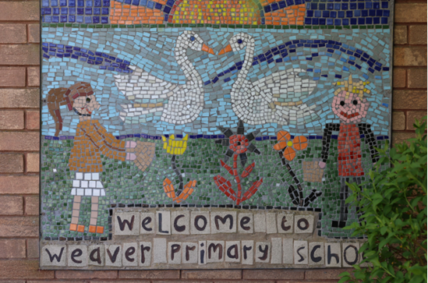
At Weaver Primary School, our mission is clear: to provide a well-rounded education that both challenges and supports every child within a safe and inclusive environment.
We place strong emphasis on self-respect and respect for others, alongside values such as honesty, cooperation, and friendship, which underpin daily school life.
We are committed to developing confident and independent learners, while celebrating both academic success and personal development. Our staff model high expectations in behaviour and learning, creating a culture where pupils show positive attitudes and build strong relationships. This leads to good outcomes for children across the school.

Weaver Primary School sits at the heart of the community. We work closely with parents, governors, and partners to create a supportive environment where everyone contributes to school life.
“Pupils’ personal development and preparations for life are strengths at Weaver”- OFSTED March 2023
Weaver Primary School is more than just a school; it is a place where children thrive, grow in confidence, and develop a love of learning. The friendships formed here are lasting, and many former pupils return to share their successes and inspire the next generation. With a strong sense of community, a clear focus on ambition and independence, and a commitment to celebrating the achievements of every child, Weaver Primary School is a truly rewarding place to learn and work. We look forward to welcoming a dedicated and enthusiastic teacher who will play a key role in our continued success.

