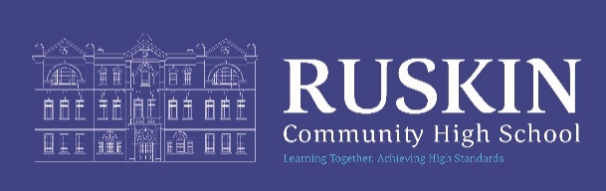

STUDENT RECEPTION - MATERNITY COVER

NJC Grade 3: FTE £24,796- £25,185 (this will be subject to pro rata)
(Actual pay £19,226 to £19,528)

Permanent/ Term Time only
33.25 hours per week, 39 weeks per year (8.15am to 3.30pm)

CLOSING DATE: MONDAY 4th MAY at 9.00am

The Governors of Ruskin Community High School are seeking to appoint a Student Services Officer for maternity cover until approximately March 2027, depending on colleague’s leave.

We are looking for a motivated and enthusiastic candidate to provide assistance and support for our students and also contribute to delivering effective administrative systems for the whole school. A positive team member with a ‘can do attitude’ who will also join in the wider school environment.

Please see the Job Description, Student Services Officer, for further information.

Your application can be completed electronically via the school’s recruitment software where you will be able to track your application.

To apply please follow the link to https://ruskin.face-ed.co.uk

For an application pack and further details of this position visit the School Website at www.ruskinhighschool.co.uk or email recruitment@ruskin.cheshire.sch.uk.

Alternatively, application forms must be returned for the attention of Miss H Goodwin, School Business Manager. It is acceptable to send applications via email to recruitment@ruskin.cheshire.sch.uk or by post to Ruskin Community High School, Ruskin Road, Crewe, CW2 7JT.

Please note – CVs will not be accepted.

Ruskin Community High School is an equal opportunities employer. Our school is committed to safeguarding and promoting the welfare of children and expects all staff to share this commitment. All posts are subject to enhanced DBS checks and references.

Telephone enquiries about the post will be welcomed if applicants require any further information at any time on 01270 560514.

We will always acknowledge receipt of applications but It will not be possible to inform candidates if they have not been shortlisted.

Please be advised that this post will be advertised on CEC Website, Jobs Go Public, Ruskin Website and internally.

