Establishing lifelong learning: rooted in knowledge, enriched by experience.

EXCELLENCE NURTURE EXPLORATION COMMUNITY
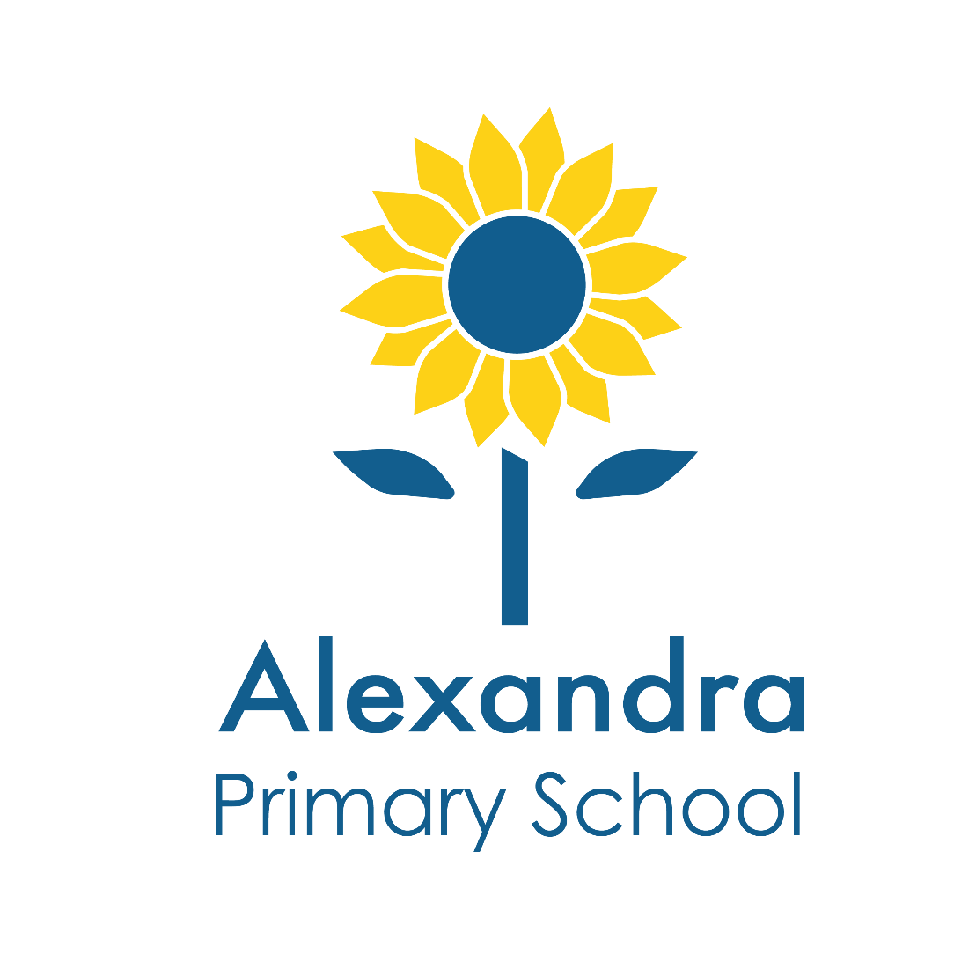

KS2 Class Teacher
Alexandra Road, Kingston Upon Thames, KT2 6SE
www.alexandra.kingston.sch.uk
Applicant Pack

“Together we nurture the genius in everyone”

Welcome from the Headteacher 3

Job Advertisement 4

Application Process 6

Job Description 8

Person Specification 10

Welcome

Dear Applicant,

Thank you for your interest in joining the team at Alexandra Primary School “Alexandra”. The school is a two-form entry primary, having grown from a three-form entry infant school. As part of our growth into a primary school, new KS2 accommodation was built including new classrooms, learning zone, art room, DT/ICT room, group space and a KS2 library. This accommodation was completed in September 2017.

Alexandra was rated outstanding by Ofsted in July 2023 and is an inclusive school with high expectations and aspirations for every pupil. We worked closely with pupils and parents to develop our school values and these shape our philosophy, practice, and the experience of our pupils. Our staff are committed to supporting and developing each pupil within our care. We provide a safe, stimulating environment for our learners and a broad and creative curriculum that provides opportunities for each child. Our curriculum places an emphasis upon experiential learning and includes forest school provision. We have a broad range of extra-curricular activities for our pupils and provide very well attended breakfast and after-school clubs.

A role at Alexandra will be a varied one as the school evolves and one that expands your professional horizons. We are looking for colleagues who share our passion, our ethos and expectations, who are positive and have the flexibility needed in a changing school. We want teachers who have integrity, who can motivate and inspire pupils and colleagues, who enjoy their work, and who enjoy working with equally committed and talented colleagues.

Please contact the school office on 020 8546 7176 to arrange a tour or an informal chat with our senior staff before the interview so that we can answer any questions that you may have. When you visit the school you will notice the calm, creative and positive learning environment where children are well behaved and keen to learn.

I hope that you are excited to find out more about our school and I look forward to receiving your application. The application closing date is Monday 11 May 2026 at 9:00am. We reserve the right to close this advert and vacancy early if we receive sufficient applications or a suitable candidate is found. Interviews will take place on Monday 18 May 2026.

Yours sincerely,

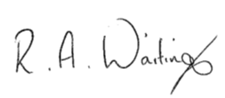

Robert Waiting
Headteacher

Job advertisement
Class Teacher

We are looking to appoint a full-time KS2 Class Teacher from September 2026.

ECTs are welcome to apply.

Contract: Permanent, full-time from 1 September 2026.

Salary: Main Pay Scale (Outer London), depending on experience.

We have an exciting opportunity for an enthusiastic and inspiring teacher to join our team. You will be a highly motivated individual who is committed to ensuring that every pupil in your class makes outstanding progress. Further details are in our Applicant Pack.

Alexandra Primary School is located close to Richmond Park and has a nurturing, welcoming and inclusive reputation.

We are looking for individuals who:
- Share our commitment to ensuring that every pupil makes outstanding progress;
- Will create an enticing and enabling learning environment;
- Are highly motivated and excellent classroom practitioners
- Have excellent communication skills and a ‘can do’ attitude;
- Are committed to developing children as independent learners and thinkers and embraces our growth mindset approach; and
- Are willing to contribute to whole school development.

We can offer you:
- An inclusive, thriving and welcoming school, rated Outstanding by Ofsted in July 2023;
- Enthusiastic and well-behaved children and engaged parents;
- Attractive, new and refurbished premises with excellent facilities;
- A positive and supportive working environment;

Read more about us at www.alexandra.kingston.sch.uk

Visits to the school are warmly encouraged. We will organise a tour on the interview day for candidates who have not been able to visit the school beforehand. Please contact the school office on 020 8546 7176 to arrange a tour or an informal chat with our senior staff before the interview day, so that we can answer any questions that you may have.

To apply: Please complete our application form and a supporting statement of no more than 2 sides of A4 stating how you meet the person specification, and email to
hr@alexandra.school
We regret that CVs will not be considered.

Closing date for applications: Monday 11 May 2026 at 9:00am. We reserve the right to close this advert and vacancy early if we receive sufficient applications or a suitable candidate is found.

Interviews: week commencing 18 May 2025.

Please note that we have very limited car park spaces and we are not able to offer on-site parking for staff except for exceptional circumstances.

Alexandra Primary School is committed to safeguarding and promoting the welfare of children and young people and expects all staff and volunteers to share this commitment.

An online search will be carried out on shortlisted candidates.

References will be sought for shortlisted candidates.

Shortlisted candidates will be asked to complete a criminal record self-declaration form, which must be returned to the school one working day before the interview at the latest. If we do not receive your completed declaration form, we reserve the right to withdraw the offer of interview.

All posts are subject to pre-employment checks, references will be sought and must be deemed satisfactory by the school, and successful candidates will need to undertake an enhanced DBS check. Candidates must have the right to work in the UK.

Application Process

Application form
Please review the Person Specification for the post and ensure that your supporting statement reflects on how you meet these requirements. You should complete our application form with a supporting statement and email to hr@alexandra.school

We regret that we cannot accept applications that are not made on the official application form. Please make sure that you complete your contact details, including email address, and the names and contact details of two referees.

School visits
We will include a tour of the school on the interview day for those candidates who have been unable to visit the school.

Closing date
The closing date for receipt of applications is Monday 11 May 2026 at 9:00am. We reserve the right to close this advert early if we receive sufficient applications or a suitable candidate is found.

Please follow the instructions on the advertisement and email your application and supporting statement to hr@alexandra.school

Shortlisting
We will assess all applications against the Person Specification criteria using the evidence you provide in your application. We will carefully check all applications for anomalies and any gaps in your employment history. Candidates who best meet the Person Specification will be invited to an interview via email.

References
We request two references for all candidates and will contact your referees if you are shortlisted. One referee should be your current or last employer.

Interviews
The interview process will take place on Monday 18 May 2026. Please provide photographic proof of identity, your right to work in the UK and proof of your qualifications with you.

Offer of Employment
We will make a verbal offer of employment by telephone followed by an offer letter in writing. Any offer is made subject to receiving references deemed satisfactory by the school, satisfactory DBS clearance and medical clearance. Each shortlisted candidate will be notified of the outcome of the interview process and telephoned with a brief feed-back.

Data Protection Act 2018
The information you have provided will be stored on the school’s secure database and will only be used to process your application. It will not be passed to any other organisation.

Safer Recruitment
We are committed to safeguarding and promoting the welfare of children and young people and expect all staff and volunteers to share this commitment. We will ensure that all our recruitment and selection practices reflect this commitment. An online search will be carried out for shortlisted candidates. References will be sought for shortlisted candidates.

The successful candidate will be subject to Disclosure and Barring Service checks along with other relevant employment checks. Satisfactory references are references that are deemed satisfactory by the school.

Job Description

Class Teacher
Scale: | MPS
Responsible to: | Headteacher and Senior Leadership Team
Important Internal Relationships: | Teaching and support staff, pupils
Important External Relationships: | Parents and carers, governors, outside agencies, visitors

MAIN PURPOSE OF JOB

All teachers at Alexandra Primary School will ensure the highest possible standards of pupil achievement, personal development and well-being, while bringing life to the school values by:

- developing and maintaining constructive relationships with parents and carers as their children’s first and most enduring educators;
- holding high expectations of all pupils and promoting the development of a growth mindset and positive attitudes to learning;
- collaborating with colleagues as part of a vibrant learning community focused on excellence;
- ensuring maximum inclusion of children who would otherwise face barriers to being fully part of the school, ensuring that specific support and agreed strategies are provided for targeted pupils, and liaising closely with the Inclusion Leader;
- providing daily learning opportunities that are enticing, engaging, relevant and challenging to create a rich and irresistible curriculum;
- making skilful use of formative assessment to fine-tune teaching and feedback.

MAIN RESPONSIBILITIES

The postholder will comply fully with the responsibilities set out in the Teaching Standards.

A teacher is responsible to the Headteacher for ensuring that the progress made by pupils within their class is good or outstanding by:

- working with colleagues to develop a curriculum, schemes of work and appropriate resources that will inspire and stretch all pupils;
- ensuring that all lessons are planned to meet the needs of different pupils within the class;
- ensuring that the internal and external learning environments are stimulating and both celebrate and support the work of pupils;
- ensuring effective behaviour for learning within the class consistent with school policy;
- embedding accelerated learning approaches to enhance progress;
- developing and sustaining a positive partnership with parents in person and via email and phone;
- providing information to parents about the learning and activities of the class and reporting to parents / carers about pupil progress through such methods as directed by the Headteacher;
- ensuring that feedback to pupils enables them to understand their targets and next steps;
- monitoring on a half-termly basis the progress and attainment of all pupils within the class and discussing data and trends with colleagues to review provision to ensure outstanding progress;
- taking appropriate action if pupils within the class are doing less well than they should and measuring and evaluating the impact of these interventions;
- ensuring that their personal conduct sets the highest standards and to act as a role model for their pupils; and
- contributing positively to the year group team and wider staff / school.

SUBJECT LEADER RESPONSIBILITIES

If the postholder is also appointed to being a subject leader they will be responsible for:
- keeping up to date with national and local policy, expectations and resources for their subject area;
- quality assuring the curriculum, schemes of work and resources for each year group to ensure that it reflects national requirements, best practice and the needs of pupils at Alexandra Primary School;
- maintaining the resources for the subject;
- providing training to staff in all year groups to ensure they have the skills and knowledge to maximise pupil progress in the subject;
- monitoring curriculum delivery and pupil data to ensure that pupils are making good or outstanding progress in the subject;
- developing support and intervention strategies where data indicates that pupils are performing less well than they should; and
- analysing performance data to review the curriculum and practice and then implement or recommend changes as appropriate to improve pupil progress and attainment.

Person Specification

CLASS TEACHER

 | Essential | Desirable
Qualifications | - QTS and a degree.  - Clear understanding of own professional development needs and a commitment to addressing these. | - Further relevant professional studies
Teaching Experience | - Successful teaching experience in KS1/KS2. | - Experience of working with children with a wide variety of learning needs including pupils with special educational needs, pupils with English as an additional language and children from challenging or disadvantaged home circumstances.
Professional skills and capabilities | - Passion for teaching and the ability to inspire and enthuse pupils and colleagues.  - Proven ability in achieving expected or better than expected rates of progress and high achievement.  - Evidence of consistent use of assessment for learning techniques.  - Evidence of personalised learning and the use of data to monitor and raise achievement.  - Excellent working knowledge of the KS1/KS2 curriculum and the expectation of standards.  - Effective planning and assessment.  - Drive and desire to lead the development of a subject across the school.  - Ability to motivate and manage pupils effectively.  - Ability to communicate effectively and sensitively with a wide variety of people, including children, staff, parents / carers and the governing body.  - Strong ICT competence and the ability to use ICT to enhance learning.  - Evidence of flexible ‘can do’ attitude, strong self-motivation, good organisation skills and of being an effective team player.
Interpersonal skills | - Excellent interpersonal skills  - Excellent communication skills, both written and oral.
Commitments | - Commitment to the safeguarding and well-being of all pupils.  - Commitment to and enthusiasm for the school’s educational vision, inclusive nature and belief in the value of parental engagement.  - Commitment to achieving high standards of progress and achievement by challenging all pupils.  - Willingness to contribute to the wider life of the school.

Selection for an interview will be based on the criteria outlined in this form. At each stage of the process an assessment will be made by the appointment panel to determine how far the criteria have been met. Candidates, who do not meet criteria marked Essential, will not be considered.
When completing your statement of application you should ensure that you provide supporting evidence of how you meet the criteria through reference to recent work or other relevant experience.
Criteria will be further tested later in the process through interviews and other methods such as observing teaching.

