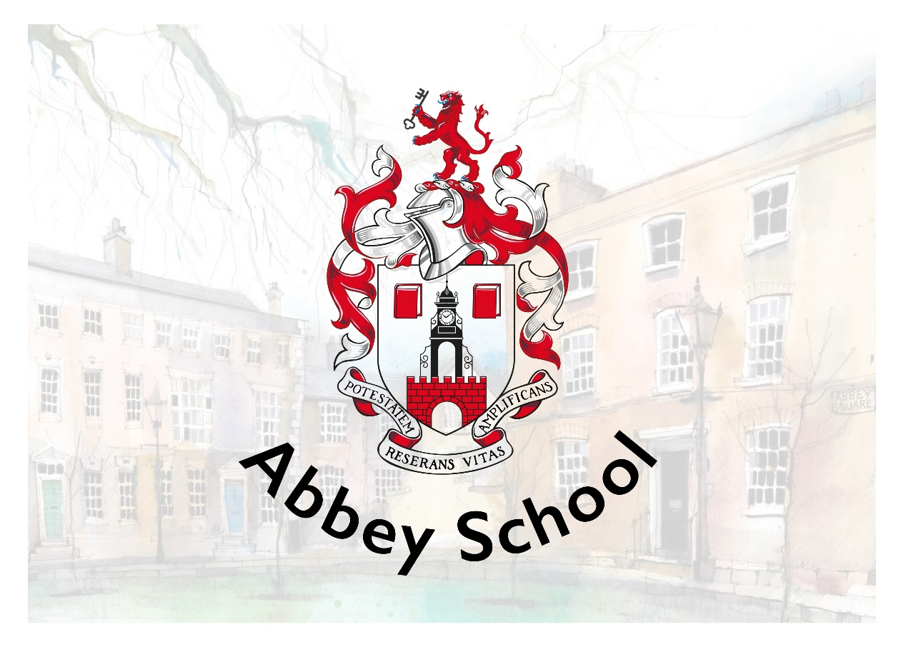

RECRUITMENT PACK
School Cleaner

Abbey School
10-12 Abbey Square
Chester, CH1 2HU
recruitment@abbeyschool.com
01244 960000

CONTENTS

Welcome from the Principal 3
About our School 4
Job Description and Person Specification 6
Benefits 9
How to Apply 10
Shortlisting and Interviews 10
Start Date 10
Safeguarding Statement 11
Equal Opportunities Statement 11
Working in Chester 12

Welcome from the Principal

Welcome and thank you for your interest in Abbey School.
Our Independent Special School provides a unique environment of high-quality, evidence-informed education, nurture and care to young people aged 4-19 with autism whom may have additional learning difficulties and behaviours that challenge. We offer a comprehensive programme of support which ensures that all of our pupils’ individual needs are met through highly personalised learning.
We are privileged to benefit from a truly wonderful location. Our school is housed in stunning Grade II* listed buildings, part of historic Abbey Square in the heart of the beautiful city of Chester. Our fantastic team of architects have designed a well-equipped and high-tech learning environment for us, whilst maintaining the beauty of the buildings and surroundings for our pupils to enjoy. We make full use of our environment and location with a creatively designed curriculum that includes focused learning and enrichment activities that support wellbeing. This enables all of our young people to experience growth, development and success.
Our highly skilled and specialist staff team includes teachers, learning and behaviour specialists, speech and language therapists and occupational therapists. This trans-disciplinary focus ensures that each pupil’s individual needs are understood, accurately planned for and closely monitored as part of day-to-day school practice.
I am extremely proud to be the Principal of Abbey School, a place where pupil-centred practice is the norm and where the voice of the young people we support and their families is central to all that we do. It really is a very special place to work and learn.
Yours sincerely
Dr. Katy Lee

About our School
Abbey School is an Independent Special School for people aged 4-19 with autism whom may have additional learning difficulties and behaviours that challenge. We provide high-quality education and care in our beautiful Grade II* listed buildings in the heart of Chester. All young people attending Abbey School have an Education, Health and Care Plan (EHCP) with school places commissioned and funded via local authorities. We work in close partnership with families and carers with support, information sharing and workshop opportunities available throughout the academic year.
Abbey School is aspirational for all of the young people that we support. This aspiration is captured in our vision, mission and values which are central to all that we do at Abbey School.
Vision
Our vision is that all children with exceptional needs receive a meaningful and fulfilling education that enables them to make their own choices about the direction of their adult lives.

Mission
Abbey School exists to provide the best education possible for young people with exceptional needs.
- Every pupil is a unique individual with potential
- Special educational needs and/or disability should not be a barrier to a valued lifestyle
- All children and young people without exception are entitled to access the best education and support available
- Best practices in education are evidence-based
- Teaching and learning decisions should be evidence-driven
- Clear goals make data-based decisions more numerous and effective
- Education is for everyone and for the whole of a person’s life
- Learning is enabling, empowering and extends the boundaries of autonomy
- If a pupil is not learning, it is the teaching that needs to change – the learner is always right
- Pupil voice should be heard and respected

Values
Our whole school approach brings together everything that is known from special education research and best practice to maximise pupil learning and wellbeing. We are an innovative learning organisation. Our day-to-day working practices routinely inform

research, evaluation and development. We have a bespoke curriculum, designed by us, specifically to meet the needs of our pupils.

Each pupil’s journey through the curriculum is personalised. Approaches to teaching and learning are individualised, goal-based and precisely assessed. The curriculum is delivered by transdisciplinary teams who benefit from a high level and intensive internal training programme.

Our unique APPs support staff in planning and monitoring each pupil’s learning journey on a moment-to-moment basis. We are centrally located in the heart of the city which provides many opportunities for community-based learning, live skills development and supported work placements as young people get older.

Every decision we make is framed in the context of the Abbey School BAGS model:
B – Belonging and connection – being part of a community and having a network of valued relationships.
A – Autonomy and control – having influence over day-to-day and life defining matters.
G – Gifts and talents – doing even better the things that are done really well, and learning to do things that are important but may not be done at all.
S – Speaking, listening and a sense of self – communicating effectively in a variety of ways not just speech, and having an identity that defines who I really want to be.

Job Description and Person Specification
Job Title | School Cleaner | Employer | Abbey School
Salary range | £12.71 per hour | Reporting to | Premises Manager
Working hours | 2 hours per day, Monday to Friday, term-time only  We have morning hours available 7am – 9am, and afternoon hours available – working 2 hours between 4pm – 7pm  With opportunity for additional hours during the main school holidays | Annual leave entitlement | 20 days plus bank holidays (rising to 25 days after 5 years continuous service) which is taken during school closure periods
Role Purpose
To be responsible to the Premises Manager for the cleanliness of the premises during the school day to enable the smooth running of the school day and to ensure a clean and safe environment for all staff and pupils.
Responsibilities and Role
Cleaning duties
- Cleaning all areas of the school site under direction of the Premises Manager such as sweeping, mopping, dusting and vacuuming
- Take initiative to perform cleaning tasks that require attention as part of maintaining overall high standards
- Regular cleaning and sanitizing of toilets, staff room, staff kitchens, and the hygiene and medical rooms
- Report low stock of cleaning supplies to the Premises Manager
- Replenish soap, paper towels and toilet paper across the site
- Spot clean spillages
- Empty bins and replace liners
- Cleaning, sweeping and tidying outside areas to ensure hazards are dealt with swiftly as directed by class teams or Premises Manager
- Regular daily cleaning of high touch points and surfaces
- Ensure Health & Safety, quality and general procedure compliance
- Supporting school laundry duties
- Report any Health & Safety issues to the Premises Manager
- General cleaning and maintenance at the reasonable request of the Premises Manager or Senior Leadership Team

Common Accountabilities and Dimensions within all Roles
- Demonstrate the vision and values of Abbey School in everyday practice, upholding the school’s ethos at all times.
- Be responsible for ensuring that your own practice is consistent with Abbey School policies and procedures
- Report all maintenance issues and hazards, including accidents and near-misses according to school procedures
- Be responsible for your own effective professional communication, orally and in writing, to the right people at the right time.
- Give full co-operation to colleagues requiring assistance in a prompt, caring and helpful manner
- Ensuring that your own responsibilities and accountabilities are clearly defined and understood and for managing your work and working proactively with your manager to that end.
- Attend training courses as required by the School
- Actively contribute to the culture of Abbey School as a learning organisation
- Uphold Abbey School policies to protect and safeguard pupils and adults at risk in order to secure their health, safety and wellbeing.
- Ensuring that personal use of resources is efficient and effective and actively upholds Abbey School’s policies.
- Assume personal responsibility for implementing the school’s policy on Equal Opportunities and inclusion for all staff and pupils.
- Support the Senior Leadership Team in managing and organising the school efficiently and effectively to ensure it meets the needs of all site users, including pupils, staff, parents and visitors and supports effective teaching, learning and support.
- Undertake any task in line with requirements of the role under the direction of the Senior Leadership Team
- This role is subject to an enhanced DBS check.

Person Specification

Criteria | Essential | Desirable
Qualifications & Training | - Understanding of CoSHH and Health & Safety  - Knowledge of cleaning best practices | - Food Hygiene Certificate
Experience | - Cleaning in a busy environment  - Disposing of waste  - Replenishing stock  - Team working | - Cleaning role in a school or similar environment
Skills & Knowledge | - Strong attention to detail and time management skills  - Ability to respond well to urgent situations in a fast-paced busy school  - Flexible attitude to work and adaptable to the needs of the school  - Able to follow verbal and written instructions
Personal  Qualities | - Demonstrates a personal commitment to safeguarding and promoting the welfare of children and young people  - A good level of fitness to meet the physical demands of the role  - Punctual and reliable  - Able to work both alone and in a team  - Professional attitude to work and with colleagues  - Willingness to take personal responsibility for standard of work carried out  - Willingness to maintain confidentiality on all school matters

Benefits
- Competitive salary
- Suite of staff benefits including pension scheme
- Technology appropriate for your job
- Comprehensive staff training programme
- Access to WeCare which is a 24/7 online GP, mental health support service, get fit programme and much more.
- Access to MediCash program for wellbeing benefits
- Refer-a-friend bonus scheme
- The opportunity to shape and improve the life chances of pupils with a disability, and in so doing, extend the prospect of an improved quality of life for family members and others

How to Apply
If you feel like you have the right qualities to join our exciting, innovative and exceptional school then please complete the school application form with a letter addressed to the Premises Manager, Mr Lee. Please ensure that you provide details of your skills and experience necessary for this position in your letter or personal statement. Application forms and letters can be emailed to recruitment@abbeyschool.com or sent by post to Abbey School, 12 Abbey Square, Chester, CH1 2HU.

Deadline
Please complete an application form at your earliest convenience. Applications are constantly assessed and early application encouraged.

Shortlisting and Interviews
Selection methods will be objective, promote equality of opportunity and guard against bias in line with the Equality and Diversity policy. The School will shortlist applicants based on the relevance and applicability of their professional attributes and personal qualities specified by the role. Essential and desirable qualities are published in the Person Specification for this role.
The School will complete an online search for all shortlisted candidates. If any incidents or issues have happened that are publicly available online, the school may wish to explore this at interview.
The interview will consist of a formal panel interview.

Start Date
As soon as possible.

Safeguarding Statement
The School will complete an online search for all shortlisted candidates. If any incidents or issues have happened that are publicly available online, the school may wish to explore this at interview.

Abbey School is committed to safeguarding and promoting the welfare and safety of all pupils and expects all staff and volunteers to share this commitment.

Child safer recruitment procedures operate and the post is subject to references and an Enhanced DBS disclosure with barred list checks.

The post is exempt from the Rehabilitation of Offenders Act 1974 and the School is therefore permitted to ask job applicants to declare all convictions and cautions (including those which are ‘spent’ unless ‘protected’ under the DBS filtering rules) in order to assess their suitability to work with children.

We are an equal opportunities employer and welcome applications from all suitably qualified persons regardless of their age, disability, gender reassignment, race, sex, pregnancy and maternity, marriage/civil partnerships, religion/belief, or sexual orientation.

Equal Opportunities Statement
We are an equal opportunities employer and welcome applications from all suitably qualified persons regardless of their age, disability, gender reassignment, race, sex, pregnancy and maternity, marriage/civil partnerships, religion/belief, or sexual orientation.

Working in Chester
Abbey School is situated in the beautiful surroundings of Abbey Square, located in the heart of historic Chester.
Chester has often been ranked as one of the best places to live in the UK with many good schools, thriving suburbs, a vibrant independent restaurant scene and new, award-winning cultural centre Storyhouse. It has good rail and motorway connections to major cities and the coast.
Chester is suitable for families and singles or couples with a good choice of city-centre accommodation and villages or suburbs within close commuting distance. To find an Estate Agent for sales or lettings in Chester visit Best Estate Agent Guide.
For further information about living in Chester, please visit the Tourist Information website .
How to Find Us
We are located in Abbey Square next to Chester Cathedral, off Northgate Street.
By Public Transport
We promote sustainable travel and recommend that public transport is used where possible. Chester train station is a 5-10 minute walk away and is served by the following rail companies Merseyrail, Avanti West Coast, Transport for Wales and Northern Rail. For Park and Ride information visit the Cheshire West and Chester council information page.
Parking
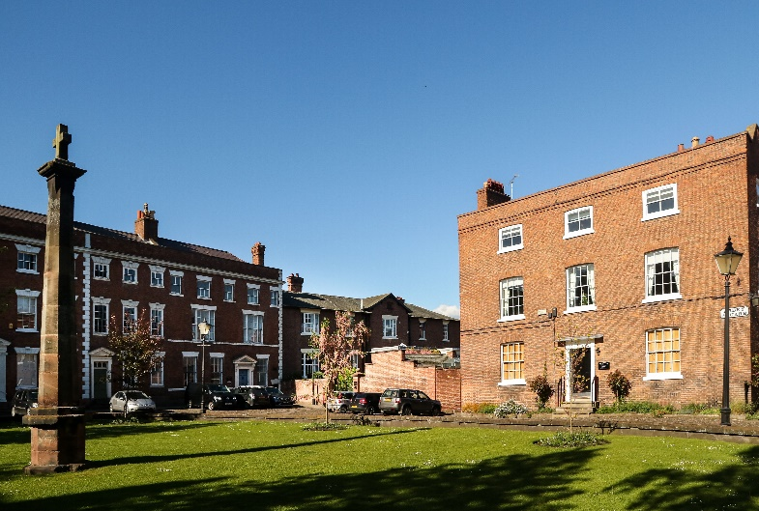
Visit the tourist information site for details of city centre car parks.

