Person Specification for:
Class teacher Post
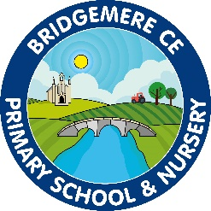
Essential | Desirable
Qualified Teacher Status | Experience of mixed age classes and of working in a small school
Proven ability as an excellent  classroom teacher | Proven experience/ examples of leading innovative work in a school
Knowledge of inclusion and strategies for  engaging all learners | Proven record of effective  subject leadership
Ability to work closely as a member of a team | Ability to plan a varied, experience led curriculum linking to class needs and interest
A thorough knowledge of the National Curriculum | Open minded, self-evaluative and adaptable to changing circumstances and new ideas
A commitment to continuing professional development | Able to enthuse and reflect upon own experience
Ability to make use of appropriate data to analyse the performance of pupils and set targets | Willingness to be involved in the wider life of the school
Understanding of assessment for learning and its use to raise standards | An enthusiasm to enrich the curriculum through out of hours learning and educational visits
Knowledge and experience of applying technology across the curriculum | Uses the learning environment to support high  standards
Excellent organisational and interpersonal skills

Use of positive behaviour management skills

Clear understanding of how children learn and awareness of effective teaching strategies for personalised learning

Understanding of current safeguarding legislation and
a commitment to implementing procedures in school
When all the above fail, to maintain a good sense of humour, a willingness
to learn and the will to continue to strive for excellence

