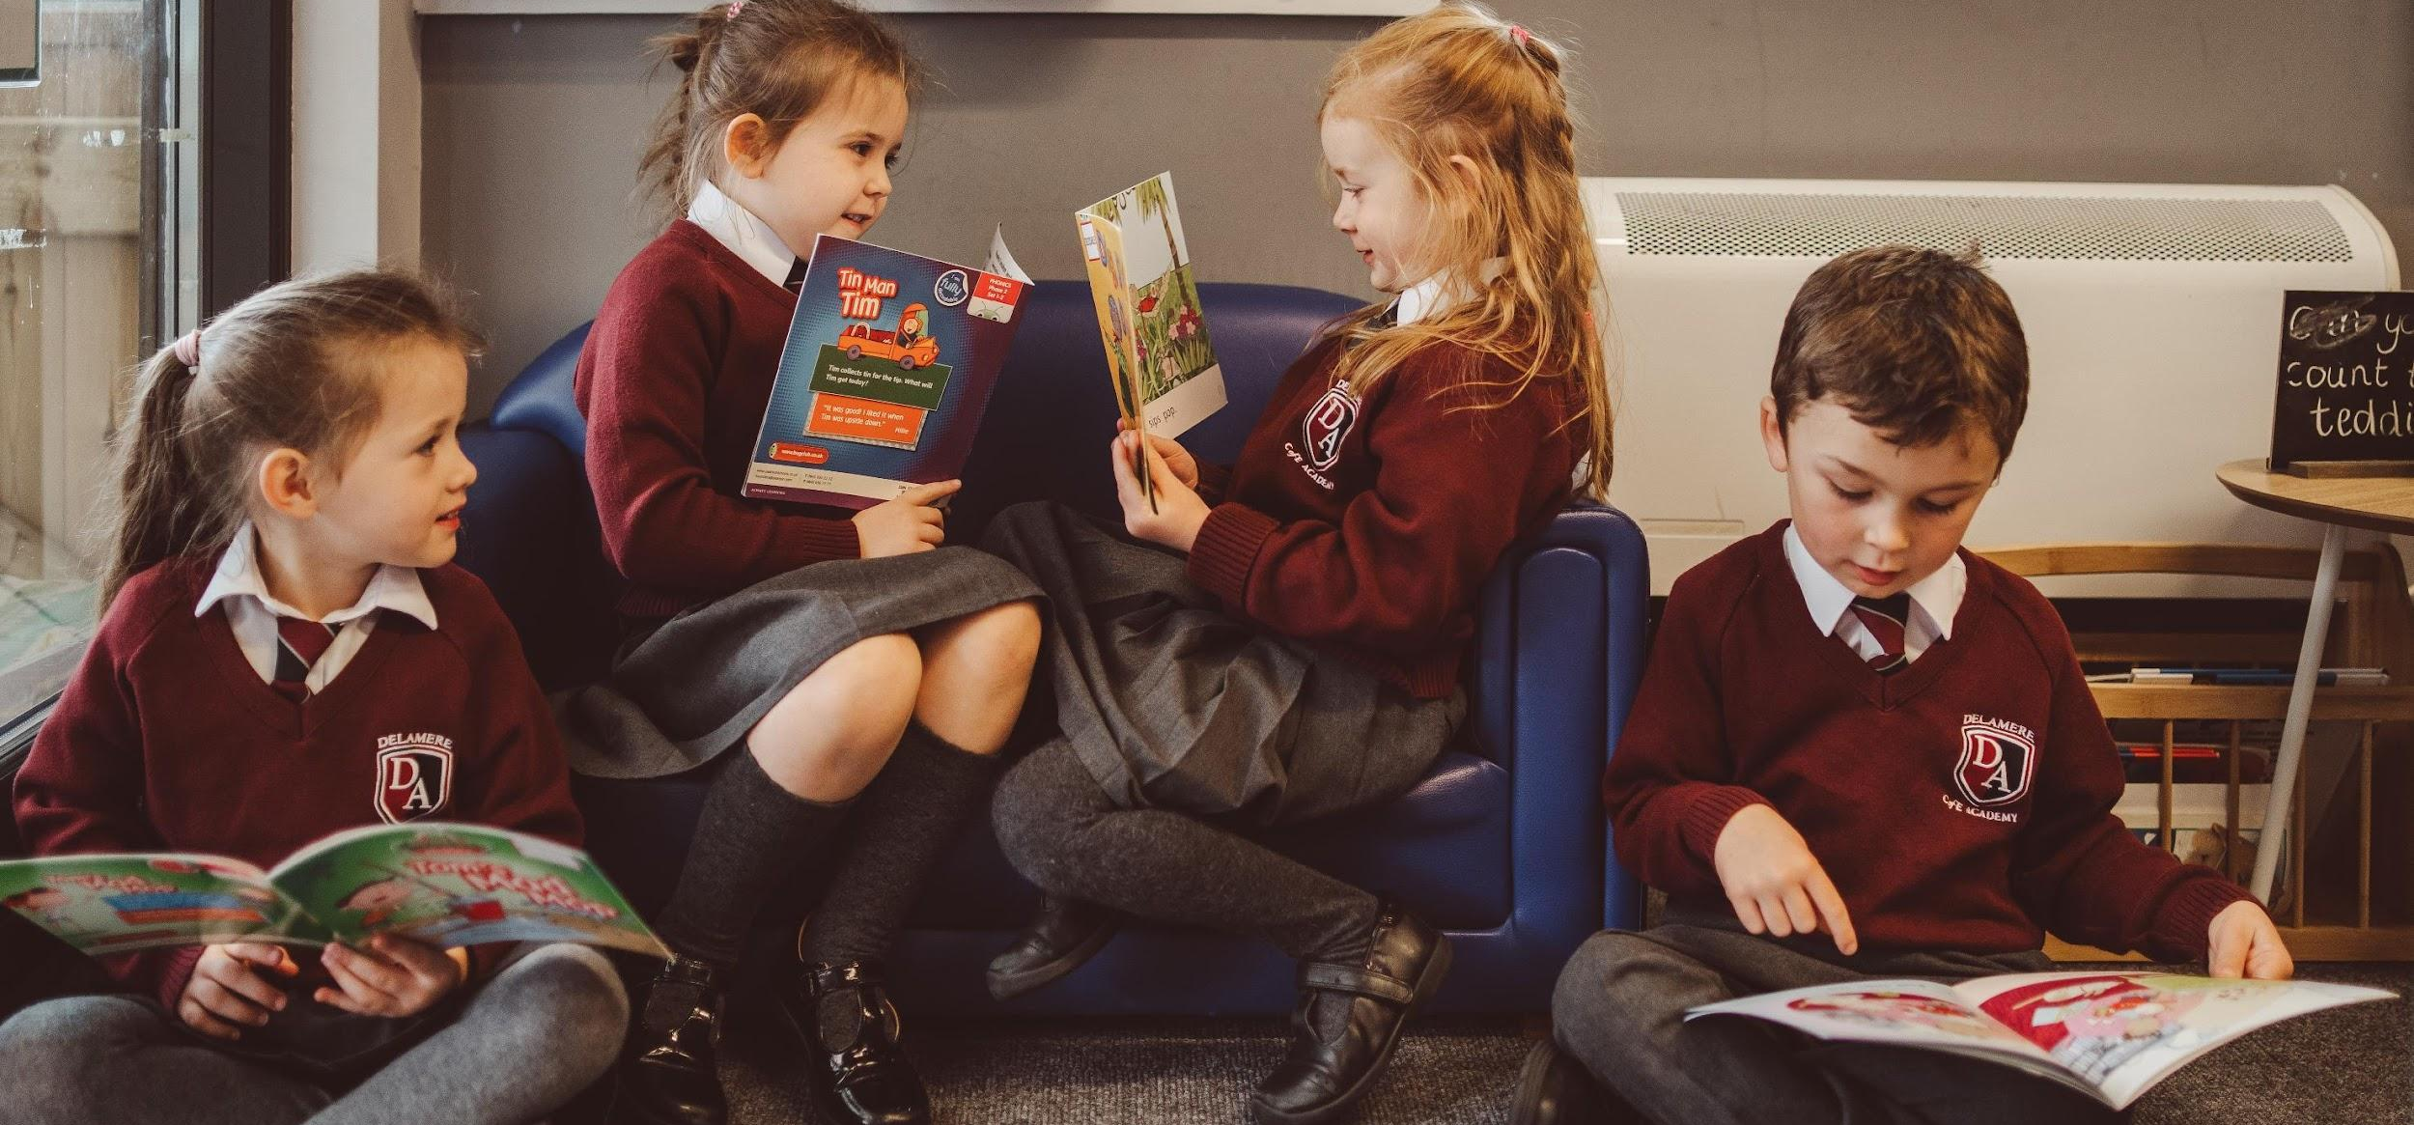


Learning Support Assistant – September 2026
32.5 Hours (5 days per week - term time only)
Competitive rates of Pay
“Helping Children Fly”


Head of School: Julie Clayton Delamere C of E Academy
Stoney Lane, Kelsall, Tarporley, CW6 0ST.
Tel: 01829 707979
admin@delamereacademy.org.uk

Key Dates

Closing date and shortlisting: 9am, 18th June 2026

Lesson observations and interviews: Tue 23rd June 2026

If you wish to visit Delamere CE Primary Academy, please contact the school office on 01829 707 979 to arrange a show around.
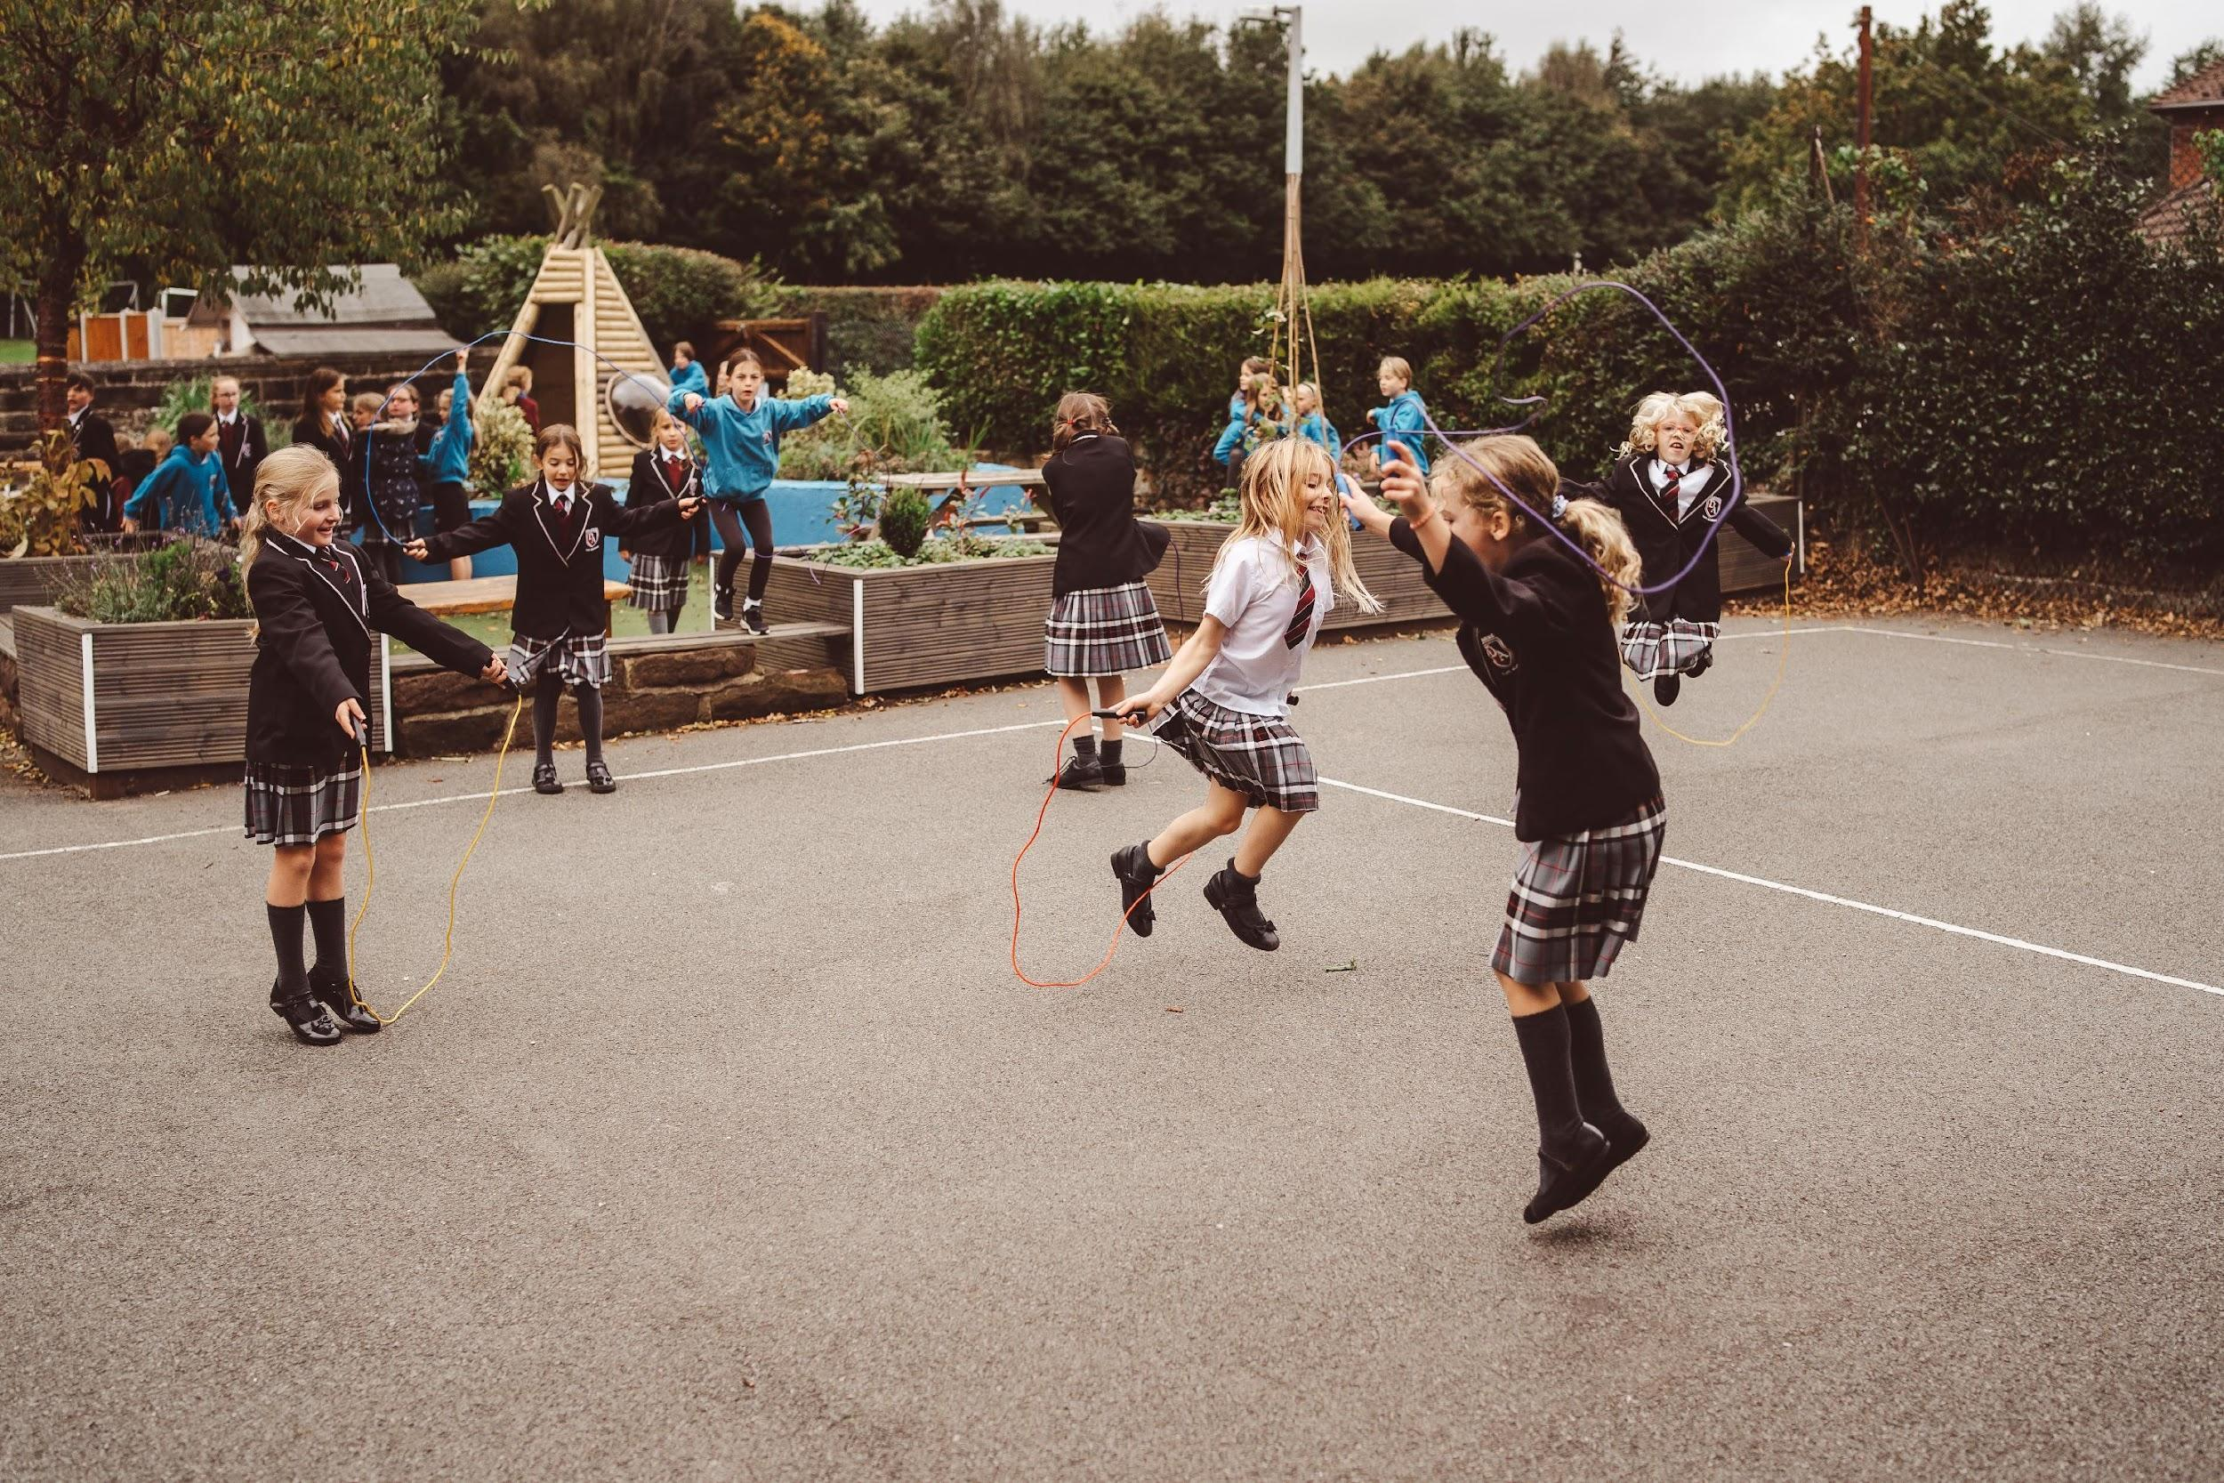


About Delamere Academy

At Delamere C of E Primary Academy, we are proud to deliver a rich and creative learning experience that enables all the children to fulfil their potential. Our vision puts children first. As a Christian School, we aim for all children to be successful, independent learners and effective decision makers. We value the individual and are committed to an inclusive education promoting respect for all, working in partnership with governors, parents and the local community.

"Beyond outstanding, helping children to fly."

Julie Clayton, Head of School


About North West Academies Trust
NWAT believes that an aspirational and inspirational education is the right of every child.


Our success is driven by a commitment to relentlessly work to improve standards and outcomes for our pupils. As specialists in providing high-quality education, we are passionate about supporting schools within their communities and helping to ensure outstanding learning opportunities for every child. The ten schools in our trust provide high-quality teaching and strong leadership in a creative, supportive and aspirational
environment. We focus on driving up standards and have the necessary experience of improving standards in education to provide the right learning environment for all children and young adults to achieve their full potential. We are an organisation built on strong foundations, enabling us to expand and welcome new schools with ease, whilst retaining focus on our core commitment to excellence in education.

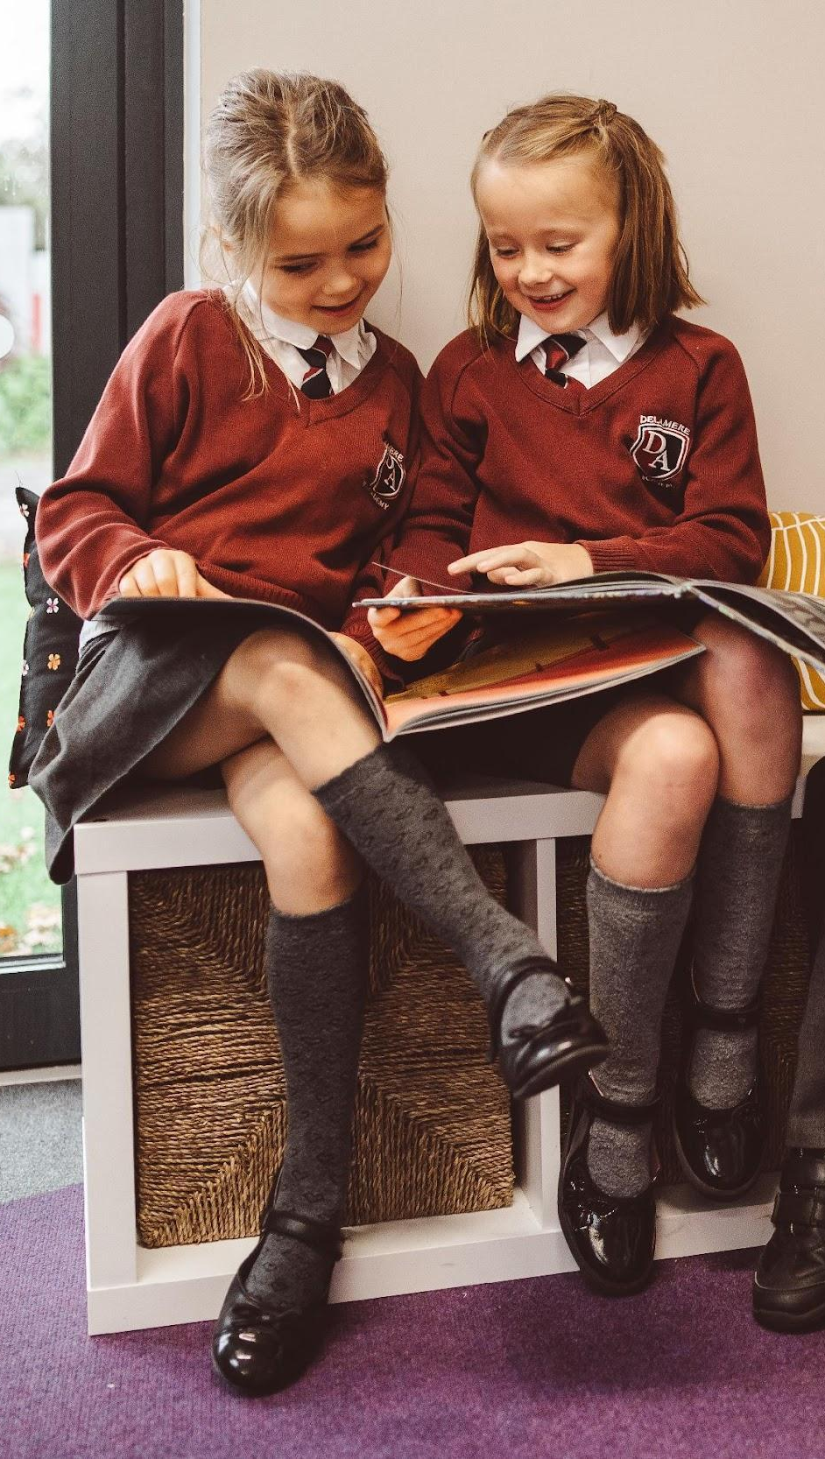
About the Role
Learning Support Assistant

Delamere Church of England Primary Academy is looking for an exceptional individual to join the school as a Learning Support Assistant. We would like someone who is good at communication with children, parents and staff, and has the skills and desire to enthuse children each and every day.

We believe that we have something special to offer the successful applicants. Delamere is a truly great place to work, our foundations being based on creating an environment that allows children to realise their full potential. If you are looking for a new exciting challenge, if you are organised and hardworking and have the passion required to work with us then please apply.

We are currently advertising for Learning Support Assistant to join our Team at Delamere Academy. This position is for 32.5 hours working 8.30am - 3:30pm. This role will involve a combination of classroom support, occasional class cover, and one-to-one support for pupils with special educational needs.

Job Description (Learning Support Assistant)
The Learning Support Assistant role is an excellent opportunity to make a real difference in our children’s education, drawing on your commitment to developing pupil learning ability and knowledge accessibility. Working closely with class teachers you will be helping pupils to expand their knowledge and play a positive role in school life. You will utilise your knowledge, communication skills and creativity to help pupils understand the information presented.
Your duties as a Learning Support Assistant will include:
- Supervise and provide learning support for a pupil with additional needs.
- Assist with the development of individual education and behavioural plans setting challenging expectations for pupils to achieve learning goals.
- Establish trusting relationships with pupils and interact with them according to individual needs and personalities.
- Encourage pupils to interact with the class and engage in activities.
- On occasion cover classes - following work set and agreed with the class teacher.
- Provide feedback to pupils and teachers on pupil’s achievement, progress and any problems that arise.
- Create and maintain an orderly and supportive environment, undertaking administrative tasks as needed.
- Promote good pupil conduct encouraging pupils to take responsibility for their behaviour.
- Support the use of technology in learning and develop pupils’ competence and independence in its use.
- Prepare resources required for learning activities and assist pupils in their use.

- Uphold policies and procedures relating to child protection and data protection.
- Supervise pupils before school, after school and on school trips including residential visits.
- Supervising lunch each day.

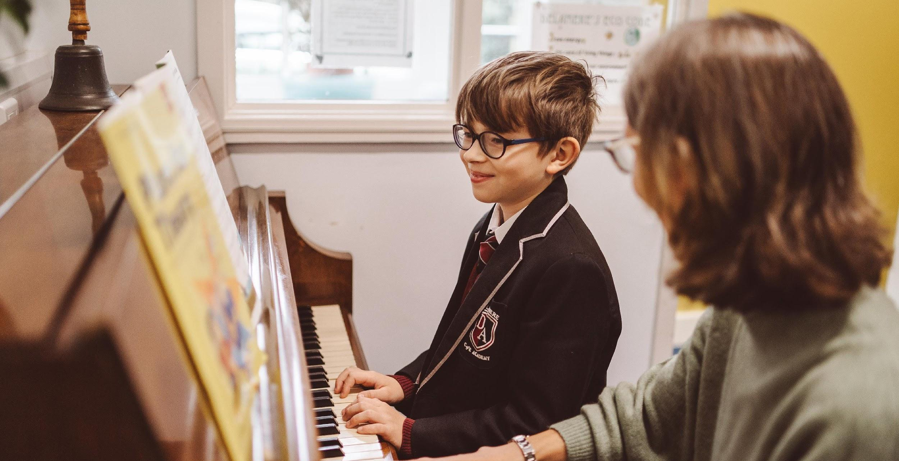
Person Specification

Prerequisite
  - Satisfactory enhanced DBS check and references.

Experience

  - Experience of working in schools
  - The ability to work with children across the primary age range.
  - Being able to work with parents and carers, outside agencies, in partnerships and collaboration to secure achievement, enrichment opportunities and resources for children.

Personal Qualities & Attributes
Skills

A good understanding of the national Key Stage (KS) curriculum and child development and learning.
The ability to demonstrate active listening skills and strong verbal communication skills, building positive relationships with pupils and understanding their needs.
The ability to provide varying levels of individual attention, reassurance and support with learning tasks as appropriate to pupils’ needs.
The ability to monitor a pupil’s response to learning activities and modify or adapt the activities to achieve the intended learning outcomes.
The ability to provide constructive feedback to pupils in a way that reinforces self-esteem, handling complex and sensitive issues with empathy and understanding.
An interest in continuing your personal and professional development, self-evaluating learning needs and actively seeking new teaching methods.
The ability to use a computer and the main office software packages competently such as Word and PowerPoint.

  - Creative, warm, engaging and transparent
  - Well organised, calm and very positive, confident and assuring.
  - Able to quickly engage and build appropriate relationships with children.
  - Able to encourage, inspire, motivate children.

  - Dependable and reliable, with an excellent record of attendance.
  - Willing to go the extra mile
  - Flexible

