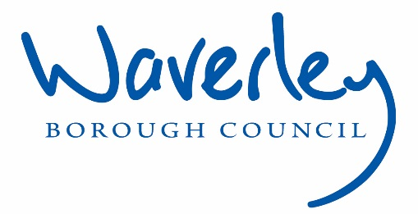

Job Description: Transformation Officer

Waverley is an ambitious authority, committed to being one of the leading Councils in the country at a time of major change by developing a high performing, highly engaged staff team to share the organisation’s values and deliver our corporate objectives.

Job Description
Job title: | Transformation Officer
Service: | Strategy and Corporate Services
Team: | Business Transformation
Location: | The Burys, Godalming, Surrey, GU7 1HR and  Millmead House, Millmead Guildford Surrey GU2 4BB
Reporting to: | Head of Transformation & Service Improvement
Responsible for: | N/A
Our Organisational Values
Collaboration   | We know, work with and support one another. We collaborate with residents, businesses and partners and realise the potential of the Guildford and Waverley Collaboration. We empower ourselves and others.
  Wellbeing | We look after our own and other’s wellbeing. We know it’s okay to talk to each other about anything we are struggling with. We stay resilient and raise any concerns we have.
Trusted   | We abide by the Nolan Principles of Public Life: Selflessness, Integrity, Objectivity, Accountability, Openness, Honesty, and Leadership.
Value for Money   | We spend public money wisely and carefully. We understand and follow our governance processes and raise any concerns with the right person. We celebrate successes and learn from mistakes.
Professionalism   | We provide professional advice and excellent service; we know our local areas and understand the communities we serve. We listen to all concerns and ideas. We benchmark our performance and always strive to improve.

Principal purpose of the role
- To play a key role in supporting the delivery of the Local Government Reorganisation (LGR), Business Transformation and Collaboration Programme, and service improvement.
- To design, develop and deliver business transformation and improvement projects so that they deliver a range of benefits to Guildford BC and Waverley BC.
- To guide, advise and support individual business improvement and transformation and collaboration projects to ensure they are on schedule and will deliver in terms of outputs and timescales.

Main duties and accountabilities
- To convene and facilitate Project Groups and ensure they have appropriate, accurate and relevant documentation in a timely and ordered fashion.
- To champion PPM methodology and advise and guide project teams on application, and on associated reporting and governance requirements.
- To be able to challenge positively, and act as a critical friend, seeking creative solutions.
- To manage projects as identified and by the AD Transformation, Head of Transformation & Service Improvement.
- Create and draft reports and presentations to inform projects and the wider work of the team.
- To manage and undertake research projects and analyse data to support Transformation and Collaboration projects, improvement projects, and LGR.
- Work closely with the communications team to develop a range of stakeholders as required by the Head of Transformation & Service Improvement.
- Identify interdependencies and key risks across projects and ensure that they are recorded and escalated appropriately.
- To provide support to project groups and boards, including issuing papers, writing minutes etc.
- Support team colleagues in producing relevant project management documentation to report projects (including but not limited to data analysis, reporting and process mapping, business cases, Service improvement and project support including risk registers, issues and action logs, monthly reporting packs etc).
Business Continuity
- Play a role in business continuity planning and should the need arise.
- Health and Safety
- Comply with all Health and safety legislation for your area of work, ensuring that risks are identified, managed and monitored as required.
Dimensions of the role
- Working in a team of 8 people
- Delivery of work-streams within a programme critical to meeting the Council’s core strategy and priorities, and supporting through a period of significant change.
Areas of Accountability/Problem Solving – Decision Making / Scope for Impact
- Each work-stream relies on the Transformation Officer’s ability to support Transformation and Collaboration in the collection and analysis of the appropriate data, critical analysis of the information gathered and creatively design of solutions meeting the objectives of the work-stream along with other project team members. There will always be interfaces with other change initiatives, and so the potential impact of a poorly designed solution will be immense.
- In some projects, the Transformation Analyst will be expected to own the delivery of a piece of work as opposed to always operating in a support role.
Planning/Organising/Controlling
- Support the delivery of the Transformation collaboration and improvement work programme.
- Analysing needs and implementing solutions to improve services and create new ways of working across a range of service areas.
- Organising and working with a number of project groups across GBC and WBC and potentially West Surrey as part of LGR.
Customers and Contacts
Internal
- Members and Senior Managers
- Staff at all levels of the organisation
External
- LGR project and workstream teams and contacts
- 3rd party suppliers
- Consultants

Service/Team Structure
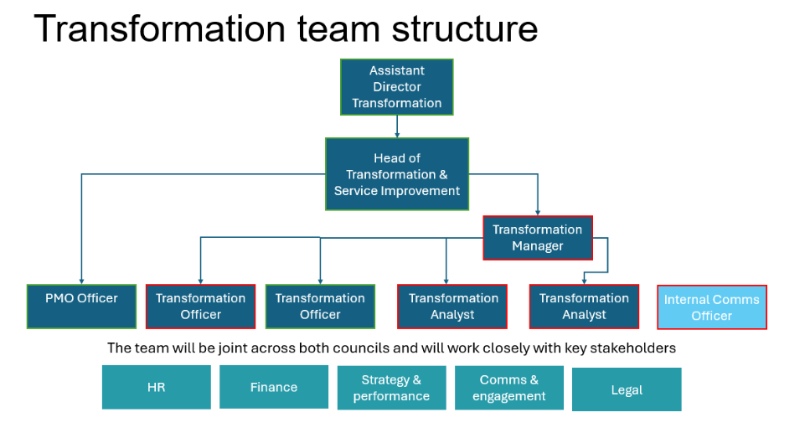

PERSON SPECIFICATION

Candidates must be able to demonstrate, giving examples, all essential criteria marked as A/I within their application form to be shortlisted for this role.

 | Person Specification
 | Essential criteria | How Assessed | Desirable criteria | How Assessed
Qualifications/ Education / Training / Experience | - Project Management experience  - PPM, PS3, MSP or other recognised project qualification. | A/I | - Educated to degree level | A/I
Knowledge /Technical Skills | - Knowledge of service improvement and review methodologies and mechanisms  - Ability to understand and act in a “change” environment | A/I  A/I | - IT system knowledge/  experience  - Procurement skills  - Awareness of Safeguarding | A/I  A/I  A/I
Communication | - Excellent verbal and written communication  - Experience of communicating at different levels of an organisation | A/I  A/  I
Customer Service | - Understanding of and commitment to promoting equality and diversity in service delivery and employment. | I
Team Working | - Proven ability to work on own initiative or part of a team | A/I | - Proven ability to deliver complex projects on time
Team Working | - Strong interpersonal skills; able to establish productive working relationships with key stakeholders. | I
Managing self and others | - Ability to manage and prioritise a varied work list | A/I
Managing self and others | - Ability to work under pressure to meet deadlines. | A/I
Can Do Approach/ Achieving Results | - Enthusiastic and committed | A/I
ADDITIONAL SPECIFIC REQUIREMENTS FOR THIS POST | - For business continuity purposes you are required to have access to the internet at home via broadband on a PC, laptop or tablet. | A

* Please note that Waverley Borough Council cannot guarantee to supply you with the provision of equipment such as laptop, tablet, mobile phone or pool vehicle

How assesed:

A = Application CV/Personal Statement
C = Certificates/professional Registration
D = DBS police check
E = Exercise
I = Interview
M = Medical assessment

For Official Use only
Job title: | Transformation Officer | Post no: | TBC
Service: | Strategy and Corporate Services | JE score: | 323
Team: | Transformation | Grade | 7
Location: | The Burys  Godalming,  Surrey GU7 1HR | Position type:  (if part time, working pattern) | Full time  37 Hours/ Five day week
Competencies:  (level 1 – 4) | Communication:
Competencies:  (level 1 – 4) | Customer Service:
Competencies:  (level 1 – 4) | Team Working:
Competencies:  (level 1 – 4) | Managing Self and Others:
Competencies:  (level 1 – 4) | Can do approach/Results
Reviewed By: |  | Date:
Checked in: |  | Date:
Last Updated: |  | Date: | August 2024

