Job Description


JOB TITLE | Property Services Officer
REPORTS TO | Compliance & Contracts Manager
DIRECT REPORTS | None
INDIRECT REPORTS | None
PURPOSE OF THE JOB ROLE
To provide accurate and professional financial administration in support of Property Services, Facilities and associated corporate estate activity. The role manages financial processing relating to repairs and maintenance including purchase orders, invoice processing, reconciliations and recharge arrangements, ensuring compliance with Financial Regulations and audit requirements. The post also supports the Commercial Asset Team through rental invoicing administration, maintaining tenant financial records and assisting with arrears monitoring and follow-up activity, contributing to strong governance, transparency and income assurance within the Corporate Landlord model.

POSITION WITHIN SERVICE STRUCTURE
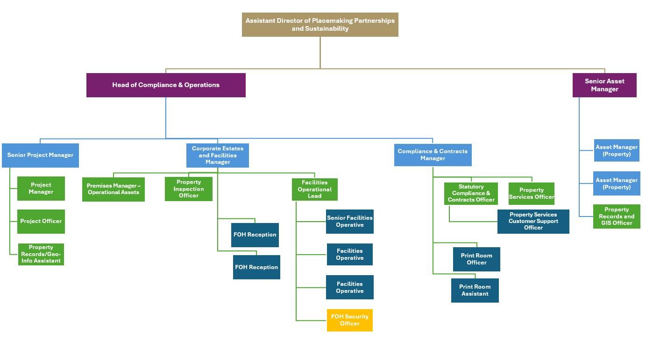
MAIN DUTIES AND RESPONSIBILITIES
- Manage day-to-day financial administration for Property Services and Facilities, including the processing, coding and reconciliation of invoices for repairs, maintenance and property-related activity, ensuring accuracy, compliance and audit trail integrity.
- Raise and manage purchase orders, receipting and associated financial documentation, monitoring outstanding actions and ensuring timely processing in line with service requirements.

- Maintain accurate financial records, schedules, trackers and supporting documentation to ensure transparency and audit readiness across Property Services and Facilities expenditure.
- Manage and administer recharge arrangements for schools, academies, partner organisations and internal services, preparing schedules and ensuring accurate supporting documentation.
- Liaise with Finance colleagues to resolve payment issues, reconcile supplier statements, investigate discrepancies and support efficient and compliant financial processing.
- Provide financial administration support to the Commercial Asset Team, including raising rental invoices, maintaining accurate records of tenant charges and supporting arrears monitoring and follow-up activity.
- Support Direct Debit administration relevant to Property Services and Facilities activity, including record keeping, reconciliation and resolution of discrepancies.
- Ensure effective and accurate use of relevant systems (e.g. Agresso and Technology Forge), maintaining high standards of data integrity and documentation control.
- Provide clear, professional communication with suppliers, schools, tenants, contractors and internal stakeholders to respond to queries, clarify information and support timely resolution.
- Support continuous improvement by identifying opportunities to strengthen financial controls, improve data quality and streamline processes in line with good practice and audit expectations.
- Provide general support to the wider Property Services team, appropriate to the grade of the post, to ensure effective service delivery and resilience.
This job description outlines the main duties and responsibilities but does not detail every task required for service delivery. You may be asked to take on additional duties at an equivalent level, on a temporary or permanent basis.
GENERAL RESPONSIBILITIES
Standard responsibilities that apply to all council staff or specific groups are set out in the Employee Handbook, these include:

- Corporate management  - Information governance compliance  - Whistleblowing  - General Safeguarding Statement  - Project and work management  - Working in a team | - Risk management including Health & Safety  - Business continuity  - Equality of Opportunity  - Our corporate values  - Budget management  - Specific responsibilities for managers

Local operating procedures and specific activities/tasks will be supplied by the service.
PERSON SPECIFICATION
Qualifications/Education/Training | - GCSEs (or equivalent) including English and Maths. (Essential)  - Evidence of strong numeracy and financial accuracy skills, suitable for a finance-focused administrative role. (Essential)  - Training or qualification in finance, business administration or a related discipline. (Desirable)  - Willingness to undertake relevant training, including financial systems, audit compliance and council procedures. (Essential)
Experience | - Experience of working in a finance, accounts, property services or similarly data-driven administrative role. (Essential)  - Experience of processing and reconciling invoices, purchase orders or financial transactions. (Essential)  - Experience of working with financial systems, spreadsheets or databases, with a strong emphasis on accuracy and detail. (Essential)  - Experience of working to deadlines, managing competing priorities and maintaining accuracy in a busy working environment. (Essential)  - Experience of communicating with suppliers, customers, schools, tenants or internal stakeholders regarding financial or administrative matters. (Essential)  - Experience of working within a local government, property, commercial asset or repairs/maintenance environment. (Desirable)
Skills, Abilities and Competencies | - Strong attention to detail and excellent accuracy when processing financial information and maintaining records. (Essential)  - Good analytical and problem-solving skills, with the ability to identify discrepancies, query issues and support resolution. (Essential)  - Confident IT user, with the ability to use financial systems such as Agresso and CAFM/property systems such as Technology Forge, as well as Microsoft Excel, Outlook and other standard applications. (Essential)  - Ability to work independently and use initiative within agreed procedures, while recognising when issues require escalation. (Essential)  - Strong organisational skills, with the ability to manage workload, prioritise tasks and meet financial deadlines. (Essential)  - Clear, professional communication skills, with the ability to explain financial information calmly and confidently to a range of stakeholders. (Essential)  - Ability to work collaboratively as part of a wider team, supporting colleagues and contributing to an efficient, well-controlled service. (Essential)
Specific Working Requirements | - Commitment to maintaining confidentiality and handling financial information responsibly.  - Commitment to accuracy, professionalism and delivering a high-quality financial administration service.
OTHER/SPECIAL REQUIREMENTS
DBS check required for this role | Not applicable
Is this role “politically restricted”? | No
ADDITIONAL JOB DETAILS
Job Grade | Grade 5
Directorate | Place
Service Area | Placemaking, Partnerships and Sustainability

