



Job Description: Legal Services Administrative Assistant

Waverley and Guildford are ambitious authorities, committed to being two of the leading Councils in the country at a time of major change by developing high performing, highly engaged staff teams to share the organisation’s values and deliver our corporate objectives.

Job Description
Job title: | Legal Services Administrative Assistant
Service: | Democracy, Law and People
Team: | Legal Services
Location: | The Burys, Godalming, Surrey, GU7 1HR and Millmead House, Guildford, GU2 4BB
Reporting to: | Legal Services Practice Manager
Responsible for: | None
Our shared Organisational Values
Collaboration   | We know, work with and support one another. We collaborate with residents, businesses and partners and realise the potential of the Guildford and Waverley Collaboration. We empower ourselves and others.
  Wellbeing | We look after our own and other’s wellbeing. We know it’s okay to talk to each other about anything we are struggling with. We stay resilient and raise any concerns we have.
Trusted   | We abide by the Nolan Principles of Public Life: Selflessness, Integrity, Objectivity, Accountability, Openness, Honesty, and Leadership.
Value for Money   | We spend public money wisely and carefully. We understand and follow our governance processes and raise any concerns with the right person. We celebrate successes and learn from mistakes.
Professionalism   | We provide professional advice and excellent service, we know our local areas and understand the communities we serve. We listen to all concerns and ideas. We benchmark our performance and always strive to improve.

Principal purpose of the role
- To provide comprehensive administrative support and assistance to the Legal Services & Information Governance team.
- To help enable an accurate, efficient and effective legal service to the Council for the broader benefit of residents in the Borough.
Main duties and accountabilities
- Assist in the opening of client files on the case management system and to support lawyers in the maintenance of their files.
- To provide general administration services, including attending to post, filing, archiving, printing, scanning, and distributing legal documents.
- To raise purchase orders, place bookings for training courses and process invoices for payment.
- To process and prepare temporary road closures, LPE1s, remortagage enquiries, notices of transfer/charge, home improvement loans and rights of first refusal.
- To support the Access to Information Rights Coordinator with the processing of Information Governance and Access to Information Rights requests.
- To provide general administrative support to the access to information rights process.
- To provide the highest levels of accuracy, speed and confidentiality
- To provide assistance with the preparation of court bundles.
- To undertake Land Registry and other searches, when required.
- To assist the Legal Service Practice Manager to ensure that the deeds rooms are maintained in good order and to ensure that all deeds are correctly stored and easily retrievable.
- To assist with the maintenance of the legal library including loose leaf encyclopaedia library updates.
- Support the sealing of the Councils’ legal documents and other duties as may be required from time to time, including dealing with post sealing instructions.
- To assist lawyers with the post completion process.
- With training, add content to the website and staff intranet.
- Supply copies of legal agreements, when required.
- Attend relevant meetings.
- Carry out any duty reasonably required by the Legal Services Practice Manager.
Business Continuity
- Play a pivotal role in business continuity planning and should the need arise assist in ensuring business recovery of key service provision in a 24 hour window.
- Health and Safety
Comply with all Health and safety legislation for your area of work, ensuring that risks are identified, managed and monitored as required

Dimensions of the role
- The Legal Services Administrative Assistant reports to the Legal Services Practice Manager and is required to provide administrative support across the team.
- Reponsible for providing support to the Legal Services Practice Manager, a critical post, which together with this post will ensure cohesive support processes to legal services colleagues.
Areas of Accountability/Problem Solving – Decision Making / Scope for Impact
- The nature of the work means that you must be able to work accurately and be self-motivated.
- You will be expected to ensure that all documentation received into the team is distributed promptly and properly.
Planning/Organising/Controlling
- Providing information to a range of customers, both internal and external to the Council.
Customers and Contacts
Internal
- Officers at all levels in both Waverley Borough Council and Guildford Borough Council
External
- Members of the public
- Solicitors from external law firms
- Other local authorities and government departments
- All types of external organisations and officials

Service/Team Structure
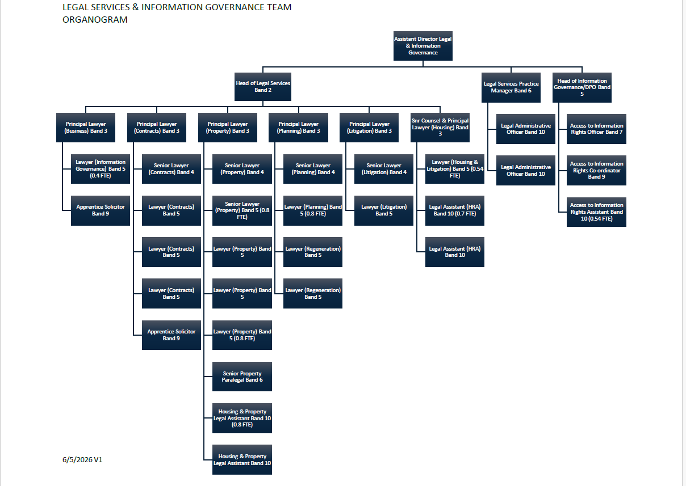

PERSON SPECIFICATION

Candidates must be able to demonstrate, giving examples, all essential criteria marked as A, A/C or A/I within their application form to be shortlisted for this role.

 | Person Specification
 | Essential criteria | How Assessed | Desirable criteria | How Assessed
Qualifications/ Education / Training / Experience | 5 GCSEs (at or above Grade C/4 including Maths and English) or equivalent knowledge gained by experience | A/C/I
Knowledge /Technical Skills | Knowledge of office procedures | A/I | Experience of legal administrative work. | A/I
Knowledge /Technical Skills | IT skills, particularly MS Word, Excel and Outlook | A/I | A working knowledge of local government. | A/I
Knowledge /Technical Skills | Ability to work quickly and accurately with excellent attention to detail. | I | Awareness of Safeguarding | A/I
 | Be process-driven and able to consistently follow procedures. | A/I
Communication | Clear telephone manner and communication skills. | A/I
Communication | Clear verbal and written skills | A/I
Customer Service | Understanding of and commitment to promoting equality and diversity in service delivery and employment. | I
Customer Service | Accurate spoken English is essential for the post | I
Team Working | Ability to work well within a team. | A/I
Team Working | Ability to build and maintain working relationships with others and act as a role model for the values of the Council.
Managing self and others | Good organisational skills | A/I
Managing self and others | A flexible approach to the need to vary daily tasks to achieve performance requirements and a willing attitude. | A/I
Managing self and others | Good time management skills | I
Managing self and others | Commitment to self development | A/I
Managing self and others | Demonstrates commitment to completing tasks and objectives | A/I
Can do approach / Achieving results | Ability to work under pressure | A/I
Can do approach / Achieving results | Able to effectively organise own workload and meet deadlines | A/I
Can do approach / Achieving results | Ability to follow instructions. | A/I
ADDITIONAL SPECIFIC REQUIREMENTS FOR THIS POST* | For business continuity purposes you are required to have access to the internet at home via broadband on a PC or laptop. | A

How assesed:

A = Application CV/Personal Statement
C = Certificates/professional Registration
D = DBS police check
E = Exercise
I = Interview
M = Medical assessment

Behavioural competencies:

COMPETENCIES  (LEVEL 1 – 4) | Communication: | 2
COMPETENCIES  (LEVEL 1 – 4) | Customer Service: | 2
COMPETENCIES  (LEVEL 1 – 4) | Team Working: | 2
COMPETENCIES  (LEVEL 1 – 4) | Managing Self and Others: | 2
COMPETENCIES  (LEVEL 1 – 4) | Can do approach/Results: | 2
Reviewed By: |  | Date:
Checked in: | HR | Date:
Last Updated: | Pamela Bowring | Date: | May 2025
For Official Use only
Job title: | Legal Administrative Assistant | Post no:
Service: | Democracy, Law and People | JE score:
Team: | Legal Services | Pay band: | 10
Location: | The Burys, Godalming, GU7 1HR and Millmead House, Guildford, GU2 4BB | Position type:  (if part time, working pattern) | Full time  37 Hours/Five day week

