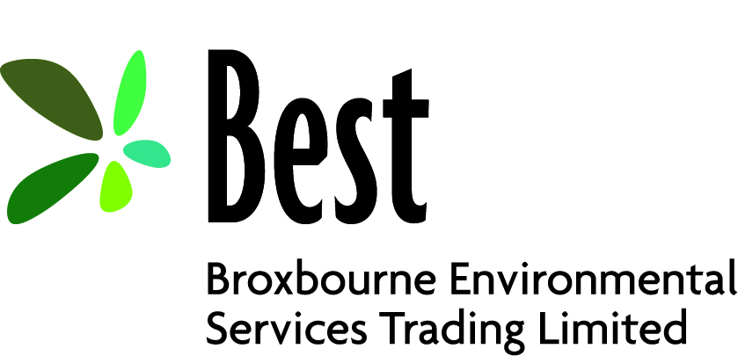

Privacy Notice for Employees
How we use your information
As an employee of Broxbourne Environmental Services Trading Limited (BEST) it is necessary for us to collect personal information about you.
This privacy notice tells you what to expect when BEST collects and processes your personal information.
Of paramount importance to BEST is its commitment to you to protect your privacy and therefore personal information throughout your employment with us.
BEST has a Data Protection Officer who makes sure BEST respects your rights and that we follow the law. If you have any concerns or a question about how BEST looks after your personal information, you can contact your line manager, the Personnel and Payroll Manager or the Head of Legal Services/Data Protection Officer, Nathalie Boateng.
Do you know what personal information is?
Personal information can be anything that identifies and relates to a living person. This can include information that when put together with other information can then identify you. For example, this could be your name and contact details.
As a BEST employee it is important that you know what personal information is and can identify when you may be processing personal information whilst working for BEST.
BEST therefore provides an online e-learning course which you should access to improve your knowledge and understanding of personal information and its processing.
The personal information we collect about you relating to your employment is:
- Your name
- Your address
- Your National Insurance Number
- Your gender
- Your contact details e.g. personal mobile, home telephone, personal email
- Next of kin, including their name relationship, address and telephone contact
- Whether or not you have any disabilities and any relevant medical history
- Your sickness and absence records
- Your bank details
- Your qualifications
- Your education and experience

Did you know that some of your personal information might be “special”?
Some information is “special” and needs more protection due to its sensitivity. It’s often information you would not want widely known and is very personal to you. This is likely to include anything that can reveal your,
- Sexuality and sexual health
- Religious or philosophical beliefs
- Ethnicity
- Physical or mental health
- Criminal history
How we collect this personal/’special’ information
- Job application forms
- New starter payroll data such as if this is your 2nd job or if you are receiving a pension
- HMRC provides us with your tax code, any student loan details and national insurance code.
- Courts notify us of any attachment of earnings orders or child support agency payments we need to deduct from your pay
Why do we need your personal information?
BEST needs some information about you to process your contract of employment, the following is a list of the types of processing (this is not an exhaustive list),
- Consider your suitability when applying for a job with BEST
- To pay you
- To meet our legal obligations in respect of salary deductions
- To operate and keep a record of absence and absence management procedures, to allow effective workforce management
- To operate and keep a record of other types of leave (including maternity, paternity, adoption, parental and shared parental leave), to allow effective workforce management, to ensure that the organisation complies with duties in relation to leave entitlement, and to ensure that employees are receiving the pay or other benefits to which they are entitled;
- To operate and keep a record of disciplinary and grievance processes, to ensure acceptable conduct within the workplace
- To inform your next of kin in the event of an accident or incident
- For your health, safety and welfare
- To maintain and promote equality in the workplace
Where BEST processes other special categories of personal data, such as information about ethnic origin, sexual orientation, health or religion or belief, this is done for the purposes of equal opportunities monitoring. Data that the organisation uses for these purposes is anonymised. Employees are entirely free to decide whether or not to provide such data and there are no consequences for failing to do so.
If you fail to provide certain required information when requested, BEST may not be able to perform the contract we have entered into with you (such as paying you or providing a benefit), or we may be prevented from complying with our legal obligations (such as to ensure the health and safety of our staff).
How the law allows BEST to use your personal information
- You have entered into an employment contract with BEST
- It is necessary to perform our statutory duties towards you
- It is necessary to protect you
- It is required by law
Who do we share your information with?
- HMRC for tax purposes
- Local Government Pension Scheme (LGPS) via Local Pensions Partnership (LPP) who administer the pension scheme for BEST
- Shared Fraud Service (SAFS)
- Disclosure and Baring Service (DBS) if you are required to have a DBS certificate under your contract of employment
- Occupational Health, if applicable
- Government departments such as the department of work and pensions
- Broxbourne’s Council tax department in respect of staff who live within the Borough
BEST does not share information about its staff with anyone without consent unless the law and our policies allow us to do so.
BEST does not allow its third-party service providers to use your personal data for their own purposes. We only permit them to process your personal data for specified purposes and in accordance with our instructions.
BEST may also share your personal information where we feel there is a good reason that is more important than protection of your privacy. This does not happen often, but we may share your information for example:
- In order to find and stop crime and fraud; or
- If there is a serious risk to you, the public or other members of staff
- With your GP and/or other health services
The risk must be serious before BEST can override your right to privacy.
How do we protect your information?
BEST will do what it can to make sure the records we hold about you both on paper and electronically are kept in a secure way and we will only make them available to those who have a right to see them.
Examples of our security include:
- Encryption, meaning that information is hidden so that it cannot be read without special knowledge (such as a password).
- Controlling and limiting access to systems and networks allows us to stop people who are not allowed to view your personal information from getting access to it
- Using secure portals to transfer data such as personal information to our payroll provider or the pension scheme administrators.
- Using secure lockable cupboards for all paper files.
- Training our staff which allows BEST to make them aware of how to handle information and how and when to report when something goes wrong.
- IT Policy. This policy ensures that all information technology users within BEST comply with rules and guidelines related to the security of the information stored digitally at any point in the network or within BEST’s boundaries of authority.
- Social Media Policy. This policy is aimed at educating employees when using social media to minimise risk which can impact on BEST and its employees.
- Keeping up to date on the latest security updates.
What you can do with your personal information
The law gives you a number of rights to control what personal information is and how it is used by BEST. It is important that the personal information we hold about you is accurate and current. It is therefore important that you keep us informed if your personal information changes during your working relationship with us.
You can ask for access to the information BEST holds about you. When we receive a request from you in writing, we must give you access to everything we have recorded about you however we cannot let you see any parts of your records which contain:
- Confidential information about other people; or
- Data a professional thinks will cause serious harm to you or someone else’s physical or mental wellbeing; or
- If we think that giving you the information may stop us from preventing or detecting a crime
This applies to personal information that is in both paper and electronic records. If you ask us, we will also let others see your records (except if one of the points above applies).
You can ask BEST to change information you think we hold that is inaccurate. We may not always be able to change or remove that information but we will correct factual inaccuracies and may include your comments in the record to show that you disagree with it.
You can ask us to delete information (right to be forgotten) in some circumstances for example:
- Where your personal information is no longer needed for the reason why BEST collected it in the first place;
- Where there is no legal reason for BEST to hold your information
Where such personal information has been shared with others, we will do what we can to make sure those using your personal information comply with your request for erasure.
Please note that we cannot delete your information where:
- We are required to have it by law;
- It is for health purposes
- It is for or statistical purposes where it would make information unusable
- It is necessary for legal purposes
- It is required by BEST to comply with its contractual obligations
How long do we keep your personal information?
There is often a legal reason for keeping your personal information for a set period of time; we try to include all of these in BEST’s Document Retention Policy which you will find on BEST’s website.
Changes to this private notice
BEST will keep its privacy notice under regular review. This privacy notice was last updated on 1st April 2019
BEST’s Data Protection Officer
BEST’s Data Protection Office is Nathalie Boateng and she may be contacted by email: legal@bestbob.uk or by letter at:
Broxbourne Environmental Services Trading Limited
Legal Services
Bishops’ College
Churchgate
Cheshunt
Hertfordshire
EN8 9XQ

Information Commissioners Office
If you want any further information about your privacy rights or to make a complaint you can contact the Information Commissioner’s Office at the following address,
Information Commissioner’s Office
Wycliffe House
Water Lane
Wilmslow
Cheshire Sk9 5AF
Email: https://ico.org.uk/global/contact-us/
Website: www.ico.org.uk

