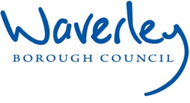


Job Description: Joint Private Sector Housing Manager

Guildford and Waverley are ambitious authorities, committed to being leading Councils in the country at a time of major change by developing a high performing, highly engaged staff team to share the organisation’s values and deliver our corporate objectives.

 | Job Description
 | Job title: | Joint Private Sector Housing Manager
 | Service: | Regulatory Services
 | Team: | Environmental Regulation
 | Location: | The Burys, Godalming, Surrey, GU7 1HR and Millmead House, Guildford, GU2 4BB
 | Reporting to: | Joint Head of Environmental Regulation
 | Responsible for: | Regulation of Empty Homes, Caravan Sites, Private Sector Housing and Public Health Funerals.
Our shared Organisational Values
Collaboration   |  |  | We know, work with and support one another. We collaborate with residents, businesses and partners and realise the potential of the Guildford and Waverley Collaboration. We empower ourselves and others.
Wellbeing   |  |  | We look after our own and other’s wellbeing. We know it’s okay to talk to each other about anything we are struggling with. We stay resilient and raise any concerns we have.
Trusted   |  |  | We abide by the Nolan Principles of Public Life: Selflessness, Integrity, Objectivity, Accountability, Openness, Honesty, and Leadership.
Value for Money   |  |  | We spend public money wisely and carefully. We understand and follow our governance processes and raise any concerns with the right person. We celebrate successes and learn from mistakes.
Professionalism   |  |  | We provide professional advice and excellent service; we know our local areas and understand the communities we serve. We listen to all concerns and ideas. We benchmark our performance and always strive to improve.
 | Principal purpose of the role
- To act as the Council’s Environmental Health advisor in relation to Empty Homes, Licensed Caravan Parks, Private Sector Housing (including the regulation of Houses in Multiple Occupation) and Public Health Funerals, developing plans, policies, overseeing training and implementation, in conjunction with the Joint Head of Environmental Regulation.
- To have direct line-management responsibility for all members of the Private Sector Housing Team.
- To make comprehensive recommendations to the Head of Environmental Regulation regarding the future efficient delivery of these functions, in cooperation and partnership with other local authorities, organisations and statutory bodies.
- To lead the Private Sector Housing team, ensuring that the team of professional and technical officers provide services to meet customers’ needs against agreed performance standards, and that the Council meets its legal obligations in respect of these aspects of Regulatory Services.
- To discharge their duties in accordance with the Council's Codes and Policies, Standing Orders, and Financial Regulations.
- To meet personal targets and performance standards on time.

 | Main duties and accountabilities
- To be responsible to the Joint Head of Environmental Regulation in leading the Private Sector Housing Team and exercising all powers and duties imposed by statute in line with officer delegations.
- To deputise for the Head of Environmental Regulation as and when required.
- To create a strong and positive team culture within Private Sector Housing Team that is focused on providing excellent customer service through a “one council” problem solving approach.
- To properly and efficiently manage workloads across both authorities including working across services to train, motivate and develop staff involved in providing accessible services which meet statutory duties on behalf of the Council and in accordance with Council policies.
- To meet all central government targets in relation to Private Sector Housing.
- To ensure the optimum value for the resources provided in administering the Team’s functions.
- To have knowledge of and support the implementation of the Corporate Strategy objectives, and maintain and develop professional knowledge in order to meet set targets.
- To prepare and present reports for Committees, Senior Management and partners as required, and to represent the Service at Committees, on Corporate Working Groups and externally at local and regional forums as may be required.
- To respond to, and make recommendations in relation to consultations regarding Private Sector Housing and related matters on behalf of the authority.
- To respond to enquiries in relation to Freedom of Information, Subject Access Requests, the media, as directed by the Joint Head of Environmental Regulation.
- To respond to formal complaints, including those from Councillors and MPs.
- To monitor and ensure that accurate data regarding the functions of the Private Sector Housing Team are gathered and forwarded to auditing and consulting bodies as part of statutory processes.
- To monitor the team’s performance and compliance with national guidance and adopted policies.
- To develop and implement Service policies and strategy to achieve and maintain a quality service to the public and internal customers that also reflect corporate objectives.
- To give advice to colleagues, members of the public, Councillors and external statutory and non-statutory bodies on matters relating to Private Sector Housing.
- To input into the Private Sector Housing budget setting process and manage the Private Sector Housing budgets across Guildford & Waverley Borough Councils.
- To prepare reports, representations and/or orders, taking enforcement action in line with Corporate Enforcement Policies, including the giving of evidence in Court to secure compliance with the law.
- To work in partnership with the Joint Head of Environmental Regulation to explore opportunities to improve the efficiency and effectiveness of the Service, including working in collaboration with other Councils and stakeholders.
- To undertake casework, particularly in relation to the more complex and/or more politically sensitive cases, and dealing with particularly challenging people and situations from time to time.
- To manage the investigation of specific cases where formal action is warranted to ensure adherence to the law, statutory guidance and council policies and procedures.
- To manage and utilise external services where necessary and monitor the operational delivery of contracts throughout their term.
- Keep the Private Sector Housing policies under constant review and undertaking consultation exercises when necessary.
- Develop and maintain the Private Sector Housing webpages on the Council’s websites to enhance customer experience.
- To assist in the management and maintenance of computer systems and to ensure accurate records are updated by the team on a routine basis. Utilise monitoring data to make recommendations for improvements to the provision of customer service and internal processes.
- Monitor and ensure that accurate data regarding Private Sector Housing functions is gathered. Utilise monitoring data to make recommendations for improvements to the provision of customer service and internal processes.
- To be responsible for staff welfare and personal development and to effectively address performance and disciplinary concerns in liaison with POD and the Joint Head of Environmental Regulation. This will include providing regular feedback on training and personal development and assessing and managing performance.
- To be responsible for the Private Sector Housing Team’s response to emergency or acute incidents, including serious pollution incidents, in conjunction with the Emergency Planning Manager, Applied Resilience and the Joint Senior Leadership Team.

General Requirements

- All employees will be expected to be flexible in their duties and carry out any other duties commensurate with the grade and falling within the general scope of the job, as requested.
- Duties and responsibilities must be carried out in accordance with relevant Council policies and procedures, within legislation and any code of professional ethics of the relevant professional body.
- All employees are expected to maintain a high standard of customer care in the context of the councils’ core values, to uphold the Equality and Diversity Policy and health and safety standards and to participate in personal learning and development necessary to the post.
- To demonstrate and positively reinforce our commitment to safeguarding and promoting the welfare of children and vulnerable adults.
- To work within the Council’s competency framework and to adhere to the Code of Conduct, the Council’s Constitution and procurement rules.
- To discharge their duties in accordance with the Council's Codes and Policies, Standing Orders and Financial Regulations and to meet personal targets and performance standards on time.
- To promote equality and inclusion at all levels of service delivery and employment.
- To work in line with the council’s Agile Working Policy and Agile Working Team Profile to support the effective delivery of the Service. From time to time, it may be necessary to attend meetings or carry out visits in the evening and/or at weekends to meet the demands of the Service.
- To carry out other duties as required by the Joint Head of Environmental Regulation and/or Joint Assistant Director appropriate to your skills and level of responsibility, not exceeding the grade on which you were appointed.

Business Continuity

- To play a supporting role in business continuity planning and should the need arise assist in ensuring business recovery of key service provision.

Health and Safety

- To be responsible for the routine implementation of the Council’s Safety Policy within the Section including the conduct and regular review of risks assessments, safe systems of work and training of staff to ensure that work is carried out in a safe manner.
- To comply with all Health and Safety legislation for your area of work, ensuring that risks are identified, managed and monitored as required.

Election Duties

- This post may, on occasion and with reasonable notice, be requested to assist with election duties. This may include working unsociable hours. A separate payment for election duties will be made as determined by the regional Elections Committee.

GBC Out of Hours Noise Service

- To participate in the Regulatory Services Out of Hours Service on a Rota basis.
- To participate in the Rota for Christmas cover as necessary and agreed with the Service Manager

This Job Description is current as at the date shown above. In consultation with you, it is liable to variation as the needs of the Council may require.

 | Dimensions of the role
- Responsible for the management and monitoring of the Service Level Agreement with the Home Improvement Agency.
- Responsible for the management of external service contracts and contractors.
- Staff - professional officers
- Approx 800 per annum service requests
- Approx. 790 licensed HMOs and 30 licensed caravan sites
- Approx. 45,000 residential premises
- Approx. 116,000 residents

Areas of Accountability/Problem Solving – Decision Making / Scope for Impact
- Accountable as the lead professional in Private Sector Housing and related functions to provide professional advice and expertise on behalf of both Councils.
- Accountable for making recommendations as to policies, strategies and functions directly affecting the health and well-being of residents, business users and visitors, in respect of Regulatory Services responsibilities in relation to Caravan Site Licensing, Empty Homes, Private Sector Housing Enforcement and Public Health Funerals, and ensuring that the Councils meet their legal obligations in respect of those functions.
- Preparation and presentation of Committee reports on Private Sector Housing issues.
- Acting on behalf of the Council in bringing legal proceedings as appropriate.
- Leading own work and preparing cases for prosecutions, serving notices, managing budgets and staff to meet demands.
- Managing and mentoring staff to meet service standards and operational demand.
- Assisting in the development of strategic housing policies and procedures on behalf of the Council.
- Responsible for making day-to-day decisions regarding service delivery and advising on policy development.

Planning/Organising/Controlling
- Organising and managing own workload, and that of the Private Sector Housing Team across both councils, within corporate priorities and agreed personal objectives.
- Monitoring and managing the performance of team members and contractors.

Customers and Contacts
INTERNAL
- Members of the Council, Management Board and other staff at all levels.

EXTERNAL
- Members of the Public, Owners and occupiers of premises and land and their agents;
- Government Departments, MHCLG, DEFRA, etc.other external statutory and non-statutory bodies in relation to special responsibilities:
- Media in consultation with the Communications Team,
- MPs, government bodies,
- Local, national and international businesses.
- Specialist contractors

Service/Team Structure
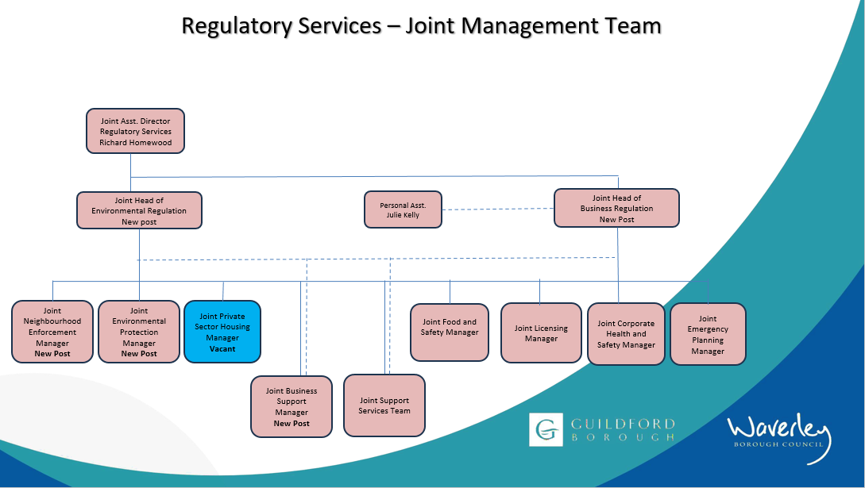
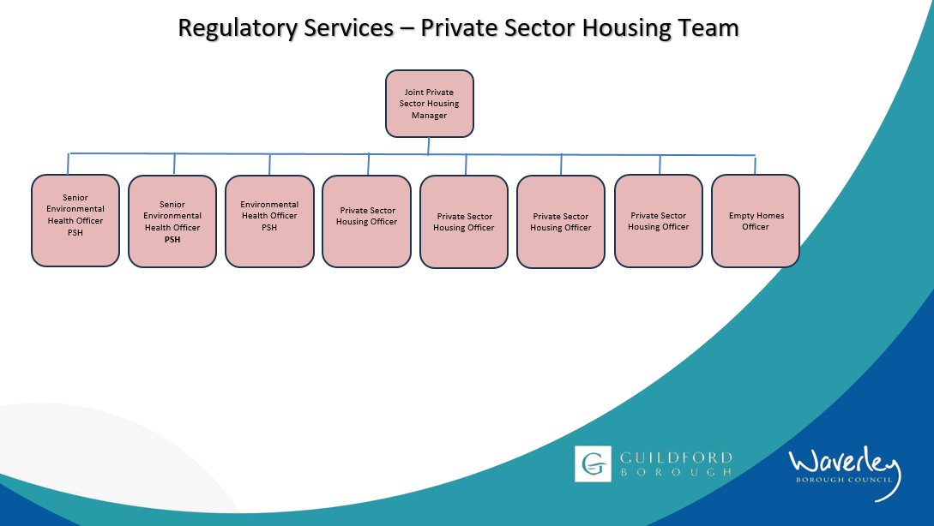

PERSON SPECIFICATION

Candidates must be able to demonstrate, giving examples, all essential criteria marked as A, A/C or A/I within their application form to be shortlisted for this role.

 | Person Specification
 | Essential criteria | How Assessed | Desirable criteria | How Assessed
Qualifications/ Education / Training / Experience | Degree / Diploma in  Environmental Health.  EHORB registration. | A/C/I | Relevant, specialist post-graduate qualification. | A/C/I
Qualifications/ Education / Training / Experience |  | A/C/I | Recognised Management Qualification. | A/C/I
Qualifications/ Education / Training / Experience |  | A/C/I | Chartered Environmental Health Practitioner | A/C/I
Qualifications/ Education / Training / Experience |  | A/C/I | HHRS qualification | A/C/I
Knowledge / Technical Skills | Extensive post graduate experience. | A/I |  | A/I
Knowledge / Technical Skills | Understanding of relevant policies, procedures and powers available in the field of Environmental Health. | A/I | Awareness of Safeguarding | A/I
Knowledge / Technical Skills | Detailed and sound understanding of relevant legislation. | A/I
Knowledge / Technical Skills | Knowledge and experience of managing and developing staff, management of contracts and successfully dealing with contractors. | A/I
Knowledge / Technical Skills | Demonstrable competence of innovative policy and strategy development. | A/I
Knowledge / Technical Skills | Experience and competence in the investigation of cases that may lead to the instigation of legal proceedings. | A/I
Knowledge / Technical Skills | Excellent problem solving and analytical skills to assimilate, analyse and translate technical and statistical information | A/I
Knowledge / Technical Skills | Awareness of the working of the Local Government Committee process. | A/I
Communication | Excellent written and oral communication skills. | A/I
Communication | Ability to prepare and present complex technical reports using appropriate styles and language | A/I
Communication | Ability to deal with difficult people and situations in a calm, professional and diplomatic manner. | A/I
Customer Service | Understanding of and commitment to promoting equality and diversity in service delivery and employment. | I
Customer Service | Ability to deal with sensitive and/or confidential issues | A/I
Customer Service | Committed to providing a high-quality professional service to the public. | A/I
Customer Service | Proven ability to improve Customer Service. | A/I
Customer Service | Accurate spoken English is essential for the post | I
Team Working | Ability to actively contribute to a positive culture within the Service. | A/I
Team Working | Ability to develop positive working relationships, work collaboratively as part of a wider team, both internally and with partner agencies. | A/I

 | Evidence of sharing best practice and information with colleagues and relevant partners. | A/I
 | Ability to demonstrate a strong team working ethic and commitment to a ‘One Council’ approach. | A/I
Managing self and others | Ability to actively influence, motivate and manage a variety of people. | A/I | Project Management Experience | A/I
Managing self and others | Ability to use computer technology to develop efficient systems of work. | A/I | Project Management Experience | A/I
Managing self and others | Ability to work under pressure, organise, plan and prioritise own and team workload to meet statutory requirements, service and corporate priorities. | A/I | Project Management Experience | A/I
Managing self and others | Embraces change in a positive and constructive manner. | A/I | Project Management Experience | A/I
Managing self and others | Has an open and approachable manner. | A/I
Can do approach / Achieving results | Has the drive and resilience to achieve results through a logical and systematic approach. | A/I | Ability to be creative and innovative in policy and strategy development. | A/I
Can do approach / Achieving results | Has a commitment to further training and development of self and others. | A/I
ADDITIONAL  SPECIFIC Requirements | For business continuity purposes you are required to have access to the internet at home via broadband on a PC or laptop. | A/I
ADDITIONAL  SPECIFIC Requirements | Ability to work out of hours, i.e. committee meetings and emergency response. | A/I
ADDITIONAL  SPECIFIC Requirements | Full and valid driving licence and use of a car during working hours | A/I
ADDITIONAL  SPECIFIC Requirements | Ability to carry out site inspections as required in the role and in accordance with the Business Travel Policy. | A/I

How assessed
A = Application CV/Personal Statement
C = Certificates/professional Registration
D = DBS police check
E = Exercise
I = Interview
M = Medical assessment

Disclosure and Barring Service
Due to the nature of the work, this post involves a check on an individual’s criminal background. The check is carried out through the Disclosure and Barring Service (DBS, previously CRB). Any offer of employment will be subject to receiving satisfactory clearance from the Disclosure and Barring Service.

For Official Use only
Job title: | Joint Private Sector Housing Manager | Post no:
Service: | Regulatory Services | JE score: | 464
Team: | Regulatory Services | Pay band: | 4
Location: | The Burys  Godalming,  Surrey GU7 1HR; and  Guildford Borough Council, Millmead House, Millmead, Guildford, Surrey, GU2 4BB | Position type:  (if part time, working pattern) | Full time  37 Hours / 5 days per week
Competencies:  (level 1 – 4) | Communication: | 4
Competencies:  (level 1 – 4) | Customer Service: | 4
Competencies:  (level 1 – 4) | Team Working: | 4
Competencies:  (level 1 – 4) | Managing Self and Others: | 4
Competencies:  (level 1 – 4) | Can do approach/Results | 4
Reviewed By: | Richard Homewood | Date: | March 2023
Checked in: | POD this…? | Date:
Last Updated: | Richard Homewood | Date: | Dec 2025

