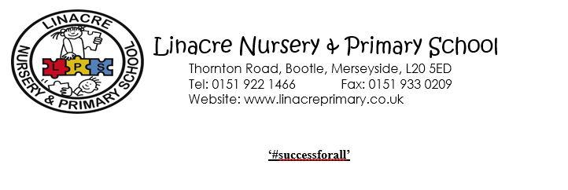
PERSON SPECIFICATION
POST TITLE: Class Teacher
 | ATTRIBUTES | E (Essential)  D (Desirable)
Qualifications & Training | - Qualified teacher status  - Degree  - Recent and relevant training in current educational initiatives | E  E  D
Experience | - Excellent classroom practitioner  - Experience of teaching in all key stages  - Experience of adapting work to meet the needs of all pupils  - Experience of sharing extended learning for children through extra-curricular activities | E  D  E  D
Professional Values | - Promote the school’s aims positively  - Establish and maintain good professional relationships with pupils, parents, colleagues and governors.  - Set high expectations of all pupils and be committed to raising attainment and achievement.  - Maintain confidentiality | E  E  E  E
Knowledge & Skills | - Up to date knowledge of current educational initiatives  - Ability to lead and manage a curriculum area  - Effective behaviour management skills  - Ability to create a high quality learning environment  - Effectively communicate to a variety of audiences: children, staff, parents and governors | E  E  E  E  E
Personal Characteristics | Have:  - a commitment to the ethos of a Christian school  - high expectations of self and others  - the ability to work under pressure and meet deadlines  - enthusiasm to participate in school life and engage in the wider aspects of school life beyond the classroom  - good interpersonal skills  Be:  - a team player  - adaptable to changing circumstances and new ideas | E  E  E  E  E  E  E

