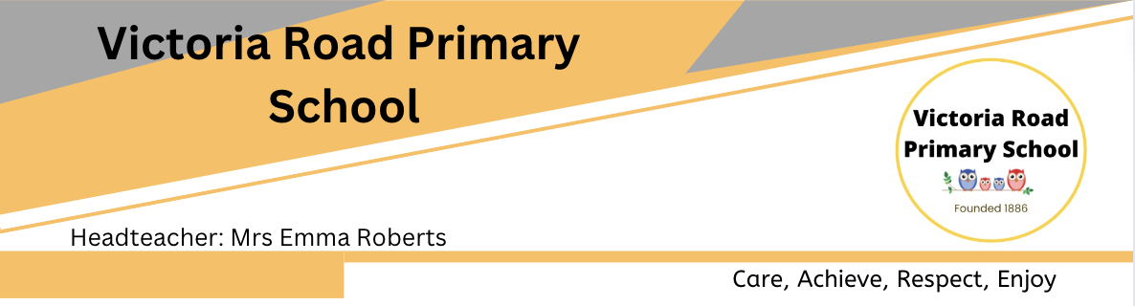
Job Title: Kitchen Assistant / School Catering Assistant (Level 2 Food Hygiene Required)

Location: Victoria Road Primary School, Runcorn, WA7 5BN

Salary details: HBC2 SCP 3-4

Weekly Hours: 20 – (Monday to Friday 4hrs per day)

Duration of contract: Fixed term role of 36 months

Reports To: Mrs Emma Roberts, Headteacher

Job Overview
We are seeking a reliable and organised Kitchen Assistant / School Catering Assistant to support the delivery of our new school catering contract.
This role involves managing the daily service of pre-prepared meals to school children, ensuring food is heated and served safely and efficiently while maintaining excellent standards of kitchen cleanliness and food hygiene.
The successful candidate will also take responsibility for weekly food ordering with the supplier and ensuring stock levels are maintained to meet service requirements.
This is an ideal opportunity for someone who enjoys working in a school environment, takes pride in food safety standards, and can work independently.

Key Responsibilities

Food Preparation & Service
- Receive, check and store deliveries of pre-prepared meals and food items.
- Prepare and safely reheat meals in accordance with food safety guidance and supplier instructions.
- Serve meals to school children in a friendly, professional and efficient manner.
- Support positive meal experiences and maintain a welcoming dining environment.
- Monitor portion control and minimise food waste.

Food Safety & Hygiene
- Maintain high standards of food hygiene and kitchen cleanliness at all times.
- Ensure compliance with Food Safety legislation, HACCP procedures and company policies.
- Carry out daily cleaning schedules and maintain kitchen equipment.
- Complete temperature checks and maintain food safety records.
- Ensure correct food storage and stock rotation practices are followed.

Ordering & Stock Control
- Place weekly food orders with the designated supplier in line with expected demand.
- Monitor stock levels and manage inventory to reduce shortages and waste.
- Receive and record deliveries and report discrepancies where necessary.

General Duties
- Open and close the kitchen area where required.
- Maintain safe working practices and comply with health and safety procedures.
- Work collaboratively with school staff and management.
- Undertake additional duties appropriate to the role.

Person Specification

Essential Criteria
- Level 2 Food Hygiene Certificate (current or willing to renew before start date).
- Previous experience working in a kitchen, catering, food service or school meal environment.
- Good understanding of food safety and hygiene standards.
- Ability to work independently and manage daily kitchen operations.
- Experience handling food ordering and basic stock control.
- Strong organisational skills and attention to detail.
- Good communication and customer service skills.
- Ability to work efficiently in a busy environment.
- Reliable, punctual and professional approach.

Desirable Criteria
- Experience working within a school or education setting.
- Knowledge of allergen awareness and dietary requirements.
- Experience using food ordering systems or supplier portals.
- Basic record-keeping and administration skills.

What We Offer
- Term-time working
- Supportive working environment.
- Training and development opportunities.
- Opportunity to be part of an exciting new catering contract.
- The opportunity to work with polite, motivated pupils and supportive families.
- A supportive governing body and leadership team.

Safeguarding Statement
This role involves working within a school environment. The successful candidate will be expected to comply with safeguarding procedures and may be subject to an enhanced DBS check and satisfactory references.




