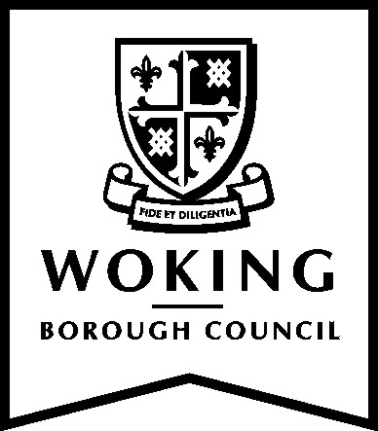

Behavioural Framework

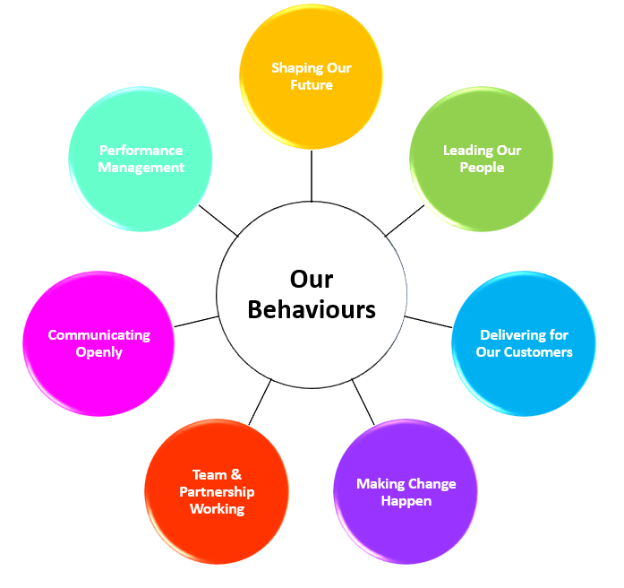

Introduction

Woking Borough Council’s Behavioural framework has been developed to support the Council’s ambitions to continually improve the services provided to our customers.

What is the Behavioural Framework?

A Behavioural Framework is a method of describing the underpinning values that shape and define the culture of the Council. It also provides a clear focus to support the development of employees in order to deliver the best possible services.

The model has seven core behaviours, these are as follows:

- Shaping our Future
- Leading our People
- Delivering for our Customers
- Making Change Happen
- Team and Partnership Working
- Communicating Openly
- Performance Management

There are 4 levels within each behaviour which are related to the role performed. Within the levels there are a number of indicators which are designed to give users a flavour of the approach the Council is looking for. The indicators are not an exhaustive list but are designed to demonstrate what ‘effective’ looks like. The levels are ‘cumulative’. That means that somebody achieving Level 4 is expected to also demonstrate the behaviours in the other levels. Equally somebody at level 1 could exceed this and demonstrate many of the behaviours at level 2.

Why do we need a Behavioural Framework?

This behavioural framework serves several purposes:

- It informs employees of the attitudes and behaviours the Council encourages when carrying out their duties.
- It informs managers and their employees of what is expected from every people manager.
- It shapes and details a culture based around strong principles such as partnership, continuous improvement and constructive challenge.
- It supports employees at all levels in their development in order to maximise their potential.

Shaping our Future

You should be:  - Clear on how your job contributes to and delivers the Council’s objectives in accordance with our vision and values.  - Openly positive about the future of the Council.  - Celebrating success. | What it is not:  - Cynicism about the corporate vision and values.  - Failing to take account of the Council’s values in your work.  - Undermining decisions which have been publicly supported.

Level 1 | Level 2 | Level 3 | Level 4
- a good understanding of your role and responsibilities  - clear how your job contributes to the delivery of the Council’s vision  - understands how changes in your area impact on your role  - behaves in line with the values of the Council  - talks and listens to customers to fully understand their needs of the Council  - keeps up to date with Council news | - a good understanding of the Council’s vision and how it applies to you  - can explain how you are contributing to achieving the Council’s vision  - aware of regulatory and other policy impacts in your work area  - demonstrates the Council’s values in all aspects of your work  - engages effectively with the customer and feeds this into improved service delivery  - can describe how the organisation’s business planning contributes to the development of service delivery plans | - a clear understanding of the Council’s vision and how it applies to you, your team and your colleagues  - translates the Council’s vision into positive local strategies and plans  - puts into practise the organisations core values  - uses customer information to inform the development of the team strategy and plans  - assesses the impact of wider changes in the Council on the plans of the team  - anticipates and manages risk and threats to organisational development | - a champion for the values and vision of the Council  - contributes to the development of the Council’s vision  - encourages others to be forward thinking and innovative in the creation of the Council’s vision  - delivers strategy and service plans using evidence based best practice  - politically aware  - a strong understanding of the workings of local government, from both an operational and political perspective  - proactively links with customer groups to indentify their needs and thereby shape the Council’s agenda

Leading our People

You should be:  - Providing inspiration and guidance to others.  - Enabling employees to fulfil their potential.  - Being an exemplar of the Council’s values.  - Looking to the future and engaging others in understanding the Council’s vision, values and future direction. | What it is not:  - Failing to listen, support and involve employees.  - Inconsistency and unfairness.  - Failure to review and improve your own effectiveness as a leader.

Level 1 | Level 2 | Level 3 | Level 4
- having a good understanding of your strengths and development needs  - applying the behaviours and skills required of your role  - continuously looking for opportunities to build your skills  - providing constructive feedback to others on their performance  - asking others for feedback on your performance  - welcoming new colleagues and assisting them through their first weeks in Woking  - regularly using “thank you” in a genuine and sincere way  - supporting the health and wellbeing of others in an appropriate way | - taking responsibility for own actions and those of the team  - open to learning new techniques and methods and encouraging others to do the same  - organising, supporting and motivating others to get the best from them  - building the team collective skills and knowledge by sharing information and ideas  - making decisions confidently to help the team achieve its objectives  - seeking and being open-minded to ideas to improve delivery and quality  - sensitive to the views and diverse needs of the team  - giving praise openly and equitably  - regularly discuss health and wellbeing issues with employees | - providing direction and energy to achieve objectives  - demonstrating the organisation’s values in own behaviour  - confidently challenging the way things are done and offering constructive suggestions for how things could be done better  - considering the impact of own demands on others’ workloads and prioritising accordingly  - aware of how to adjust own leadership style to suit different needs and circumstances  - open, approachable and willing to provide support, advice and guidance to others  - empowering individuals to make decisions, but are on hand to support when needed  - actively supports and encourages the health and wellbeing of people and ensures the capabilities of managers are developed | - defining the knowledge, skills and behaviours that represent success for your area  - Inspiring, motivating and guiding others toward the Council goals  - ensuring that development routes are appropriate, relevant and timely for your area  - using available people management data to shape the workforce strategy for your area  - taking a strategic view of people management and considering how it impacts on future service delivery  - coaching of staff in your area equipping them with the skills to do their job better  - actively addressing your own long term development needs  - continuously developing the political leadership and managerial interface  - working with others as a cohesive senior leadership group  - defining a work-life balance strategy which meets the needs of the organisation

Delivering for our Customers

You should be:  - Understanding, seeking out and delivering high quality services to our customers.  - Putting the customer at the heart of what we do.  - Constantly looking to shape our services to deliver more effectively and efficiently to customers. | What it is not:  - Unwilling to take appropriate risk to meet the needs of our customers.  - Failing to provide each customer with the necessary information within a reasonable time frame.  - Failing to be an ambassador of the Council’s commitment to high standards of customer care.

Level 1 | Level 2 | Level 3 | Level 4
- understands the range of services that the Council can offer  - delivers consistently high quality customer service in a polite, accurate, and timely manner  - always treats customers with respect, sensitivity and courtesy  - organises and prioritises your work and keeps others informed accordingly  - seeks to resolve customer queries in the first instance and refers to others when necessary | - promotes high quality customer service  - uses personal, professional, knowledge and experience to understand and meet customer needs  - knows when to ask additional questions and when to refer to the expertise of other individuals and teams  - uses customer feedback to improve customer service  - establishes and maintains positive relationships with internal and external customers. | - communicates, implements and monitors high quality customer service  - anticipates the potential concerns of customers and develops communications or solutions to address these  - takes ownership and is accountable for customer relationships  - establishes constructive internal and external relationships to foster two-way communication channels  - allocates resources to support customer service initiatives  - responds to feedback | - promotes a culture of delivering high quality customer services and strives to exceed customer expectations  - considers the impact of wider Council initiatives on the ability of your area to deliver  - works closely with customer groups to increase their understanding of what they can expect from the Council  - encourages others to take responsibility for their work, trusts and empowers them to deliver  - takes action to ensure that services are developed and adapted to meet diverse customer needs  - Identifies hard to reach groups within the community and develops strategies to encourage communication and engagement  - invites customer scrutiny as part of continuous improvement  - manages workload levels of team, adapts priorities when necessary

Making Change Happen

You should be:  - Looking for ways to improve the services that the Council provides.  - Open to try new approaches and directions.  - Using initiatives to improve and develop services. | What it is not:  - Resisting change.  - Avoiding the unknown.  - Making changes without communicating your plans to others.

Level 1 | Level 2 | Level 3 | Level 4
- listening and respecting the views of others  - looking for ways to improve the way we do things  - learning from your mistakes  - considering new ideas from others positively  - putting forward your own ideas and trying them out as appropriate | - sharing your views, ideas and personal feelings about change  - communicating with others about change and how it will affect them  - helping others to cope with change  - understanding how to make new ideas work within the Council  - Identifying potential areas for change and improvement  - showing resilience and persistence to overcome obstacles.  - using your initiative to improve processes and procedures  - viewing mistakes as learning opportunities. | - implementing change to realise the Council’s vision  - identifying opportunities for effectively changing service delivery  - looking to work smarter – evaluating the work of your team  - building capacity for change by reviewing existing priorities and resources  - engaging the customer early in the development of new products or services  - analysing mistakes or performance issues and identifying what needs to be done differently  - address poor performance in a constructive manner | - setting and promoting high standards of performance  - creating a culture of innovation and creativity by welcoming new ideas from everyone  - willing to take decisions and calculated risks to help develop services  - fully involving and informing relevant employees in developing and implementing change initiatives  - fostering a learning culture where all are committed to continuously improve and develop  - looking to best practice, from all industries, to identify opportunities for change and improvement

Team & Partnership Working

You should be:  - Working effectively with others.  - Working collaboratively with partners internally and externally.  - Building partnerships. | What it is not:  - Overlooking the benefits of cross sector working.  - Viewing partnership working as competition.  - Preventing full team participation.

Level 1 | Level 2 | Level 3 | Level 4
- accepts responsibility for own actions and behaviour  - polite and friendly and aware of impact on others  - an active and effective member of team  - respectful towards colleagues  - values diversity | - involves the team in decision making  - shares the credit for successes as well as sharing responsibility for failures  - encourages differences in approaches  - celebrates good performance and addresses poor performance promptly  - creates an environment where team members act promptly and constructively to deal with inappropriate behaviour  - encourages co-operation and working together within the team and with teams across the organisation  - delegates effectively  - positively resolves conflicts / disputes within the team | - leads teams that are recognised for their ability to deliver  - consults internal and external partners in service delivery  - understands the role of partnerships in improving customer service  - encourages partnership working  - develops and sustains high levels of team member commitment and “ownership” for decisions  - builds pride in the team and inspires team members to be the best they can be  - ensures that everyone can contribute equally  - are professional with Members, action in a frank and fair manner | - builds strong relationships with staff, Members and partners  - builds teams that are diverse, competent and motivated  - identifies key partners and opportunities for joint working  - proactively engages partners in developing services and joint delivery opportunities  - consults widely, engaging with stakeholders  - encourages cross team working, including external partners  - actively works to improve relationships with Members
Communicating Openly

You should be:  - Getting the message across and adapting it to the audience need.  - Ensuring transparency. | What it is not:  - Failing to listen and communicate.  - Using jargon rather than plain English.  - Demonstrating a lack of sensitivity when communicating with others.

Level 1 | Level 2 | Level 3 | Level 4
- adapts content and style to help others understand  - are open and honest  - makes sure people are regularly informed  - understands the impact of using appropriate language, gestures and tone when talking with others  - listening to what others are saying  - checks others have understood and seek advice when necessary communicates professionally | - uses appropriate and precise methods of communication  - using positive body language to show that you are listening  - communicates positively and respectfully  - checks others understanding  - clearly explains and justifies decisions made  - encourages team members to think about and suggest improvements  - actively seeks to improve all forms of communication with others | - promote a culture of open communication  - are accessible to your team and colleagues  - communicates effectively using a variety of styles, with a broad range of people  - creates and develops networking opportunities  - actively listens and respects others point of view  - checks own and others understanding  - encourages frank and open discussions | - sets the style and tone of communication for your area - communicates positively and respectfully  - supports other by creating opportunities for them to contribute  - selling your ideas by exploring the concerns of others and clearly explaining the rationale behind the proposed solution  - facilitating cross-service area communication to ensure information flows between different groups and services  - fostering an environment where giving and receiving difficult messages is supported  - ensuring all employees have a voice within the Council  - creating and encouraging two-way communication inside and outside the organisation  - personal credibility with a variety of different groups and uses networks  - actively listens and respects others point of view
Performance Management

You should be:  - Supporting a clear process and system for monitoring and evaluating performance.  - Clear on the priorities and demands on your area. | What it is not:  - Failing to appraise employees and address poor performance.  - Ignoring development needs.  - Failing to set clear objectives.  - Setting confusing or conflicting priorities.

Level 1 | Level 2 | Level 3 | Level 4
- prepares appropriately for performance reviews  - gets on with your job and delivers against your agreed targets to the required standard  - identify opportunities to improve your job and asks for help and support when needed  - identifies areas where you need further training | - identifies priorities and key activities to develop team delivery  - provides feedback and develops employees to their next level of performance  - listens to problems and resolves these by monitoring performance and providing feedback through regular Performance and Development Reviews (PDRs)  - consistently undertakes PDRs for all the employees that you are responsible for  - challenging people to improve performance and/or systems  - holding team members accountable for achieving results  - effectively managing poor performance (e.g. sickness) and proactively managing under-performance | - delegating and adapting systems to improve performance  - setting clear team objectives and priorities and monitoring achievement  - challenging current working practices where these could be more effective  - looking at ways to continuously improve service delivery  - consulting and encouraging the opinions of others  - providing the necessary tools for staff to achieve their work objectives and looking to eliminate obstacles  - acting as a coach to employees and other managers | - ensuring that clear priorities to deliver objectives are produced in a timely fashion and the resources are determined  - demonstrating an understanding of business and service planning and performance management and making these links clear to colleagues  - effectively setting short and long term goals and communicating effective strategies to achieve them  - proactively and consistently monitoring progress and evaluating outcomes and revising plans to meet desired goals  - is a role model  - celebrates excellent performance

