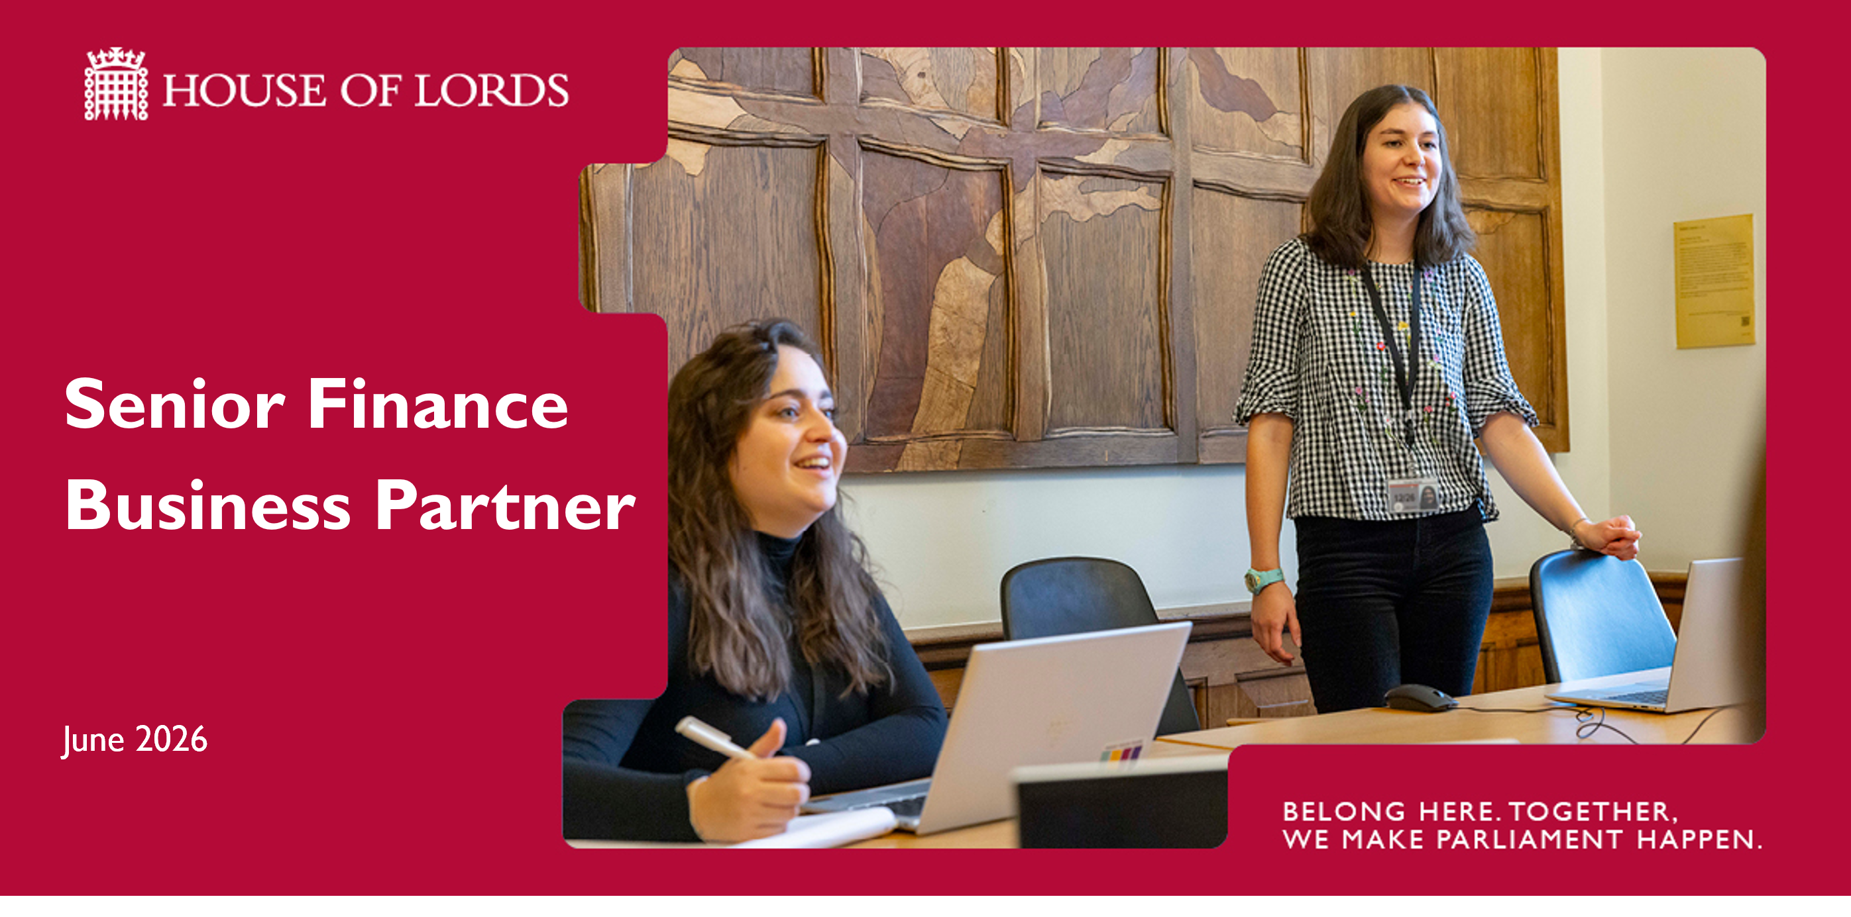

Salary: £60,500 - £70,700 per annum.

Contract: Permanent (House of Lords pay band HL8)

Location: Parliamentary Estate / Hybrid working

Hours: Full-time (36 hours a week)

What you’ll do
As a Senior Finance Business Partner, you’ll play an important role in supporting the UK’s parliamentary democracy. Your work will help ensure members of the House of Lords are able to carry out their responsibilities effectively, contributing to something bigger than any one role.
You’ll be delivering a high quality, data-led and insight-driven finance business partnering service to stakeholders across Parliament at all levels including the Finance Director, Lords Management Board and Budget Holders. You’ll report to the Head of Finance Business Partnering and line manage up to 4 members of the team.
Your other responsibilities will include;
Business Partnering, Relationship Management and Reporting
- Building and sustaining trusted, credible relationships with House of Lords budget holders, senior managers, and key stakeholders, developing a deep understanding of their areas to support the delivery of organisational priorities and value for money
- Establishing and maintaining strong effective networks across Parliament, including the House of Commons, Parliamentary Digital Service, R&R Client Team, and bicameral shared service areas, ensuring organisation-wide financial insight and collaboration
- Acting as a strategic partner to stakeholders, providing high-quality, analysis-driven financial information and support to enable effective delivery and value for money of the Houses of Parliament major programmes and contracts, and providing high quality Accounting Officer advice to the Clerk of Parliaments
- Delivering accurate, timely, and relevant management information to provide clear insight on performance, risks, and opportunities
- Producing and presenting high-quality data-led and insight driven financial reports for senior audiences, including the Finance Director, Lords Management Board, and Finance Committee, translating complex financial information clearly
- Providing constructive challenge to stakeholders on financial plans and in-year performance
- Deputising for the Finance Director, Head of Finance, and Head of Finance Business Partnering as required.

Financial Planning, Budgeting and Forecasting
- Partnering with budget holders and senior managers through the annual planning and in-year forecasting processes, providing robust analysis and constructive challenge
- Supporting the development of a strong and credible Medium-Term Financial Plan, aligned with the House of Lords overall strategic priorities, working closely with the Head of Finance Business Partnering and Governance Team on business planning to align financial and organisational priorities
- Leading on the provision of financial planning information, working collaboratively with HR colleagues to ensure alignment between workforce planning and financial plans.

Business Cases and Investment Decision Support
- Playing a key role in the business case assurance process, working with the Enterprise Portfolio Management Office and acting as a trusted advisor to stakeholders
- Reviewing and challenging business cases, change controls, and resourcing proposals, ensuring value for money and alignment with strategic priorities and HM Treasury’s Five Case Model
- Partnering with budget holders to develop robust financial options, costings, and analysis to support high-quality business cases
- Working collaboratively with House of Commons colleagues to ensure visibility and alignment on cross-Parliament projects and programmes.

Continuous Improvement and Corporate Contribution
- Contributing to finance transformation and improvement initiatives, including the Finance Systems Improvement Programme
- Maintaining effective financial reporting, performance measures, and dashboards to ensure clear, reliable financial information to support transparency and accountability
- Building effective relationships with internal and external auditors, ensuring strong financial governance and control.

Leadership and Team Development
- Providing leadership and line management to up to four staff, fostering a high-performing and collaborative team culture
- Supporting the development of team members through coaching, stretching objectives, and continuous professional development
- Contributing to the wider leadership of the Finance function, promoting consistent, high-quality business partnering practices.

You may occasionally take on additional responsibilities in line with your role and grade.

What you’ll bring
We’re looking for someone who can bring their skills and experience to make a meaningful contribution.
Qualifications:
- You must be a fully qualified accountant (CCAB or equivalent).
Essential criteria:
- Relationship management and influencing - Proven ability to build and sustain strong, effective, credible relationships and networks at all levels, becoming a trusted advisor to stakeholders. Experience of working collaboratively with a wide range of internal and external partners, including auditors, and providing constructive challenge to support value for money and informed decision-making.
- Analytical thinking and problem solving– Highly developed analytical skills, with experience of interpreting large volumes of complex data and translating this into key insights. Ability to challenge and support business outcomes, identify risks, issues, and opportunities, and develop a pragmatic approach to solving problems.
- Communication and stakeholder engagement – Excellent communication skills, with the ability to convey complex financial information clearly and concisely to non-finance audiences. Confident in tailoring messages to different stakeholders and supporting informed decision-making through clear, impactful narrative.
- Delivery, accuracy and resilience - Strong attention to detail combined with the ability to prioritise and deliver high-quality outputs to tight deadlines. Remains composed and focused in a fast-paced environment, balancing multiple priorities while maintaining accuracy.
- Leadership and people development - A proven track record of building capability and developing people, with experience of supporting, coaching and enabling colleagues to perform at their best. Contributes to a high-performing, collaborative finance function.
- Finance expertise and technical capability – Strong experience operating as a finance business partner within a complex organisation, with well-developed accounting knowledge and the ability to apply this in a practical way with a focus on stakeholders. Advanced IT skills, including extensive use of financial systems and Microsoft Excel, to support robust analysis and reporting.

Desirable:
- An understanding of the public sector financial framework as it applies in central government.
- Experience of reporting platforms such as Power BI.

About this team
You’ll be joining the Finance Department, led by the Finance Director and comprising c.30 colleagues. The office delivers a comprehensive range of financial services to the House of Lords, including strategic financial planning, financial accounting, management accounting, resource and capital accounting, payments, Members’ expenses and staff payroll.
You’ll be part of a highly effective finance business partnering function, placing strong emphasis on building trusted relationships with stakeholders. The team plays a critical role in aligning financial insight with organisational priorities, supporting strategic and operational decision-making, and ensuring value for money in a complex and high-profile environment.

About us
Every day, we support the UK’s parliamentary democracy. It’s work that matters — helping Members of the House of Lords examine legislation, hold government to account and contribute to national debate.
You’ll be based on the Parliamentary Estate, a unique UNESCO World Heritage site at the heart of Westminster. It’s a place shaped by history and powered by the people who work here today. From the House of Lords Chamber and committee rooms to offices, kitchens and public spaces, it’s a working environment like no other — busy, varied and full of purpose.
You’ll be joining a community of colleagues from a wide range of backgrounds and professions. Researchers, specialists, project managers, digital experts, caterers, security teams and many more all play their part. Whatever your role, you’re part of something bigger — working together to keep Parliament running smoothly.
How we work is just as important as what we do. Our values guide our day-to-day behaviours:
- Respect – we treat each other with fairness, kindness and consideration
- Inclusivity – we value difference and diversity, and create space for everyone to contribute
- Professionalism – we take pride in our work and aim for high standards. We act with impartiality, integrity and openness
- Responsibility – we take ownership of our work and actions. We hold each other to account and keep learning.
We know that when people feel they belong, they can do their best work. That’s why we’re committed to building an inclusive and welcoming environment, where you’re supported to grow, develop and contribute in ways that matter.

Flexibility
We know flexibility matters. Wherever possible, we’ll support working patterns that work for you — including options like hybrid working, part time working or adjusted hours.
You’ll get a very generous annual leave allowance of 30 days, which increases to 35 days after a year. Most annual leave is taken when parliament is not sitting, and we offer different types of paid special leave for when “life happens” and won’t wait until recess.
Not every role can offer the same level of flexibility, and this will depend on the nature of the work. We’ll always be open about what’s possible and talk this through with you. For this role, the following working patterns are available:
- Part-time working
- Job-share
- Compressed hours
- Home working (1-2 days a week)
If you’re invited to interview, we can discuss your preferred working pattern so we can understand what works best for you.

Benefits
Alongside your pay, you’ll have access to a wide range of benefits and development opportunities. Full details can be found on our Benefits - UK Parliament page.
Benefits include a commitment to your learning and development, an in-house health and wellbeing service, on-site gym and nursery, the opportunity to attend events including the State Opening of Parliament, on-site canteens and restaurants, and the civil service pension schemes.

Being impartial
Working here means upholding impartiality in everything you do. You’ll provide services, make decisions and carry out your responsibilities without being influenced by personal political views, or favouring one perspective over another.
In practice, this usually includes not taking part in political activity or public campaigning outside of work. If you have any questions about what this involves, please contact us at hlrecruitment@parliament.uk — we’re happy to help.
Inclusion and belonging
We’re steeped in history but not limited by it, and we want everyone to feel they belong here. We welcome applications from all candidates with diverse characteristics, including different ages, disability, sex, gender reassignment/trans, marriage and civil partnership, pregnancy and maternity, race/ethnicity, religion or belief, sexual orientation and socio-economic status, and support a range of workplace adjustments, including for caring responsibilities.
How to apply
Apply online by 23:59 on Sunday 19th July 2026.
We expect to invite shortlisted candidates to interview w/c 3rd August 2026 in Westminster. We may also ask you to complete an assessment or test.
As part of your application, you’ll need to submit:
- An anonymised CV outlining your career history, responsibilities and achievements
- An application form, providing examples against the essential criteria in this job description, showing how your experience matches what we’re looking for.
We’ll assess your application based on what you tell us about how you meet the essential criteria in the job description, so please include clear, relevant examples.
These examples can come from work, education, volunteering or other relevant experiences. Focus on what you contributed and the difference you made.
A helpful way to do this is the STAR approach:
- Situation – set the context
- Task – explain what you needed to do
- Action – describe what you did
- Result – share the outcome and impact
A few things to know
- We can only accept applications submitted through our online portal. We can’t accept late applications, but we never close campaigns before the advertised closing date.
- We don’t use AI to shortlist applications. If you choose to use AI when preparing your application, please make sure your answers are truthful and provide specific examples.
- We ask you to remove personal details from your CV (such as your name and age) as part of our commitment to inclusive recruitment. You can include names of previous employers.
Support with your application
We want everyone to feel able to apply and do their best.
If you need any adjustments during the application process, or have any questions, please contact us at hlrecruitment@parliament.uk — we’re here to help.
For guidance on applying and to learn more about our recruitment process, visit:
- Guidance for applicants - UK Parliament
- Application process - UK Parliament
Pre-employment checks
Before we can confirm an offer, you’ll need to complete some standard pre-employment checks. These help us make sure everything is in place for you to start with confidence.
These usually include:
- References
- Health checks (where appropriate)
- Security vetting
- Online presence (we will review publicly available information to assess suitability).

Security vetting
As part of working here, you’ll need to meet the same security requirements as if you worked for a government department.
For this role, a standard Counter Terrorist Check (CTC) is required. You’ll need to pass this before your appointment can be confirmed. This includes:
- Confirming your identity and right to work in the UK
- Providing your employment or academic history and address history from the past three years

If you’ve lived outside the UK for more than two of the past five years, we’re sorry that you won’t be able to pass our security checks.
In some cases, we may ask for additional information to help complete these checks — for example, if there are gaps in your employment or time spent abroad.
You can find more details in the National Security Vetting booklet.
Want to know more?
You can find more information about the House of Lords at www.parliament.uk – or see member of the UK parliament in action on Parliament Live.
More information about working at the House of Lords, including the variety of roles we need to support members and the House on our careers page.

