

Waverley is an ambitious authority, committed to being one of the leading Councils in the country at a time of major change by developing a high performing, highly engaged staff team to share the organisation’s values and deliver our corporate objectives.

Job Description
Job title: | Registered Building Inspector (Class 2 A- F)
Service: | Commercial Services
Team: | Building Control
Location: | The Burys, Godalming, Surrey, GU7 1HR
Reporting to: | Registered Building Inspector (RBI) Team Leader
Responsible for: | When required, supervisory responsibility for RBIs registered at a lower competence level and within the limits of own registration/competence.
Our Organisational Values
Collaboration   | We know, work with and support one another. We collaborate with residents, businesses and partners and realise the potential of the Guildford and Waverley Collaboration. We empower ourselves and others.
  Wellbeing | We look after our own and other’s wellbeing. We know it’s okay to talk to each other about anything we are struggling with. We stay resilient and raise any concerns we have.
Trusted   | We abide by the Nolan Principles of Public Life: Selflessness, Integrity, Objectivity, Accountability, Openness, Honesty, and Leadership.
Value for Money   | We spend public money wisely and carefully. We understand and follow our governance processes and raise any concerns with the right person. We celebrate successes and learn from mistakes.
Professionalism   | We provide professional advice and excellent service, we know our local areas and understand the communities we serve. We listen to all concerns and ideas. We benchmark our performance and always strive to improve
Principal purpose of the role and team
TEAM:

- to undertake all aspects of the Building Control function on behalf of the council

ROLE:

- To protect the health, safety, sustainability, energy conversation and accessibility of people in and around buildings within Waverley using the Building Act 1984, Building Safety Act 2022, current Building Regulations and other legislation.

- To be able to effectively manage a range of projects within BSR registration, examining plans, and carrying out physical and remote site inspections, initiating and delivering enforcement action where needed, answering queries as required and any other statutory requirements.

- To support the Building Control Team in marketing, promoting and developing the Waverley Building Control service.

- To act in accordance with the Building Safety Regulator Operational Standards Rules, Code of Conduct and any other Quality Assurance Systems.

Main duties and accountabilities
Based upon ongoing validated competence of minimum Class 2 A Building Inspector level and registration with the Building Safety Regulator, undertake the following:

- To examine and check plans for compliance with the Building Regulations and issue decisions on those plans.
- To examine and assess work on site for compliance with the Building Regulations ensuring a robust audit trail to completion.
- To be accountable for maintaining accurate, legible records of site visits and ensuring any follow-up actions are completed in a timely manner.
- To manage dangerous structures and take all necessary action during normal working hours, together with preparation of reports, sketches, photographs, correspondence, recovery of costs and follow up procedures.
- To deal with the statutory control over building demolitions; following Building Control protocol and/or legislation and taking action as appropriate.
- To maintain an accurate and thorough knowledge of appropriate technical standards, legislation, codes of practice and UK standards and maintain performance in accordance with ISO9000, Operational Standards Rules, Code of Conduct and any in line with your relevant professional membership body.
- To deal with technical queries as appropriate and escalate where necessary.
- To identify contraventions to the building regulations and take enforcement action where required.
- To make recommendations and guide/signpost householders/builders/architects etc. on the correct course of action required under the Building Regulations for the situation in hand to achieve compliance within the remit of registration and observing the Operational Standards Rules.
- To liaise with the Fire Authority on matters concerning means of escape and fire precautions generally, under the Building Regulations.
- To liaise with the Environment Agency and Water Authorities on matters concerning drainage, under the Building Regulations.
- To check fees on new applications and produce quotations for work dependent on ability and scope of project.
- To ensure work is correctly charged for throughout the life of the project; calculating any revisions and liaising with the client/admin to ensure correct payment is made.
- To deal efficiently with all aspects of correspondence, reports etc., concerning Building Regulation non-compliance and unauthorised works, and taking necessary enforcement action.
- To liaise with planning enforcement regarding any planning infringements you become aware of.
- To proactively deal with general correspondence, complaints and issues relating to building regulations, maintaining clear and accountable notes and record of information.
- To always work within the team with consideration for team members and to foster good working relationships.
- To undertake all necessary CPD activities in line with the requirements of your professional membership and/or BSR registration.
- To carry out any other related duties or functions as may be directed from time to time by the Building Control management team within scope of your registration

Limits of Competence
- The post holder must only carry out unsupervised functions and / or activities that are within the limits of their competence and registration. Undertaking functions beyond these limits must be under the supervision of a suitably competent RBI.

Business Development
- To promote and market the Waverley Building Control Service and to improve the market share.
- To liaise and build successful relationships with all customers, internal and external stakeholders i.e. Asset Management, Housing, planning, architects, developers/contractors, engineers, surveyors, applicants and potential applicants.

Business Continuity
- Play a pivotal role in business continuity planning and should the need arise assist in ensuring business recovery of key service provision in a 24-hour window.

Health and Safety
- Comply with all Health and Safety legislation for your area of work, ensuring that risks are identified, managed and monitored as required.

Dimensions of the role
- The Team consists of a Business Manager, 2 RBI Team Leaders, 4 RBI’s, Trainee RBI, Business Support Team Leader, 2 Addressing Officers, 2 Business Support Administrators.
- As team: processing over c1500 applications, c5500 site inspections and c300 plan checks p.a.
- Income of approximately £700,000 p.a.
- The role is flexible with office and home working, incorporating site inspection (currently patch based - responsible for your own area within the borough) and visits to other locations for training / CPD events /networking and business development.

Areas of Accountability/Problem Solving – Decision Making / Scope for Impact
- Accountable for assessing plans and works on site ensuring your assessments and notes provide a robust audit trail to demonstrate compliance with Building Regulations.
- Accountable for assessing building structures to make safe and/or issuing enforcement action.
- Determination of fees and quotes and subsequent accountability for checking that charges are correct and that work in progress aligns with these.
- Attend team, client and design team meetings when required.
- Willingness to undertake further training to develop and deliver other competencies or specialist services and support the team function.
- Customer Relationship Management to develop and increase income – introducing and developing new clients, maintain existing customer relationships and provide an excellent, solution-driven customer service.
- To uphold and maintain ethics and conditions of your BSR registration, Operational Standards Rules and competency level.

Planning/Organising/Controlling
- Able to manage own workload and time effectively and efficiently.
- Respond to changes in workload and changing priorities in a flexible manner which may include working extended hours at the beginning and/or end of the day.
- Be an effective, participative team member working with colleagues to balance workload and deliver excellent customer service.
- Take ownership of self-development and competency and work towards next level, supporting others to do the same and sharing best practice.

Customers and Contacts
Internal
- All Council services and contractors

External
- Waverley residents
- Architects, Builders, Partners working with Waverley Building Control, RBCA’s, Structural Engineers
- LABC (Local Authority Building Control), Guildford Building Control, Guildford depot
- Surrey Partners, Fire, Highways, Police, Water Authorities etc.
Service/Team Structure
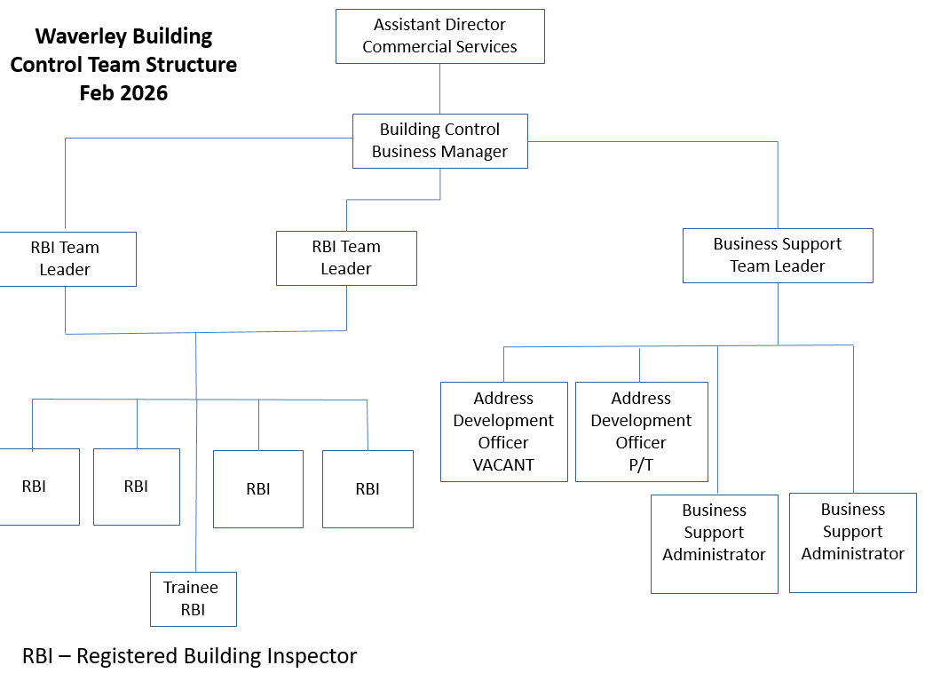

PERSON SPECIFICATION

Candidates must be able to demonstrate, giving examples, all essential criteria within their application form to be shortlisted for this role.

 | Person Specification
 | Essential criteria | How Assessed | Desirable criteria | How Assessed
Qualifications/ Education / Training / Experience | - Maintained competency i.e. BSCF, CABE or BCCA and a minimum Class 2A Registration with the Building Safety Regulator  - Levels 2 A – F considered. | - A/C | - Degree or relevant qualification in Building Surveying / Construction and/or have relevant experience  Full membership of RICS, CABE or equivalent | - A/C
Qualifications/ Education / Training / Experience | Demonstrable experience in a same/similar role | - A/I | - Minimum 4 years’ experience in a same/similar role | - A/I
Qualifications/ Education / Training / Experience | - Extensive experience of working with contractors / architects / builders / tradespeople / developers. | - A/I
Qualifications/ Education / Training / Experience | Extensive experience of plan checking all types of application and performing site inspections. | - A/I
Qualifications/ Education / Training / Experience | Experience of dealing with and checking initial notices and related tasks associated with RBCAs. | - A/I
Qualifications/ Education / Training / Experience | Up to date technical and legislative knowledge and understanding of a Building Control Service - Regulations, Approved Documents, technical requirements and current practices. | - A/I
Knowledge /Technical Skills | - Able to interpret and implement the requirements and translate them to our customers. | - I | - Has experience in a variety of sectors including building control matters | - A/I
Knowledge /Technical Skills | - Up to date awareness of new construction related products, trends, materials and building techniques and practices. | - I
Knowledge /Technical Skills | - Knowledge of Construction Health and Safety. | - A | - Knowledge of Safeguarding | - A/I
Knowledge /Technical Skills | Broad knowledge of dealing with Dangerous Structures. | - A/I
Knowledge /Technical Skills | Able to use IT systems proficiently including Microsoft Office packages. | - A
Knowledge /Technical Skills | - Ability to collate evidence, review information against appropriate guidance, maintain clear and concise and accountable records and produce accurate correspondence, reports and records. | - A/I
Knowledge /Technical Skills | - Able to effectively deliver difficult messages and explain complex information in a positive and clear way so that people can understand. | - I
Communication | - Effectively communicate in writing, on the telephone and in person | - A/I
Communication | - Understanding of and commitment to promoting equality and diversity in service delivery and employment. | - A
Communication | - Understanding of and ability to provide excellent Customer Service across all existing and potential customers. | - A/I
Customer Service | - Able to network and build strong working relationships with clients, customers and colleagues. | - I
Customer Service | Must have good listening and communication skills in order to manage expectations and situations and be able to de-escalate conflict situations | - A/I
Customer Service | Able to work effectively within the team environment to deliver a seamless, responsive and efficient service. | - A/I
Team Working | - Able to take ownership and have accountability of own work yet able to support the delivery of the service for the whole team. | - I
Team Working | - Effective time management skills, managing own workload and being flexible to the clients’ needs. | - A
Managing self and others | - Ability to use initiative and work without direct supervision, making considered, appropriate decisions about building regulations matters. | - A/I
Managing self and others | Able to understand our clients’ needs and the sectors in which they operate. | - I | - Account Management skills – building new business relationships, managing client relationships (providing excellent service and support), being target driven and promoting our service whilst balancing the requirements for building control. | - A/I
Managing self and others | - Able to multitask balancing day-to-day work activities, taking ownership of own training and development whilst ensuring team performance is maintained and colleagues supported. | - I
Managing self and others | - Ability to work to deadlines. | - A/I
Can do approach / Achieving results | - Solution Driven – positively working with the client to achieve compliance in an effective and efficient manner. | - I
Can do approach / Achieving results | - Being proactive to maintain and increase workload | - A/I
Special Requirements | Must have access to own roadworthy vehicle for carrying out site inspections in line with the Council’s Policies. | - I/C
Special Requirements | Car for work purposes with full and valid Driving Licence. | - I/C
Special Requirements | - Able to work at height and in confined spaces. | - A/I
Special Requirements | - For business continuity purposes, you are required to have access to the internet at home via broadband on a PC, laptop or tablet. | - I

How assessed
A = Application CV/Personal Statement
C = Certificates/professional Registration
D = DBS police check
E = Exercise
I = Interview
M = Medical assessment

Basic Disclosure Clearance- Government Requirement for Accessing Council and Government Data
To comply with the Public Sector Networks (PSN) “Code of Connection”, Waverley Borough Council, like other public organisations, need to undertake basic disclosure checks for unspent convictions only, in respect of those staff who will access our IT systems. As a result, a Police Act Disclosure form, together with Guidance Notes, will be sent to you if you are successful in the appointment of this post.

For Official Use only
Job title: | Registered Building Inspector | Post no:
Service: | Commercial | JE score:
Team: | Building Control | Pay band: | PLN5
Location: | The Burys  Godalming,  Surrey GU7 1HR | Position type:  (if part time, working pattern)
Competencies:  (level 1 – 4) | Communication: | Add level
Competencies:  (level 1 – 4) | Customer Service:
Competencies:  (level 1 – 4) | Team Working:
Competencies:  (level 1 – 4) | Managing Self and Others: | Add level
Competencies:  (level 1 – 4) | Can do approach/Results
Reviewed By: |  | Date:
Checked in: | Employee Services this…? | Date:
Last Updated: | Add date | Date:

