JOB PROFILE

Street Scene

SERVICE AREA

Grounds Operative

JOB TITLE

Various

POST NUMBER

C

GRADE

Deputy Operations Manager
Operations Manager Head of Service

RESPONSIBLE TO

KEY LIAISON WITH  JOB PURPOSE | Service Managers Team leaders
KEY LIAISON WITH  JOB PURPOSE | To work as a small team of Street Scene Operatives within an area specified by the Deputy Operations Manager.  The post holder could be based at various sites throughout the Borough and will assist in the maintenance and cleansing of a wide range of the Council’s public places and open spaces on a shift basis covering Monday to Sunday.
KEY CORPORATE ACCOUNTABILITIES
- To work with colleagues to achieve service plan objectives/targets.

- To participate in Employee Development Scheme/Appraisals and contribute to the identification of your own and team development needs.

- To actively promote the Council's Equal Opportunity Policy and Diversity Strategy and observe the standard of conduct which prevents discrimination taking place.

- To ensure full compliance with the Health and Safety at Work Act 1974 etc., the Council's Health and Safety Policy and all locally agreed safe methods of work.

- To fully understand and be aware of the commitment to Section 17 ‘Duty of the Crime and Disorder Act 1998 to prevent crime and disorder’.

- At the discretion of the Head of Service, such other activities as may from time to time may be agreed consistent with the nature of the job described above.

KEY SERVICE RELATED ACCOUNTABILITIES
- To provide a wide range of duties connected with the delivery of Street Scene Services, including:
  - Grounds maintenance
  - Street cleansing (including mechanical sweeping)
  - Golf Course
  - Building cleaning
  - Cemetery (including assisting with grave digging & Maintenance)
- To ensure that the wide range of duties specified by the Deputy Operations Manager are delivered, to a high standard.
- Following instructions given by the Deputy Operations Manager, attending pre planned appointments promptly, assisting with the organising of materials required, completing and handing in record sheets daily and following administrative procedures as directed.
- Driving Council vehicles, ensuring that vehicles and plant are clean, in good working order.
- Maintaining training and licences relevant to the vehicles used.
- Work to a high standard ensuring high quality workmanship whilst maintaining an acceptable level of productivity commensurate with skills and experience.
- To complete time sheets, claim forms, daily defect checking, keeping records and to fulfil statutory checks as required.
- Ability to adapt to changing working environments and work patterns as deemed necessary to meet the strategic goals of the Service Area.
- Represent Street Scene in a manner conducive with the standards expected, in the correct wearing of the uniform and PPE supplied.
- To communicate with customers, Management Team and members of the public in a polite manner placing the highest possible emphasis on customer care, whilst encouraging customer involvement and feedback.
- Responsible for maintaining health, safety and welfare of self, other employees and members of the public ensuring adherence to safe working practices and environmental procedures. Including attendance of team meetings to discuss operational issues and Health and Safety updates.

PERSON SPECIFICATION

JOB TITLE: Grounds Operative

SERVICE AREA: Street Scene

Information for Applicants: The Person Specification provides an outline of the experience, skills and abilities we expect the Successful Applicant to possess. You should match your own skills, experience, and abilities to those listed below. Tell us in what way you have carried out the criteria asked for. Disabled people will be offered an interview where they meet the Essential Criteria alone

Method of Testing 1 = Application Form 2 = Interview 3 = Assessment Tests

Weighting of Criterion 1 = Low Importance 2 = Medium Importance 3 = High Importance

Key Competencies and Behaviours | How  Measured  1 - 3 | Weighting  of Criterion  1 - 3
1. Skills and Abilities – Essential
- Basic literacy and numeracy skills.  - A current driving licence for the correct class of vehicle.  - The ability to work outdoors which will involve some exposure to inclement weather, disagreeable or difficult surroundings/conditions.  - The ability to work unsociable hours, including weekend working and Bank Holidays.  - The ability to communicate at all levels in a clear, concise and open manner. Working with a range of individuals and other Departments within the Council.  - Excellent organisational skills and time management, with the ability to work under pressure.  - Demonstrate a high degree of attention to detail, and have a keen interest in maintaining the Council’s areas of responsibility  - Excellent team working skills | 1,2  1,2,3  1,2  1,2  1,2  2,3  2  2,3 | 2  3  3  3  2  2  2  2
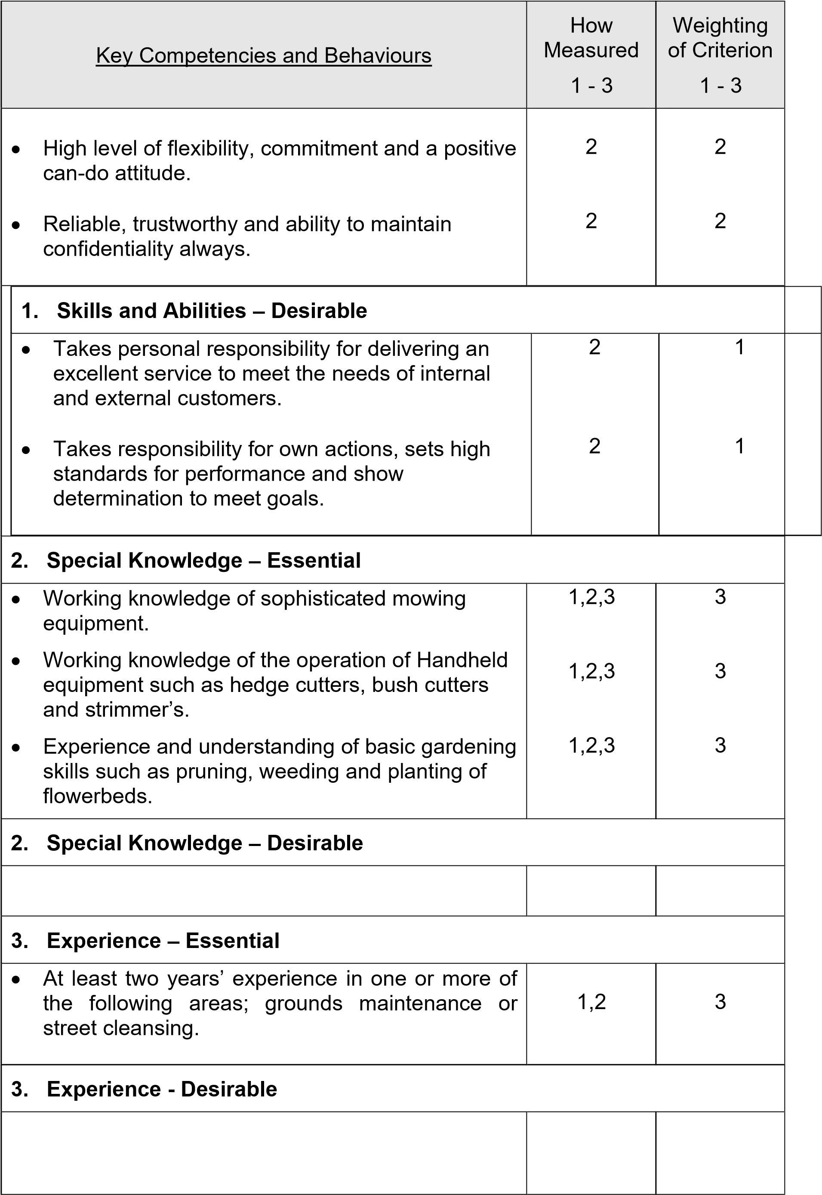
Key Competencies and Behaviours | How  Measured  1 - 3 | Weighting  of Criterion  1 - 3
4. Other Requirements – Essential
• To undertake a Council Driving Test | 3 | 1
4. Other Requirements – Desirable
- Qualification within a Specialised Area.  - PA1 & PA6 spraying certification. | 1,2  1,2 | 1  1
5. Equality – Essential
• An understanding of and commitment to the principles of equality and diversity in all aspects of the Council’s work. | 1,2 | 3
5. Equality – Desirable

