Job description
Job title | Arboricultural Apprentice
Grade | B
Directorate | Place
Service/team | Environmental Sustainability
Accountable to | Principal Arboricultural Officer
Responsible for | N/A
JE Reference |  | Date Reviewed | 16/06/26

Purpose of the Job

The post holder will be supporting the Principal Arboriculture Officer in providing a holistic tree management service on behalf of the Council. The role will focus on the planning of long-term management of the Council’s arboricultural assets and the delivery of strategic objectives in line with local, regional and national policy.

Duties and Responsibilities

This is not a comprehensive list of all the tasks, which may be required of the post holder. It is illustrative of the general nature and level of responsibility of the work to be undertaken.

Responsibilities - Specific

- To support the Principal Aboriculture Officer in developing the Council’s policy and strategy to conserve, improve and maintain the borough’s treescape. To ensure, through effective management, and strategic long-term planning the sustainability of trees in the borough.

- To assist in undertaking the surveying of the Council’s tree stock.

- To assist with tree related enquires.

- To support with the identification and application to relevant grant funding bodies.

- To work with the Mersey Forest and local partners to deliver projects on site and support the creation of woodland management plans.

- Must demonstrate a keen commitment to customer care, displaying flexibility in approach to work to achieve service and corporate priorities.

- Good written and verbal communication skills, able to engage confidently with diverse groups of people and build effective relationships

- Good interpersonal skills including the ability to work across services and organisational boundaries.

- Good project management skills to deliver projects to completion.

- To promote and implement the Council’s Equal Opportunities Policy in all aspects of employment and service delivery.

- Willingness to undertake and achieve a relevant occupational qualification as part of the apprenticeship programme, demonstrating commitment to ongoing learning and development

As part of your role with the Council, you share a collective responsibility to support and champion children and young people who are cared for by the Council and young people who are care experienced. Children and young people tell us that including this in all job descriptions “is good” because they want all Council employees to understand how important it is to “treat children in care and care experienced young people as they would their own”. We ask that you do this with the same commitment, care and ambition that any parent would, regardless of your job role or service area. Children and young people tell us that they want all Council employees to be “genuine”, helping to create a supportive environment, remaining alert to any worries and concerns, and ensuring that safeguarding is promoted and responded to appropriately.

Knowsley Better Together – Staff Qualities

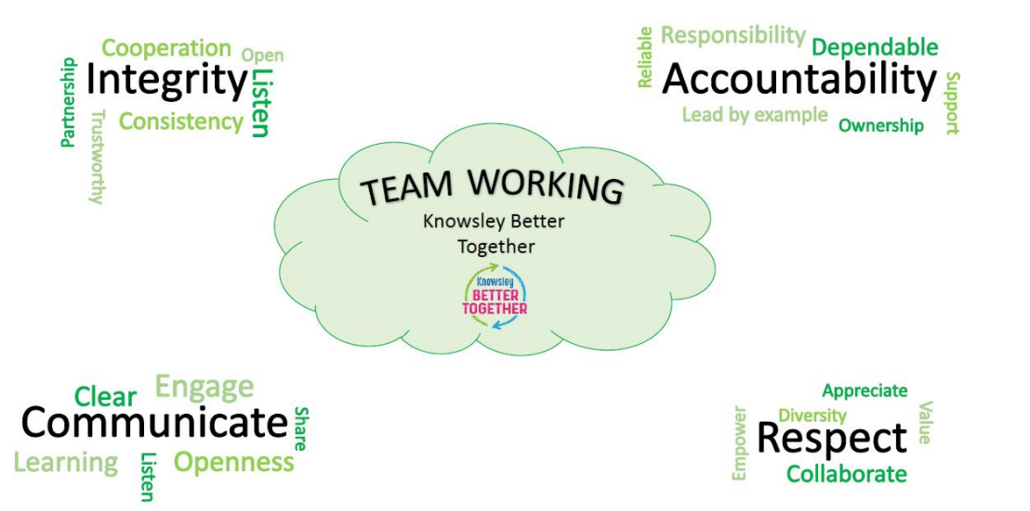

- Integrity. You are required to be open and honest, maintain high standards of personal behaviour and display strong moral principles.
- Accountability. You must take personal responsibility for your actions and decisions and understand the consequences of your behaviour.
- Communication. You must listen and talk to others, taking account of other people’s points of view. You should share information and strive to work together.
- Respect. You must treat people with care and dignity, observing the rights of other people, and helping and supporting others where you can.

Health and Safety

- To use equipment as instructed and trained.

- To inform management of any health and safety issues which could place individuals at risk.

Data Protection and Information Security

- Implement and act in accordance with the Information Security Acceptable Use Policy, Data Protection Policy and GDPR.

- Protect the Council’s information assets from unauthorised access, disclosure, modification, destruction or interference.

- Report actual or potential security incidents.

